ETX CONGREGATIONAL YOUTH MINISTRY: CONTINUING REPORTS OF TEENAGERS’ EXPERIENCE OF THEOLOGY, COMMUNITY,
AND WORSHIP IN EAST TEXAS

A Paper Given at the 2025 AYME Annual Conference in Des Moines IA, October 17-19

Dr. Michael Mauriello
Clinical Associate Professor of Youth and Family Ministry
George W. Truett Seminary at Baylor University, Waco, TX

Mrs. Stephanie Berglund (Research Assistant)
Master of Divinity Student, Talbot School of Theology; La Mirada, CA
Assistant Director; Passage Institute for Youth and Theology
LeTourneau University, Longview, TX

PURPOSE OF THE STUDY
This paper provides updates from a paper presented at the 2024 AYME Annual Conference in Charlotte, NC, where very preliminary research was presented on congregational youth ministry in East Texas (Mauriello and Berglund 2024). There is currently no qualitative or ethnographic study of youth ministry within the boundaries of East Texas (ETX). Nor is there any qualitative research on Christian ETX teenagers’ experiences of their congregational youth ministries (CYGs). Therefore: The purpose of this multi-method qualitative study is to examine Evangelical Protestant ETX congregational youth ministries and Christian ETX teenagers’ experiences of community, theology, and worship in those Evangelical Protestant ETX congregational youth ministries. The qualitative study’s mixed methods include an ethnography of ETX CYGs’ primary programmed event. It would also include focus groups with high school aged participants who can provide thick and rich description of their experiences in their youth groups. The study aims to answer the following research questions:
- How do Christian ETX teenagers describe themselves and their reasons for participating in the youth group?
- How do ETX teenagers create community at the primary youth group event in Evangelical Protestant ETX congregations?
- What practices, pedagogies, and rituals make up the programming at Evangelical Protestant ETX congregational youth ministries?
- How are practices, pedagogies, and rituals which make up the programming at Evangelical Protestant ETX congregations formative to Christian ETX teenagers?
- What theology is communicated through the youth group programming at Evangelical Protestant ETX congregations?
- How do ETX teenagers narrate their theology based on their youth group programming?

GENESIS OF. THE STUDY
This paper followed on the completion of assessments for the Lilly Endowment’s HSYTI grant implemented at LeTourneau University (LETU) through the Passage Institute for Youth and Theology (Passage). As Passage assessed its programming with Christian junior and senior high school fellows who were described as theologically maturing teenagers (these teenagers described their experiences at their congregational youth groups as boring and anchorless. The disconnection did not imply that they would not go to youth group; indeed they regularly spoke highly of their youth pastors. But they struggled with connecting with peer relationships at their CYG and also sometimes struggled with condescending leaders. Further, they felt that CYG’s over-emphasized evangelism and emotive worship experiences (Mauriello 2022, 2024).
Upon the completion of these assessments (Mauriello 2019, 2021, 2022, 2023, 2024) as also reported to AYME (Mauriello 2023 B, 2024 B), it was determined that research needed to be done to see clearly within ETX CYGs. Indeed, TMTs themselves acknowledged that they were one demographic of a large spectrum of students in their CYGs, and that youth pastors and leaders had to minister and program CYGs to address a variety of needs from diverse students. So, last year a study was begun funded by AYME 2023-2024 Taylor University/ Lilly Foundation Grant to begin a robust ethnography of ETX CYGS. This current paper presents updated research on the ongoing project, having now gathered data and findings from fifteen participant churches and focus groups.
LITERATURE REVIEW
While parents no longer necessarily view the church’s ministry to their children as the primary educator in their faith (Cf. Smith and Adamczyk 2021, Smith, Ritz, and Rotolo 2020), the church has always viewed its ministry as education particularly to the young. Christians learn through direct interaction with God’s personal saving acts in their lives but also in the context of the church as they are integrated more fully into their local bodies of believers. Such learning might be described as situated learning: “Learning viewed as situated activity has as its central defining characteristic a process that we call legitimate peripheral participation” (Lave and Wenger 29, LPP). LPP, according to Lave and Wenger describes the relationships between “newcomers and old-timers, and about activities, identities, artifacts, and communities of knowledge and practice” (29). “The meaning of learning is configured through the process of becoming a full participant in a sociocultural practice “(29). Wenger builds on these assumptions in his own work. To him, 1) humans are social beings, which occupies the center of learning; 2) knowledge is “competence” in valued enterprises, 3) knowing “is a matter of participating in the pursuit of such enterprises,” and 4) meaning “is ultimately learning is to produce” (40). The four components of learning for Wenger are therefore meaning, practicing, community, and identity. (5). Notice that Wenger’s paradigm for learning overlaps with two of the Fuller Youth Institute’s dimensions for spiritual growth and thriving in young people: Identity and belonging. Since learning involves working in concert towards mutual goals in Wenger’s paradigm, The Fuller Youth Institute’s third dimension is also present; purpose.
JKA Smith in his Desiring the Kingdom would agree that places and experiences are pedagogical, even if that pedagogy is implicit rather than implicit. His account of a shopper/consumer’s experience in the mall is formative through the architecture and space, or the materiality of the place and its meaning (cf. Elizabeth Ellsworth’s Places of Learning). Asks Smith: “What has liturgy [participation in worship] have to do with learning?” (26); to him, the answer is, “Quite a bit.” Smith suggests that education is not about information (ideas) but formation into “certain kind of people.” These “distinctives” are formed by a picture of the good life. “An education then is a constellation of practices, rituals, and routines that inculcates a particular vision of the good life by inscribing or infusing that vision into the heart (the gut) by means of material, embodied practices” (26), which to him are liturgies or “civic pedagogies” (27).
Christians, however, ought to ask about a further concept: what of story? Story is also a means of learning, especially since stories are the primary way human beings make meaning in the world. This has become an essential component of Bartholomew and Goheen’s paradigm for their understanding of the church’s mission and participation within God’s mission (missio dei). They write:
This is also true of human life. In order to make sense of our lives we depend on some story. Some story provides the broader framework of meaning for every part of our lives. Again, MacIntyre says it well: “I can only answer the question, ‘What am I to do?’’ if I can answer the prior question, ‘of what story do I find myself a part?” Our lives-the questions and events and decisions and relationships that fill it-take their meaning from within some narrative.” (Bartholomew and Goheen, citing MacIntyre, 18).

The significance of story is emphasized in the wake of The National Study on Youth and Religion (NSYR). Conducted by Christian Smith and colleagues, the NSYR has highlighted that North American teenagers, while expressing religious commitments to religious congregational institutions and their youth groups, do not articulate historical faith commitments to their congregations’ or traditions’ historical confessions. Rather, a new implicit public faith, Moralistic Therapeutic Deism (MTD), is the dominant religion among North American teenagers. MTD could be previously described in five simple beliefs:
- A god exists who created and order the world and watches over life on earth.
- God wants people to be good, nice, and fair to each other, as taught in the Bible and in most world religions.
- The central goal of life is to be happy and to feel good about oneself.
- God is not involved in my life except when I need God to resolve a problem.
- Good people go to heaven when they die. (Smith and Denton 2005,162-163; Dean, 2010, 14)

The reasons for this departure from historic Christian belief are plethora. On the one hand, Kinnaman and Hawkins suggest that young adults described as prodigals (that is, young adults who have renounced Christian faith) and nomads (young adults who still describe themselves as Christians but are open to other faith commitments and have left their leave their congregations or Christian faith for issues related to [digital] access to information regarding critical skepticism of Christian faith, alienation from older generations of congregants, and authority. Further, Root, following Taylor’s work outlining successive historical versions of secularity, suggests that Christianity has followed Secular₃ and replaced encounter with the transcendent yet human Christ with ideological appropriations of Jesus’ teaching or ministry, requiring an authentic and performative self-articulation and practice of such ideologies or personal values (Root 2017).
That said, Smith and Denton suggested in their original research that a small minority of students express more faith commitment than other categories of teenagers (Smith and Denton 2005, 110-113). These highly devoted teenagers develop their faithfulness by accessing a cultural toolkit with a meaningful God-story, a community that enacts that God-story, practices for living out the God-story, and a vision of the future (Dean 2010, 49). Congregations who are more successful in nurturing highly devoted teenagers utilize such a toolkit to develop generative faith. Creasy Dean suggests that part of a congregation’s task is to equip students to speak two languages; the language “behind the wall” that is robustly and particularly theological, and the language “on the wall” of culture which is the language of the culture to which a congregation is sent (Creasy Dean 2010, 112-15). While the primary instructor in such catechesis are the parents and parents clearly are the most significant factor in developing highly devoted teenagers; congregations and their youth ministries and leaders also participate in passing a theological language to speak and a story to live in (117). That language is learned as congregations 1) teach a specific God-story 2) from a community that embodies that God-story 3) and enable practices that enact that God-story 4) as the congregation works intentionally (missionally) towards a future hope. Thus, for Dean: the pedagogy of the story precedes the practices of the community. Without a clear and distinct picture of who God is and what God does, practices lose their specific and explicit meaning and cannot guide life for young adults.
Consequently, it is not surprising that this study suggests an emerging set of clear pictures about pedagogies of place, practices, and community. Concerningly, specifically articulated pedagogies of story and theology are lacking, accounting for a lack of transmission to teenagers in ETX.
METHODOLOGY
The study consists of two parts. The first part is creating a descriptive ethnography of what happens at a typical “primary programmed event” for ETX youth groups; that is a typical youth group event. The researchers set-up two video cameras to record the youth group’s structured evening program. One records teaching, worship, or other upfront activity done by the youth pastor or youth leaders. The camera captures the youth group response. The researchers also collected field notes in journals and analyzed the video for qualitative categories and themes. Informed consent was procured prior to site visits from the senior pastor, governing board, or youth leaders. Participant congregations were informed of their right to reasonable confidentiality, termination of participation, and the right to see the finished research products. No financial compensation was given to the churches.
To participate, the CYG’s participating in the study had to meet the following definition of ETX Evangelical Protestant Congregational Youth Ministry. The criteria for inclusion would be Evangelical Protestant congregations in ETX. For this study, ETX is defined as the geographic region from the Louisiana border on the East to the Oklahoma border on the North; ending east of Dallas and north of Houston. For the sake of this study, it will encompass the area created by a radius of approximately ninety miles around Longview TX. By Evangelical Protestant is meant congregations in the Protestant tradition that adhere to:
  - The doctrine of the final authority of the Bible.
  - Historical character of God’s saving work recorded in Scripture.
  - Salvation to eternal life based on the redemptive work of Christ.
  - The importance of evangelism and missions
  - The importance of a spiritually transformed life.

The congregations participating had CYGs with at least fifteen students regularly attending to 150 students regularly attending. The youth ministry program also must have a primary event (such as a Wednesday night group) that meets separately from adults other than adult volunteers.
The second part of the research involved organized focus groups conducted at the local church with four to five Christian teenagers who regularly participate in the church’s CYG. Informed consent was sought from the teenage participants and their parents or guardians, seeking their permission and willingness to participate in the study via the focus group. The teenage participants and the two researchers met for approximately an hours’ time at each church, though some meetings went longer and some went shorter. One to two video cameras, an cell phone audio recorder, and computer audio recorder captured the focus groups. The participants were led through a semiformal interview protocol of ten predetermined questions that were be interspersed with impromptu questions based on the group’s conversations. Like the congregations, these participants were informed of their right to reasonable confidentiality, right to not answer questions, right to termination of participation, and the right to see the final research products. Focus groups occurred at the participant’s church. No financial compensation was given to the participants.
The teenagers who participate in focus groups would need to meet the following criteria:
- The teenagers must be upper classmen in high school (juniors to seniors).
- The teenagers must be self-described Christians. By Christians, the study mean students who have expressed a faith commitment to Christ as Savior and who seek to follow Christ’s example in their lives.
- The teenagers must be identified by their youth leaders as invested in the youth group.
- The teenagers must be regular participants in the congregation’s youth group, which will be defined as two to four times a month at the youth group’s primary event.
- The teenagers must have participated in the youth group for approximately one year.

IRB approval was sought from LeTourneau University. Letters of informed consent were sent to the students and the students’ parents for mutual consent to participation in the focus group via the primary youth leader, outlining expectations for reasonable confidentiality, rights reserved to the students in the focus group, including right to terminate participation and access to the finished research. Audio recordings and video recordings of the focus groups would be made with audio being transcribed by a transcription service and checked by the researchers. NVivo software would be utilized to generate a first round of coding. The primary researcher would then continue coding the transcriptions, videos, and field notes from the focus groups. Codes and themes would be examined through a member check process with teenagers who participated in the focus groups.
The semi-formal focus group protocol consisted of the following questions.
- Tell me about yourselves and how you became involved in this youth group.
- Why do you think other teenagers who participate come to your youth group?
- What specific relationships are important to you in this youth group?
- What parts of a normal youth group meeting are the most important to you?
- Share a story about a meaningful moment that occurred at your normal youth group meeting.
- If you could choose three adjectives which describe the teaching at a normal youth group meeting, what would they be and why?
- What do you appreciate about how the leaders teach at a normal youth group meeting?
- Describe what you have learned about God and what he does from this youth group.
- Describe what you have learned about humans and their purpose from this youth group.
- Why you would or why you would not invite someone to this youth group?

FINDINGS
The findings will be divided in the two parts of the study. Part 1 will examine themes gathered so far from the site visits. Part 2 will examine categories and themes from gathered so far from the teenage participant focus groups.
A note is appropriate here. These findings are compiled from the field notes only of the two researchers. Due to life circumstances of work transitions, personal family losses, and familial moves, there simply has not been time to code the videos or recordings. It is a goal to have those coded and ready for integration, along with ten more site visits and focus groups at diverse churches for a final report next year in 2026 in Dallas, TX.
Site Visits
By AYME 2024 conference, the researchers had visited seven churches but only presented on limited findings from five churches. By the end of June 2025 the researchers had visited fifteen churches over five communities in ETX (Longview, Kilgore, Diana, White Oak, and Tyler); site visits and semi-formal interviews were done at each of the fifteen churches. All churches were primarily middle-class Caucasian churches. While the researchers had hoped to solicit participation from ETX African American churches and Hispanic churches, it has not yet proved possible to arrange site visits or focus groups. Since the goal of the project is to eventually reach twenty-five participant churches, the researchers hope to solicit participation from ten diverse congregations before the 2026 AYME conference.
The researchers were successful in soliciting participation from a range of denominations and ecclesial traditions including three Baptist traditions, nondenominational, Christian Missionary Alliance, Bible church, Christian Church, Church of Christ, Evangelical Presbyterian, United Methodist, and Acts 29 affiliated churches. The greatest representation comes from nondenominational churches and Baptist churches.
TABLE 1: ECCLESIAL TRADITONS REPRESENTED
Acts 29-1 | Christian Missionary Alliance-1
Bible Church-1 | Church of Christ-1
General Baptist Convention of Texas-1 | Evangelical Presbyterian Church-1
Reformed Baptist-1 | Non-denominational -4
Southern Baptist Convention-2 | United Methodist Church-1
Christian Church-1

TABLE 2: FOCUS GROUP PARTICIPANTS BY CHURCH
Church | Total  Participants | Male | Female | African American | Asian | Caucasian | Hispanic
Acts 29 | 3 | 3 | -- | -- | -- | 3 | --
Bible | 4 | 2 | 2 | -- | 1 | 3 | --
GBCT | 4 | 3 | 1 | -- | -- | 4 | --
RBC | 3 | 1 | 2 | -- | -- | 1 | --
SBC 1 | 5 | 2 | 3 | -- | -- | 4 | 1
SBC 2 | 3 | 1 | 2 | -- | -- | 3 | --
CC | 3 | 1 | 2 | -- | -- | 3 | --
CMA | 4 | 1 | 3 | -- | 1 | 3 | --
CC | 4 | 2 | 2 | -- | -- | 3 | 1
EPC | 5 | 5 | -- | -- | -- | 5 | --
ND 1 | 4 | 2 | 2 | -- | -- | 4 | --
ND 2 | 5 | 2 | 3 | -- | -- | 5 | --
ND 3 | 5 | 2 | 3 | -- | -- | 5 | --
ND 4
UMC | 3 | 1 | 2 | -- | -- | 3 | --
TOTAL | 55 | 28 | 27 | 0 | 2 | 51 | 2

TABLE 3: EAST TEXAS COMMUNITIES REPRESENTED

Towards Pedagogy of Place
Last year, the research yielded two primary architectural configurations for ETX CYGs. Those initial two configurations were still salient, but a third configuration emerged in this current round of site visits. This configuration will be described as configuration 3: Congregation’s Sanctuary Theater. In addition, artistic aesthetic styles became clearer, and the screen emerged as the dominant artifact of the youth ministry space.
Architecture of the Spaces
Configuration 1: Large Three Room Space. Congregational youth ministry (CYG) occurs in a distinct building set apart from the primary church building and exclusively for children or youth which is configured into two or three primary spaces. The first space is some combination of a foyer space, eating area, table game room, and/or hangout area. This space can include kitchen access and serving bar or have a serving bar protrude into the space. The third space is the worship and teaching space with a well-equipped stage including drums, large screen, and ceiling or pillar mounted lights. There is perpetuals blue or purple light illuminating the stage and a sound booth in the back corner of the room. The “vibe” of these rooms is semi-industrial with corrugated metal and large wood paneling on the walls.
Configuration 2: Single Multi-Purpose Room: CYG occurs in a room either in the primary church building or a secondary building, but that building is not exclusively youth or children oriented. The space is oblong, with one of the shorter walls equipped with a large screen television and the other wall providing shelving and counter space for snacks, games, and other supplies. The center of the room is ringed with overstuffed chairs or couches. Objects like pianos, stacked chairs, and folding tables are stored in these rooms and are usually unused during the youth group event; these items are pushed out of the way to the walls.
Configuration 3: Congregation’s Sanctuary Theater: In this arrangement, the church does not host or open a dedicated or partitioned youth ministry space. Rather, the entire church becomes the domain of the youth ministry. The foyer, great room or café area, and hallways are open to the youth, who typically have free range of this space for about an hour before the actual youth group program begins. There are no organized games or activities, and there is little to no youth group iconography or specific artifacts other than what the church always displays in its spaces. There are games like four-square, catch, spike ball positioned throughout the church, but students are invited to play at will. Volunteers roam around with the students, striking up random conversations. Food might be served or available for purchase, but there is no gathered meal.
The significant space is the sanctuary, which is closely organized like a theater space. There is a stage with electronic band equipment, but the dominant architectural feature is the screen or screens. The screens are huge, often three times the size of a person. The sanctuary is largely dark, with lighting to find one’s seat, but the screen produces most of the light and curates the entire service through high resolution and dramatic graphics, lyrics to songs, announcements (which feel like advertisements at a movie), and the speaker or the speaker’s slides.
Important Artifacts in Youth Spaces: CYG spaces include significant artifacts that bond the youth group together or are important symbols for the church. The American flag is displayed in some fashion, perhaps alongside the Christian flag. World maps are displayed on the wall of the space. Quote walls or boards or photograph walls or collections of youth events or specific teenagers are prominent. In one church, the information bar was a central gathering space for interaction with the youth leaders.
The salient artifact, however, is the omnipresent screen. If one took screens away from youth workers, it would be difficult to describe the impact to ETX CYGs. While in each configuration the significance of the screen changes, the screen is still a mediating presence of content, of worship, and relationship.
At this stage of the research, it is difficult to interpret if youth workers understand the significance of the screen as artifact and technology. What youth workers would likely rather acknowledge as a dominant artifact would be the Bible, or journals or notebooks either provided or brung to CYGs by students.
Two Salient Aesthetic Themes; The Suffering of Jesus; the Word of God as Art: While the screen is the dominant artifact, there are two primary artistic motifs which dominate youth ministry spaces. Generally, these two themes are not intermixed; ETX CYGs prefer one aesthetic over the other. The first is the theme of the suffering of Jesus. In this theme, Jesus is portrayed on paintings or posters either having received the marks of his suffering (scourged back, crowned with thorns, carrying the cross) or is in the midst of his crucifixion itself. Jesus’ face, when pictured, is bloodied; in fact Jesus’ blood is a key feature of this aesthetic. Jesus is clearly in distress and discomfort, but also Stoic or his face is hidden so as to not see his reaction. The second theme is the Word of God as art. Key Bible passages and verses are treated rather like concrete poetry; the text is shaped to make a picture or stands alone in artistic but simple detail to stand on its own. On occasion a simple graphic representation of the text is created to pair with the stated text. These texts can take the form of stylized graffiti on walls or key entry and exit points in the youth room.
Participant Use of the Space: Teenagers typically segregate themselves by gender when staking out territory or seating during the evening, with one gender claiming a side of the worship space or a side of the ring of couches. The exception is when there is a dating couple in the youth group; these pairs sit together on the girl’s side of the building or ring. In the foyer spaces, territory is also staked out between the boys and the girls and between middle schoolers and high schoolers, especially when there are different zones of seating. Girls will claim a ring of couches and sit in a large circle. Boys prefer to sit at tables; with middle school boys near the food counter or snack bar. While there is always a large group discussion, small groups are gender bases. During small group discussions, the students spread out in the worship and foyer spaces or move outside. In the single multipurpose room configuration, other rooms in the building or hallway are commandeered by the group as meeting spaces. The the primary youth leaders take up positions at the start of the evening in one of two places; the youth pastor or primary leader will either be stationed just outside the main entrance to the foyer space, or at the information table just inside the front door. Youth volunteers on the other hand, congregate in two places throughout the evening. The first is the kitchen or food preparation space. The kitchen is the space where adults have their space and sanctuary. Students may periodically enter this space, but it belongs to the adults. The second is the back or edge of the sanctuary, particularly in the congregation sanctuary theater configuration. Adults and student interactions are catalyzed in two places: organized games or activities; and in the small group section of the evening. Curiously, while there was never an evening with no student cell-phone usage, there was a conspicuous absence of students on their phone. Rather, students would gather around students playing board games such as chess to cheer or jeer the players.
Program Structure of the Evening
General Program Structure: ETX CYG’s run on clear schedules with sharp start and stop times. Students may come early and may stay late, but the programmed events are clearly delimited by the clock. The schedule of a youth group evening ran in the following manner: Initial gathering of students/mealtime, structured game time, worship in song, lesson or talk, and small groups. Worship is not always included, youth groups with a multipurpose room configuration either did not have worship or did not have worship weekly (one group opted for a monthly worship evening run by teenagers in the group). Churches with the three-room configuration always had worship in song led by a band. The band might include a combination of students and adult volunteers, might be students only, or might be the youth leaders doing an acoustic set. Regardless, churches who have participated so far only had two songs per worship set. Small groups, as will be seen below, were an important aspect of the evening to the focus group participants, and they were the last component of the evening.
The Lesson or the Talk: Youth leaders took a broad approach to the pedagogy and structure of their formal teaching, no two taught alike. None-the-less, there were some recurring themes. On the one hand, CYGs utilizing a three-space layout with a formal worship space taught from the front in lecture style (either sermon, biblical study, or thematic lesson). On the other hand, CYGs utilizing a multipurpose space layout utilized either a video curriculum or a prewritten subscription curriculum which came with its own predetermined small group questions.

Interpreting the Spaces: Pedagogies of Place
The three configurations all have their own pedagogies and their own ways of shaping the students and the adults into community. That is, the spaces themselves are formative expressions of what Christian community and discipleship are like. The first two configurations share certain similar values within this pedagogical space; they are highly programed with intentional gathered meals, intentional interactive games or other activities with adults and students in collaboration, and intentional small group interaction after either interactive lecture or conversational lecture around a video curriculum. The screen is significant in its mediation in these spaces. The screen imports the speaker in the case of video curriculum; that is it mediates the content and the speaker through a DVD, streamed, or downloaded curriculum. It is the fulcrum of attention, but only partially. Youth workers create interaction through conversation before and after the DVD, and then there is the break to small groups. In the case of upfront lecture, the screen acts as part of a split fulcrum, or two foci in an ellipse. Foci one is the speaker or youth pastor himself or herself, and foci two is their material moving the student through their presentation or the biblical text. In these configurations, the person(s) in the room counterbalance the screen’s mediating effects. The screen is not everything, and it stands in counter relation to the other activities and the other elements of the youth arrangements (gym, foyer spaces, circled up couches).
In the congregation sanctuary theater, the time prior to the worship service is unplanned, informal. Students self-curate their entrance and experience in the first portion of the youth group evening. Games are available, but not mandatory. Teenagers rather glob in pairs, threes, and larger groups; some are content to be alone on phones. Students might eat together, but eating together is not mandatory. Adults provide one key component of structure, security. Students in this configuration are checked in and out of the evening; adults patrol and check-in, but do not curate the experience for the teenagers in this hour. This observation does not mean that adults are not meaningfully checking in with students; but adults cannot cover the large number of students who attend churches configured in this way and may only be able to check in with one or two students for whom they have particular affinity and connection. In other words, peer relationships are the relationships within this configuration of group.
The informality is inverted, however, once worship begins. The worship service is precisely timed, intensely rehearsed, highly choreographed, and specifically arranged. Student worship bands are practicing and preparing during the first hour with intensity and are carefully watched by key leaders. The worship service begins with anticipatory countdowns and “previews” of upcoming special activities. The service begins with song immediately, with a well trained and passionate youth band (again, note that as youth mediate the first hour one their own, youth lead the youth into the act of worship). The primary youth leader usually appears in the transition to the sermon or talk-which is tight, rehearsed, professional, and either delivered from an I-Pad or with no notes. The stage and the screen keep sacred time; this is a transcendent space with a transcendent atmosphere, mediated by the screen.
The researchers feel it is unexplained why ETX CYGs craft intentional and expensive worship spaces only to have two songs played at worship sets. Electric guitars, amplifiers, screens, drums, complicated sound boards and booths, lights; all are salient in ETX CYG. And yet, two is the number of songs in the worship set. As will be obvious below, ETX Christian teenagers crave meaningful worship and often feel as if they find it in their worship services.

FIGURE 1: THE THREE CONFIGURATIONS
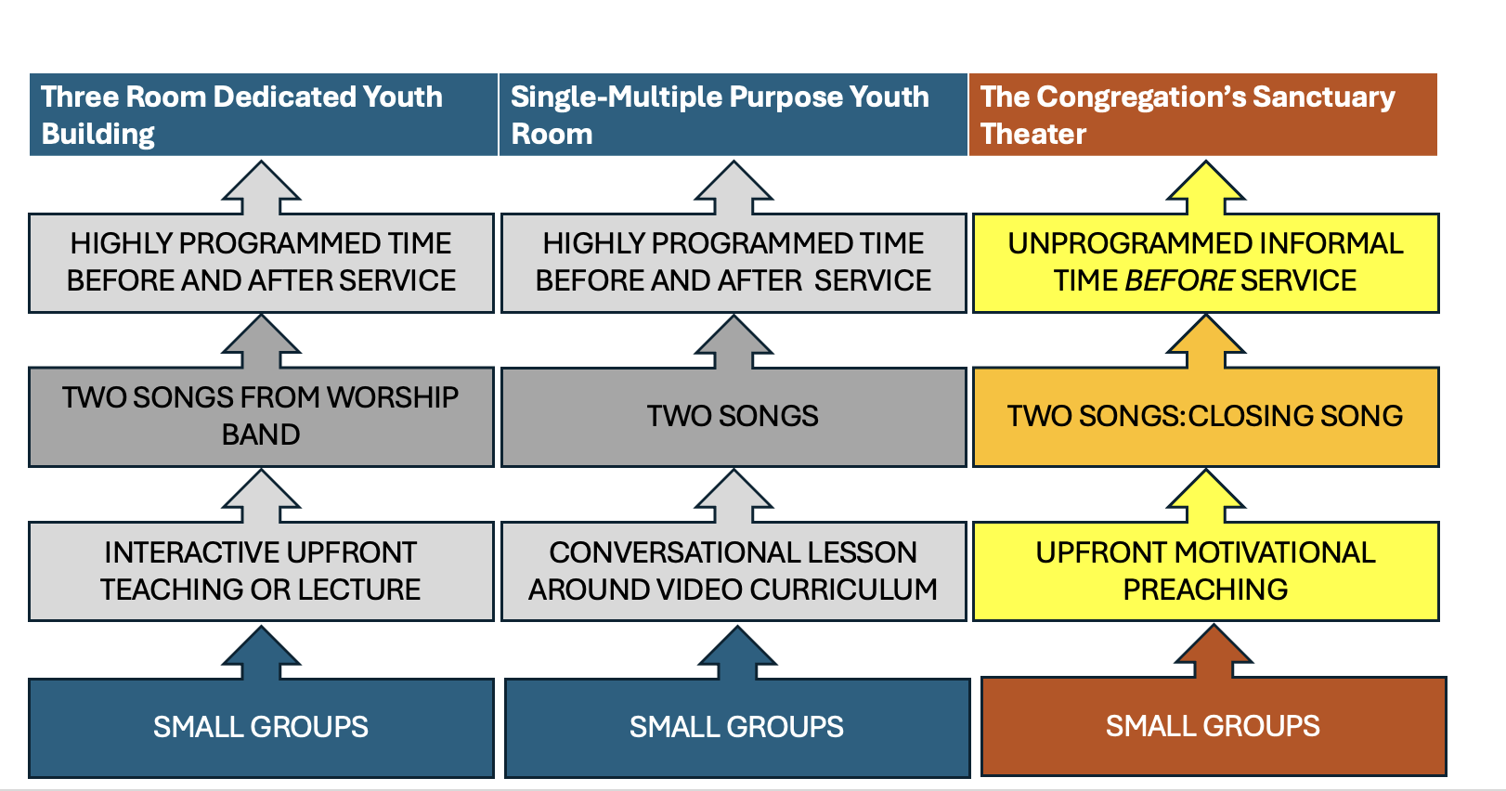
FIGURE 2: ADULT INTERACTIONS
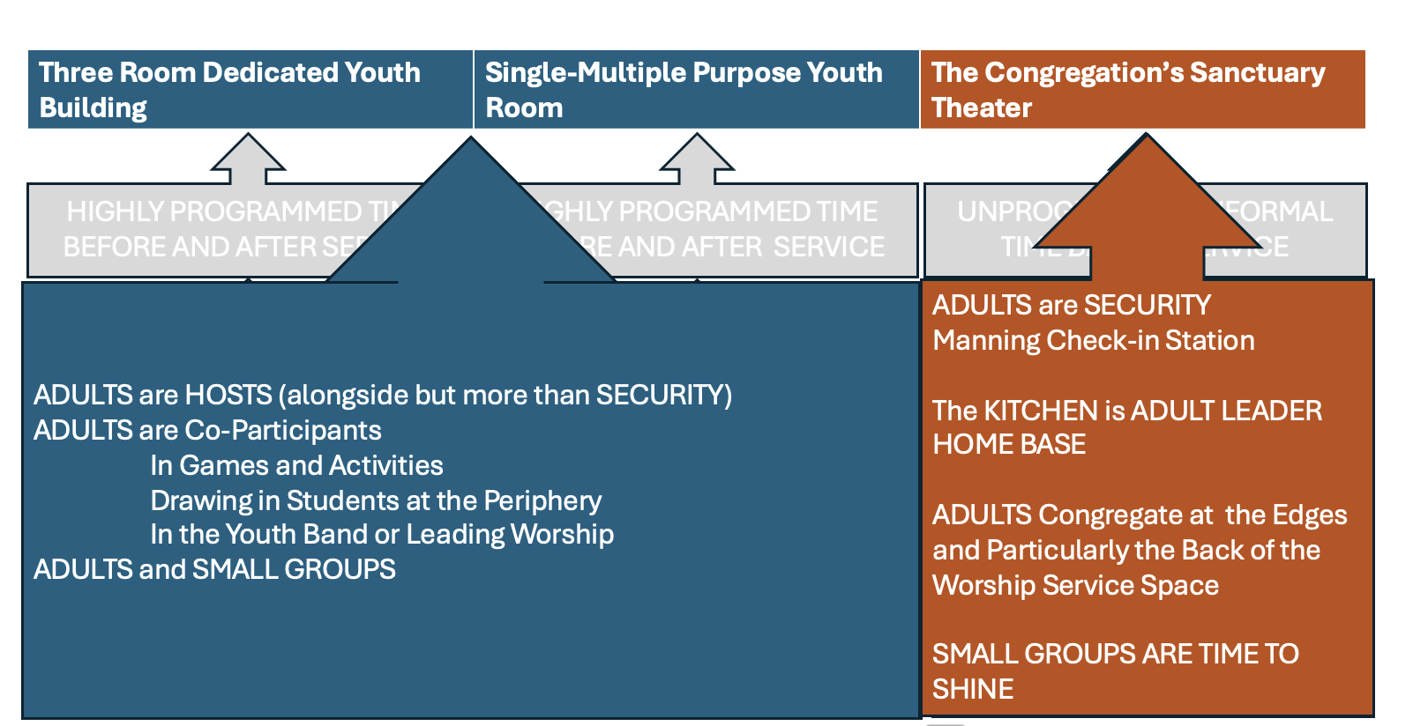
FIGURE 3: VALUES IN ADULT INTERACTIONS
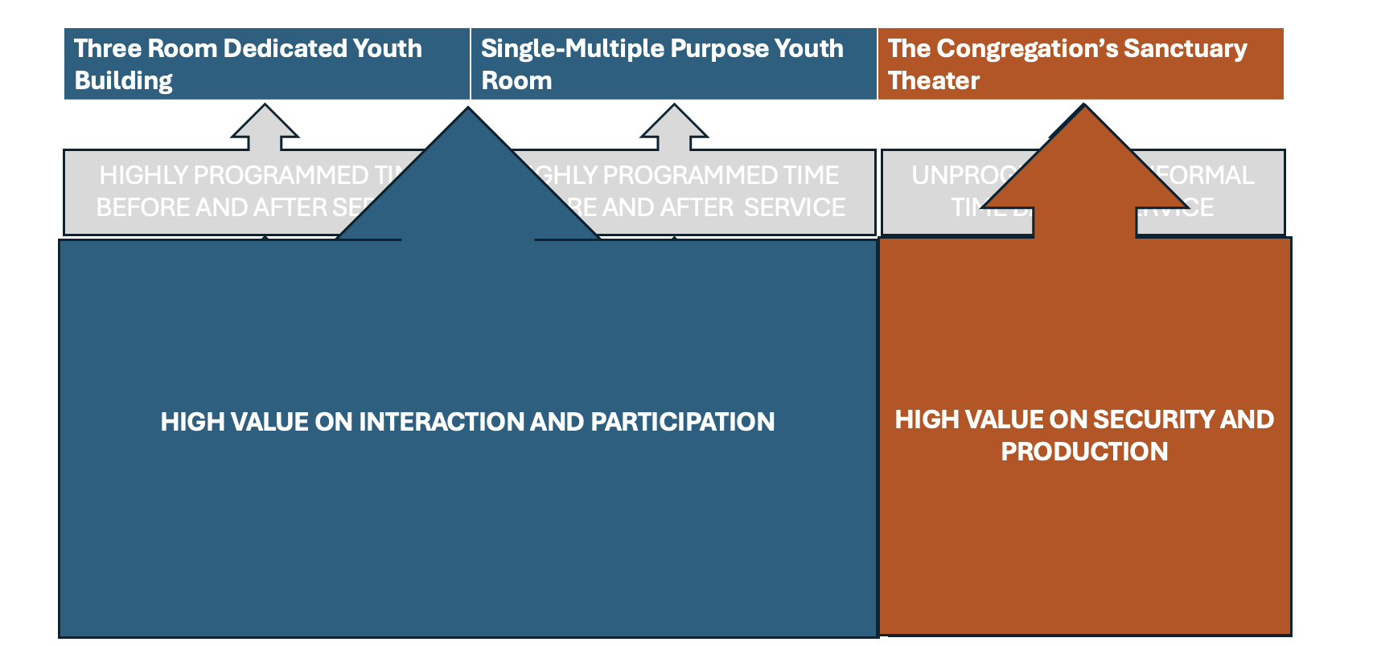

The Teenager Focus Groups
The teenager focus groups all occurred on the site of the church with participants solicited by the primary leaders of the CYG. However, not all of the focus groups occurred on the night of the site visit. While youth leaders rescheduled for weather once and lateness two or three times, the researchers encountered challenges with the focus groups. First, youth leaders often forgot to assist in organizing the focus group; forgot to pass out letters of informed consent, or forgot the focus group was scheduled at all. In some instances, focus groups were thrown together at the last minute, with informed consent being granted over the phone by parents to the researchers, and with students being asked the night of by the youth leaders if they would participate. Consequently, some focus groups had only three members rather than the preferred four or five members; two had members who were freshmen or sophomore rather than juniors or seniors. In one case, this was because the youth leader believed the younger students were more mature than the upperclassmen; so two freshmen were included because of their perceived maturity and theological awareness; one was taking dual credit at a local Christian University.
Small Group Participants
Focus groups consisted in every instance but two of a mix of male and female participants. Focus groups were three to five members each with the exception of a single group with three members. By self-description; focus group members fell into three categories: committed life-long church attenders (which were discussed in the 2024 report), as well as students who lived in the community but transferred churches, and newer believers.
Committed Life-Long Church Attenders
Focus group participants described themselves as lifelong attenders at their CYG’s church. They describe themselves having faith in Jesus from a very young age, but have a resurgence or recommitment to faith later in their middle school or early high school years. For these teenagers, their parents pre-determined their church participation by the selection of their church.
Transfers
Transfer students were moved by their family from one church to another, as the category clearly implies. These students are still rooted in the church’s geographic or political community, and most likely did not move from one place to another, but simply switched churches.
New Christians
New Christians are students who were invited to the CYG and experienced a conversion to Christian faith through the ministry of the CYG. Such students are enthusiastic about their CYG and are adopted into the group by the students.
Why Teenagers Come: A Safe Place to Be a Christian
When asked why other individuals come to their youth group, focus group participants described their youth groups have a safe space. Christian teenagers who attend public schools and Christian private schools feel a mix of loneliness and social awkwardness at their schools. Youth group provides a social atmosphere where meeting with other believers is possible. ETX teenagers report that they are “the only Christian” or one of a few Christians at their school. Even at Christian private schools-participants report that a majority of students do not follow Christian faith and practice in a way the focus group participant perceive as authentic.
Focus group participants see their CYG’s as openly friendly and welcoming. There are two key factors involved in the safety of small groups: the leaders and the other students.
Leaders do not have to be like teenagers; indeed, one focus group expressed immense respect for a male leader who was “scary” but committed and consistent. Leaders are broader than youth pastors or key leaders. Indeed, one focus group had transitioned through three youth pastors in about four years. Youth leaders can provide Christian perspective on life challenges or simply be another adult who is “not my mom or dad.” Youth leaders often provide a model, a picture for the teenager of what constitutes maturity in a Christian. The youth leader becomes an inspirational and copiable model of imitation for the teenagers in the group. Nonbelievers seem to be welcome at youth group, though some teenagers are uncomfortable with the idea of inviting lots of non-Christians to youth group. The fear is that the presence of non-Christians will somehow threaten the safety of the atmosphere for Christian students.
Other teenagers are also key components of the CYG community. Focus groups describe their CYGs as “not cliquey” or moving away from being cliquish. Focus group participants attributed this to the size of their groups- a sort of Goldilocks experience of being neither too big or too small. This set of friends provides the peer connections of safety.
The Small Group is the Liturgical Climax of the Evening
When asked what the focus group participants particularly enjoyed about the evening, the teenagers described small groups as of upmost importance. One focus group described their church as having two sets of focus groups: discussion groups which were gender-based accountability groups that occurred before the formal youth group programming began, and the small group discussions which happened after the lesson just prior to dismissal. Only one CYG did not do small groups on their primary event, but they did on Sunday mornings during the Sunday school hour. Small groups are where the pay-off for the intense relationality of the friendships occurs. Small groups are where teenagers feel safe enough to discuss the challenges of their school and family lives and discover that they are not alone in the trials they face. The adult leaders proctor these small groups, insuring the safety of the disclosures which are lubricated by humor.
It would not be incorrect to say that the small group therefore functions as the necessary crescendo of the youth group evening. As the Eucharist is the climax of the Roman Catholic liturgy, and the sermon is the climax of the Evangelical Protestant liturgy, so the youth group is the climax of the youth group. It simply cannot be dispensed with.
Worship is About Decompressing and Connecting
Students viewed worship as a way to decompress from the pressures of life at public and private high school life. The relationships and secular influence at high school is overwhelming to many of them. Worship provides a means of release and connection to other Christians also facing the same pressures. Worship is catharsis from school.
In the sanctuary theater configuration, worship also serves as the entry point into the transcendent experience of the entire night. While the three-room configuration worship service begins with worship, other formal structured activities have provided for youth group bonding between adults and students alike, including meal
Camp is the Foyer to the Youth Group: In conjunction with discussing the youth group evening and the small groups particularly, the focus group participants cannot help but bring up summer camps. Summer camp trips sponsored by the youth group are important to cementing the bonding that occurs in the friendships between the students. Camp is where a matrix of shared experiences and “inside jokes” forge relational interconnections between the teenagers in the youth group.
The Value of Teaching
When asked to describe the teaching of the youth group in three words, the teenager focus groups turned to words like “relatable” (in that students could connect with their leaders over the material when they gave personal examples from their life) “intentional” (exhibited trust in the leader’s selection of the material), and “deep” (what happens when students get to dig into the intricacies or the meaning of a biblical text). One focus group described the teaching as “serious.” The value of the teaching might revolve around students’ admiration for the leader who has spent time preparing or with whom they particularly relate.
The Pedagogy
With one notable exception, where the leadership was shared between a married couple, the lesson is led by a male leader; the hired youth pastor. Each youth group had a different learning strategy, but there were still commonalities. Churches utilizing a three-large space configuration had talks given by the youth pastor. Churches using a multipurpose room configuration had large group discussions paired with a pre-written or video curriculum. In both configurations, the evening ended with gender based small groups. The teaching shared one particular common theme: responding to the world. The world is negative and in opposition to the church; teenagers must respond to it through moral example, gospel witness (evangelism), and resilience against evil.
What Teenagers Learn in Youth Group
When it came to questions eight and nine of the interview protocol, the questions appeared to be the hardest to answer for the focus group participants.
God and God’s Actions: The teenager focus group participants struggled to answer the question, “What have you learned about who God is and what God does from this youth group?” Usually, a list of God’s non-communicable attributes was given: omnipotent, omniscient, omnipresent. That is, God is big and great. God is often recognized as the creator. One student described God as Father, but God’s fatherliness was not connected to the Trinity but rather to God’s actions as creator. God is loving or love. One student admitted that it was hard to pull apart what her parents had taught her about God, some struggled to separate what they had learned in a camp context versus the youth group context. Answers often seem to come as a catalog of recent curriculum. However, the answers also appear to be sincere and personal, although thin and devoid of biblical narrative and theological richness.
Humans and Human Purpose: This question was also complicated for the teenager focus groups to answer. Humans are described as made to glorify God. Humans are the image of God, but students struggle to clarify what is meant by the Image. Human purpose is often linked to “spreading God’s Word” or “gospel.” Humans are never described ontologically or eschatologically.
IMPLICATIONS
Same as the findings, the study is at far too early a stage to make any solid implications that may or may not be transferrable to other youth ministry contexts outside of East Texas (ETX). Five congregational youth groups (CYGs) is far too small a sample size from to propose certain generalizable implications. None-the-less, acknowledging the need for further research, with the data currently available this paper now turns to implications which might arise as important themes from which CYGs can learn in the future.
Youth Ministry in CYG as Lived Religion
Pete Ward writes concerning David’s Hall understanding of lived religion. “Lived religion is closely linked to the notion of practice. David Hall speaks about practice as the choice that individuals take to act. Lived religion is akin to the idea that culture is enacted or performed through practices (Ward 56, citing Hall’s Lived Religion in America, vii).” Lived religion is activated by practice, and individual theologies are generated through a range of experiences- “in the street, in homes, in churches (57).” Moreover, a lived theology “operate[s] in relation to formal and informal conceptions of God” (57), or the official theology of an authoritative body.
It should be clear, then, that ETX CYG’s teenagers are expressing their lived religion as they narrate and engage in their youth ministry context. What is also coming clear, however, is that such lived religious faith appears to have loose connection to specific Evangelical Protestant beliefs, either those in agreement with the wider Protestant Tradition, Roman Catholicism, or Orthodoxy or more narrowly within Evangelical Protestant traditions. Parrett and Kang are worth quoting at length here:
Of course, to attend to faithful and substantive content does not, in and of itself, equal good education. Both the history of religious education and the current experience of the church bear this out. However, some who lead and labor in evangelical Christian education seem to have erred in the opposite direction, largely neglecting any significant transmission of content. We submit that little transmission of content is not an advance over what is often dismissed as mere transmission of content. (Parrett and Kang 78)

Safe Space!
The ministry of congregational youth ministries in ETX, as perceived by the Christian teenager participants, is to create a safe place for teenagers to be Christians together. The safety is in the network of Christian relationships which have existed for a long time between the students who have grown up with each other in the church and perhaps have survived multiple youth pastors or other key significant leadership, and the current network of youth leaders who shepherd the space. Small groups and summer camps are significant as places of relational connectivity, participation or discovery of common shared experiences, and affirmation of Christian identity from adults and peers. Adults function as guardians of the environment and models of Christian maturity in terms of character and relational intelligence. The teenagers function as welcoming and fun social contacts which connect to each other as they affirm and share Christian experience. The teenagers seem to police this environment themselves to foster the relational connectivity; avoiding their phones and other electronic devices to enter face to face relational space. It cannot be overstated as far as the teenagers are concerned: no small groups and no camp means no youth group.
Teaching and Worship Support Christian Identities as Behavior
The primary function of teaching and worship in ETX CYGs is to support Christian identity formation within the youth group while resisting the world. The teenager focus group participants affirmed this when they called the teaching relatable. It is important to remember that each church had its own unique approach to delivery of content or teaching. That teaching or content, however, was always aimed at the behavioral. By behavioral, it is not implied a certain legalistic rule standard, but rather that behavior cemented Christian identity outside of the youth group in certain behaviors which identified one as being a Christian. Christians for example, witness to non-Christians about Jesus, invite friends to church, act as salt and light in the world, date or pursue singleness in a distinctive way, etc. These behaviors, however identified in the content, are what make one a Christian; relationships between Christians flow over and through these behaviors.
Discipleship is Performative Axiology
Again, while emphasizing it is too early in the study to suggest definitive implications, this understanding of Christian identity is only axiological, and not properly theological, ontological, or epistemological. That is, the content of lessons did not focus on theology but application. Axiology without theological mooring borders on the pragmatic and ideological. That is, it is identity in action only, not in being. Identity in being appears to be missing in ETX CYG’s, which explains why identifying who God is and what God does was difficult, and why identifying humans and human purpose was even more difficult. This produces an orientation to application which depends on the vision of the leadership rather than a rigorous theological framework for union and mission with God. This also explains why relationships with adults are pivotal to understanding Christian maturity. The leader shows the student the proper behaviors. Faith formation becomes performative.
It also explains why teenagers were not sure about evangelizing or bringing non-Christians into the youth group. Non-Christians do not know how to act like Christians. To bring non-Christians into the space is to de-Christianize the space, which makes it unsafe to act like a Christian. Again, faith formation becomes performative.
In short, the practices are thick, but the theological story is thin. A thin God is not enough to support thick practices. The thicker the practices, the thicker the story and the thicker the reality of the God needs to be in ministerial settings designed to bring students into relationship with the God revealed as Father, Son, and Holy Spirit through the Scriptures of Israel and the Church and in the incarnation of the Lord Jesus Christ.
FURTHER RESEARCH
Obviously, this present study needs to be carried out until saturation occurs in the findings. However, several future avenues for research already suggest themselves, even at this early point in the study. Already under development is a study on lead youth workers at East Texas (ETX) congregational youth groups (CYG). This study takes the form of a grounded theory, and seeks to determine who is leading ETX CYGs, the constitution of their preparation for ministry, the nature of their calling to the ministry, and their goals and values within their congregations.
However, since the 2024 presentation, it has become clear to the researchers that more data is needed to describe the teaching and learning of content specifically. That is to say, the two questions at the end of the protocol evoke more questions than clarity, at least at this point. If it were possible, the researchers imagine an additional round of questions asking a fuller set of theological questions that are story-specific.
In addition, pursuing a fuller picture of ETX CYG curriculums and rhythms would also be a valuable study. A descriptive ethnography of camp weeks of ETX CYGs would be valuable, though time consuming. A parallel study of ETX parachurch youth ministries (PYMs) would also prove valuable. The goal would be to paint a comprehensive social, theological, picture of the entire array of youth ministries in the ETX area, which might provide transferrable implications to youth ministries in other areas of Texas or the broader North American context.
BIBLIOGRAPHY
Bartholomew, Craig G. and Michel W. Goheen. The Drama of Scripture: Finding Our Place in the Biblical Story. 2nd ed. Grand Rapids, Baker Academic: 2004.
Dean, Kenda Creasy. Almost Christian: What the Faith of Our Teenagers is Telling the American Church. Oxford UK, Oxford University Press: 210.
Denton, Melinda Lundquist and Richard Flory. Back-Pocket God: Religion and Spirituality in the Lives of Emerging Adults. Oxford UK: Oxford, 2020.
Ellsworth, Elizabeth. Places of Learning: Media, Architecture, Pedagogy. New York, Routledge, 2005.
Kinnaman, David with Aly Hawkins. You Lost Me: Why Young Christians are Leaving Church…and Rethinking Faith. Grand Rapids, Baker Books: 2011.
Lave, Jean and Etienne Wenger. Situated Learning: Legitimate Peripheral Participation. Cambridge UK, Cambridge University Press: 1991.
Mauriello, Michael M. 2024. “Theologically Maturing Teenagers: How Theological Community Catalyzes Bored and Lonely Christian Teenagers.” Paper for the Society of Professors in Christian Ministry Annual Conference in Charlotte, NC: October 17-19, 202
_______. 2022. “Bored and Anchorless Christian Teenagers: Academic Theology Camp as Diagnostic of East Texas Youth Ministry Discipleship and Curriculum.” Presentation given at the annual conference of the Association of Youth Ministry Educators,” San Diego, CA, October 21-23, 20

Mauriello, Michael M. and Stephanie Berglund. 2024. “A Mixed Method Qualitative Study of East Texas Christian Teenagers’ Experiences and Theological Learning at Congregational Youth Ministries.” Paper for the Association of Youth Ministry Educators Annual Conference in Charlotte, NC, October 18-20, 2024.
Parrett, Gary A. and S. Steve Kang. Teaching the Faith, Forming the Faithful: A Biblical Vision for Education in the Church. Downers Grove, IVP Academic: 2009.
Powell, Kara and Brad Griffin. 3 Big Questions that Change Every Teenager: Making the Most of Your Conversations and Connections. Grand Rapids, Baker: 2021.
Root, Andrew. Faith Formation in a Secular Age. Ministry in a Secular Age vol. 1. Grand Rapids, Baker: 2017.
Smith, Christian and Amy Adamczyk. Handing Down the Faith: How Parents Pass Their
Religion on to the Next Generation. New York, Oxford: 2021.

Smith, Christian, with Melinda Lundquist Denton. Soul Searching: The Religious and Spiritual
Lives of American Teenagers. Oxford UK, Oxford: 2005.

Smith, Christian, Bridget Ritz, and Michael Rotolo. Religious Parenting: Transmitting Faith and
Values in Contemporary America. Princeton, Princeton University Press: 2020.
Smith, James K. A. Desiring the Kingdom: Worship, Worldview, and Cultural Formation. Cultural Litrugies Volume 1. Grand Rapids, Baker Academic: 2009.
Ward, Pete. Introducing Practical Theology: Mission, Ministry, and the Life of the Church. Grand Rapids, Baker Academic: 2017.
Wenger, Etienne. Communities of Practice: Learning, Meaning, and Identity. Cambridge UK, Cambridge University Press: 1998.

Follow-up research explored by Denton and Flory, suggests that MTD has evolved into a second form of cultural spirituality which can be summarized in the following tenets. - Karma is real - Everyone goes to heaven - Just do good - It’s all good - Religion is easy - Morals are self-evident - No regrets (Denton and Flory 2020, 228-231)
C.f CharlesTaylor’s A Secular Age. Cambridge, Belknap/Havard: 2007 and JKA Smith’s How Not to Be Secular. Grand Rapids, Eerdmans: 2014.
Cf. Marsden, George. Understanding Fundamentalism and Evangelicalism. Eerdmans, 1991. Pp. 4-5.
The researchers felt it important to work at first with diverse churches within the Passage network, since trust would have been developed, and then ask for assistance in contacting other diverse churches after completing the initial site visit and focus group. This proved complicated: the researchers could not get a site visit calendared with primary partners do to churches switching locations, turnovers or transitions of leadership, and delays in communication. In the future, the researchers will solicit more “cold call” contacts with area churches.

