Keep Faith Alive: Grandparent Faith Transmission in Two Churches, the United States and Korea
AYME, Dallas, TX
Oct. 23-25, 2026

Dudley Chancey, Ph.D.
Oklahoma Christian University, Intergenerational Faith Center
U.S. study, 2025
Young Woon Lee, Ph.D.
Director of Religious Education, Fort Hood, TX
Korean study, 2026
Min Ho An, D.T.L.
Sung San Evangelical Holiness Church, Seoul, Korea
Korean edition: editorial and curriculum development

Abstract
Grandparent ministry rests on a premise most practitioners treat as settled: healthy grandparents do not replace parents but reinforce the parental role, safeguard the relationships around the child, and tell what God has done in their own lives. This paper tests it. In 2025 Dudley Chancey surveyed and interviewed U.S. grandparents (N=995); in 2026 Young Woon Lee administered the same questionnaire, translated, in Korea (N=220), by survey alone. The Korean respondent-level file — 220 respondents by 94 items — is held by the present analysts, so every Korean figure below is computed item by item, reported with its denominator, and, where it concerns one sex, computed within that sex. Three findings follow. On a closed check-all item answered by 203 of 220 respondents, Korean grandparents are higher than U.S. grandparents on every explicitly religious act of transmission — praying together 72.0 percent against 45, sharing a faith story 59.5 against 32, reading the Bible aloud 50.0 against 29 — while the United States leads decisively on the one item that uses no religious vocabulary at all, showing how to treat people, at 75 for U.S. grandmothers and 73 for U.S. grandfathers against Korea's 36.0. On the other non-religious item, life lessons grounded in faith, Korea's 44.0 is 10.0 points below the grandmother column but only 2.0 below the grandfather column. The item ranked first in the United States ranks last in Korea, and an open-ended item of entirely different format, coded by us, points the same way. On grandparents' authority over the parents, about two-thirds of U.S. respondents disagreed, while Korean agreement within sex is 78.6 percent of women and 85.3 percent of men, and not one of the 220 chose "strongly disagree"; yet reported support to adult children runs well below the American figures and is flat across every authority position (r = −0.09 and −0.06), the least supportive group being the one that takes no position at all. Asked what legacy they will leave, 86.4 percent of the 162 who answered gave faith itself, usually the single word 믿음, against 63.4 percent for the legacy received, while "nothing" falls from 13.4 percent to 1.2. The premise survives normatively and fails descriptively, in a direction a translated curriculum would not address: it would prescribe to Korean grandparents what they already do most and would be silent about what they do least. An eight-week workshop is presented whose pre- and post-session instrument abridges the questionnaire to sixteen items.
Keywords: grandparent ministry; intergenerational faith formation; faith transmission; cross-cultural replication; Korean church; curriculum design; comparative survey research; respondent-level analysis

1. Introduction
The working premise of grandparent ministry in North America can be stated in a single sentence. Healthy grandparents do not replace parents in the formation of the next generation; they reinforce the parental role, they safeguard the relationships that surround the child, and they tell the story of what God has done in their own lives. Almost every curriculum and denominational initiative in this field assumes some version of that sentence, which is attractive because it is theologically defensible, pastorally humane, and easy to teach.
This paper does not assume it. It tests it.
A U.S. survey of grandparents (N=995), conducted by the first author in 2025, established how grandparents in American congregations understand and practice faith transmission. In 2026 the second author administered a Korean translation of the same questionnaire to Korean church grandparents (N=220), item wording and response categories unchanged; the third author has been preparing the Korean edition and the workshop curriculum that follows from it.
The Korean side of the comparison rests on the respondent-level file: 220 respondent rows by 94 item columns, held by the present analysts. Every Korean figure below is computed from that file item by item rather than read off a summary table, which makes two things available at once — the denominator behind each percentage, and the link between one respondent's answers to different items. The first lets a Korean cell be set beside an American cell knowing what each is a percentage of; the second lets a claim about persons, and not only about samples, be tested.
It is worth naming early what kind of object the premise turns out to be. A premise of this kind functions as a compass, not as a map. A compass tells a minister which direction is north — build up the parents, protect the relationship, speak of God's work in your own life — and it points north in Seoul as reliably as in Oklahoma. A map tells him what the terrain ahead contains: which river is in flood, which bridge is out. The premise remains a good compass and a poor map, and the American curriculum built on it carries the terrain of one church in it.
Three questions organize the paper. RQ1. Administered in a Korean church population, does the register in which faith is deliberately handed on replicate the U.S. pattern, or invert it? RQ2. Does the claim that grandparents reinforce rather than replace parents describe Korean grandparents' stated convictions, their reported behavior, both, or neither — and, since respondents can be linked item to item, do conviction and behavior travel together within a person? RQ3. Does the vocabulary in which grandparents name a legacy narrow as it crosses the generation?
One commitment governs the paper. Every Korean number reported here has been computed from the respondent-level file, and every denominator is stated.

2. Background

2.1 Why grandparents became a research question, and why parents still organize it
Grandparents became a distinct object of study for demographic reasons: longer life expectancy produced overlapping generations no previous century had seen, women's paid work redistributed weekday caregiving that grandmothers largely absorbed, and rising divorce placed grandparents in positions once held by a second parent. But the finding that organizes the field is not about grandparents at all: parents are the strongest single influence on a child's life (Smith & Denton, 2005; Kehrwald, Roberto, Roehlkepartain, & Roehlkepartain, 2016). Hence the premise's form: a grandparent who displaces a parent degrades the odds of transmission rather than improving them. Strom and Strom made the point operationally, one goal of grandparent education being that the limits parents have set are known to the grandparents (Strom & Strom, 1991).

2.2 The family as primary context, and the solidarity tradition
Two further bodies of work stand behind it: one treating the family rather than the congregational program as the primary context of formation (Wuthnow, 1999), and the intergenerational-solidarity tradition (Bengtson & Roberts, 1991), which applied to religion yields four modes of grandparental influence — taking the parents' place, reinforcing it, challenging it, ignoring it (Bengtson, Putney, & Harris, 2013). The manuscript names the second the ideal scenario, which is the premise in its most precise form; Chapman and Campbell (2016) and Pew Research Center (2023) complete the frame.

2.3 The specific claim: direct telling beats indirect modeling
The original study advances a sharper claim, and this is the one the Korean data complicate: direct telling of one's own faith story is more effective than indirect modeling. Among the ways U.S. grandparents said their own grandparents had helped their spiritual growth, only 7 percent involved sharing the faith in words, and in interviews with adult grandchildren the original author could not find a single case of a grandparent deliberately telling a faith story. The diagnosis is that U.S. grandparents showed but did not tell; the prescription is that they should speak (Chancey, 2025a). That is a diagnosis of the church that produced it, and Section 4.1 shows the Korean deficit to be very nearly the American surplus.

2.4 The scriptural frame
The original study works from Deuteronomy 6 and Psalm 78, and the Korean edition retains that frame. The point usually left out is the purpose clause: Psalm 78:4 commands that what has been heard be told to the coming generation, and verse 8 gives the reason, that the next generation not be like their ancestors, "a stubborn and rebellious generation, whose hearts were not loyal to God." What is commanded to be handed on therefore includes the record of a generation that failed, not only the record of what succeeded. Deuteronomy 6 has the same structure: the answer a parent gives a questioning child begins, "We were slaves of Pharaoh in Egypt." What is asked for in both texts is a narrated life with particulars in it, and Section 4.3 reports what these respondents produce when they are asked for exactly that.

3. Method

3.1 Design
Table 1. Study design comparison
 | United States | Korea
Researcher | Dudley Chancey | Young Woon Lee
Year | 2025 | 2026
N | 995 | 220
Instrument | Grandparent Project questionnaire | Translation of the same questionnaire, item wording and response categories unmodified
Mode | Online survey, focus groups, and interviews | Online survey only
Analysis | As reported in the published study | Respondent-level computation; cross-tabulation; both total-response and valid-response bases reported
Raw data available to the present analysts | No — published tables only | Yes — 220 respondent rows × 94 item columns

Note. The asymmetry in the last row governs what this paper can and cannot say. Every Korean figure is computed here, with its denominator; the U.S. figures throughout are those printed in the published study, which the present analysts cannot recompute.

3.2 The instrument, and the verification that matters
The Korean questionnaire is a translation of the U.S. instrument, item wording and response categories carried across without modification. Translation alone establishes only that a topic crossed, not that an instrument did. The verification is internal to the tables: the Korean comparison tables reprint the U.S. figures alongside the Korean ones, and those reprinted figures match the published U.S. tables item by item, exactly. The instrument travelled, and that is the precondition for everything below: a difference between the two columns of a table in Section 4 is a difference between two populations answering the same question in the same words, not an artifact of two questionnaires.

3.3 Analysis
The Korean workbook contains four sheets and only one is usable for aggregation. Sheet 2 holds all 220 respondents across items 1 to 67 and is the source of every Korean figure here. Sheet 3 is a code sheet covering 146 rows — the 145 women plus the respondent who left sex blank — and Sheet 4 a free-text extract from those same 146, with blanks removed and columns pulled upward so respondents cannot be linked across columns. Neither of the two 146-row sheets covers the men, and neither preserves the respondent as a unit, so both are unusable for the analyses reported here and nothing below is computed from them. Codes were recovered by matching Sheet 2's stored labels against Sheet 3's numeric codes respondent by respondent and against the questionnaire's printed option order; values outside the printed range are marked out of range and not guessed.
All percentages are reported with their denominators. Sex-specific rates are computed within sex, not against the pooled respondent base, because the two bases give materially different values. Three denominators exist in this dataset and they are never interchangeable: the full sample of 220; the number who answered the given item, which ranges from 61 to 220; and the sex-group sizes, 145 women and 74 men. Where a rank order or a comparison could depend on the choice, both bases are printed. Cross-tabulations report cell counts and row percentages together, and correlations are Pearson coefficients on those answering both items, with that n stated. No significance testing is reported: the substantive claims here concern differences of 20 to 40 percentage points, or correlations near zero, and neither is decided by a p value. Two free-text items were coded by the present authors, since no coding sheet accompanied the file; the rules and the response-by-response coding are published in the supplementary material so that other analysts can dispute them.

3.4 The U.S. sample
The U.S. sample is not a portrait of American Protestantism. Of the 995 respondents, 95 percent were white, 80 percent were married, and 74 percent identified with the Republican Party. More than 800 belonged to a single fellowship, the Churches of Christ, and most participants were between 65 and 75 years of age. Two-thirds were women. This is a portrait of older believers in one conservative American tradition, and within it of a stable social stratum. The comparison in this paper is therefore better read as a comparison of two church communities than of two nations.

3.5 The Korean sample
The Korean sample is N=220, drawn from Korean church grandparents and administered online. Sex is recorded for 219: 145 women, 74 men, and one blank, which this paper assigns to neither group. Year of birth is recorded for 208 respondents and ranges from 1931 to 1973.
Item-level response rates vary by item format rather than by subject. The closed items sit high — income at 94.5 percent, the authority item at 95.0, the check-all item on how faith was handed on at 92.3. The free-text items sit low — 73.6 percent for the legacy a respondent will leave, 50.9 for the legacy received, 40.5 for the item on what a grandparent specifically did, and 27.7 for the item asking what event changed the respondent's life. The questionnaire offered no "not applicable" and no "don't know" anywhere and carried no skip logic, so a blank was the only channel for both non-response and non-applicability. Even with the raw file in hand the two cannot be separated, and the valid-response bases used here must be read as "respondents who wrote something," never as "respondents to whom the item applied."

4. Findings

4.1 Two registers of transmission
The first question this comparison raises is not whether faith is deliberately handed on in these two churches. It plainly is, in both. The question is in what language.
Two items bear on it, built so differently that their agreement is worth more than either would be alone. One is open: respondents wrote in their own words how a grandparent had specifically helped their spiritual growth, with no categories until we made them. The other is closed: respondents checked, from seven printed options, how their own parents had intentionally passed the faith on to them, which required no coding at all. They were answered by overlapping but different subsets of the sample, 89 respondents and 203. They point the same way.
Take the open item first. Of its 89 responses, twenty said in one form or another that there had been no help; four described a grandparent who was absent, of another religion, or died early; four could not be decoded. Sixty-one substantive answers remain, coded against the categories in Table 2, with multiple coding permitted where a respondent named two things.
Table 2. Free-text item on how a grandparent specifically helped (Korea)
(89 responses; 61 substantive; multiple coding permitted, so percentages sum above 100)
Category | Coded mentions | % of 61 substantive | U.S. %
Church attendance, being led to church, worship | 18 | 29.5 | 30
Praying together | 18 | 29.5 | —
Faith itself, or the family's line of faith | 18 | 29.5 | —
Showing by one's life | 12 | 19.7 | 40
Bible and Scripture | 7 | 11.5 | —

Note. Non-substantive responses: 20 "no help," 4 grandparent absent or of another religion or died early, 4 undecodable. Dashes mark categories with no clean U.S. counterpart, since the U.S. categories were coded by a different team on a different response set. Percentages are of the 61 substantive answers, the base stated with every figure drawn from this table; the mention counts are printed beside them so that any other base can be applied.
The two leading U.S. answers to the same open question were being an example, at 40 percent, and attending church together, at 30. The Korean answers divide by category rather than uniformly by level: on church attendance the two samples are indistinguishable, 29.5 against 30, while on showing by one's life Korea runs at about half the American rate, 19.7 against 40. The same shape appears inside the Korean column alone, where showing by one's life stands fourth of five, at two-thirds the level of the three devotional categories.
The closed item puts the same contrast on firmer ground, because nothing in it depends on anyone's coding. Respondents were asked how their own parents — the grandchildren's great-grandparents — had intentionally passed the faith on to them. Two hundred and three of 220 answered, 200 of those decodably, an average of 3.73 selections each: not a single channel of transmission but close to four.
Table 3. How the respondents' own parents intentionally passed on the faith
(check-all; Korea n=200 decodable of 203 responding; U.S. N=995; sorted by the U.S. grandmother percentage)
Item | U.S. grandmothers % | U.S. grandfathers % | Korea % | Difference (Korea − U.S. grandmothers) | Difference (Korea − U.S. grandfathers)
Showing how to treat people | 75 | 73 | 36.0 | −39.0 | −37.0
Life lessons grounded in faith | 54 | 46 | 44.0 | −10.0 | −2.0
Praying together | 45 | 47 | 72.0 | +27.0 | +25.0
Taking them to church | 45 | 45 | 59.0 | +14.0 | +14.0
Sharing their faith story | 32 | 31 | 59.5 | +27.5 | +28.5
Telling them Jesus loves them | 30 | 30 | 52.0 | +22.0 | +22.0
Reading the Bible to them | 29 | 30 | 50.0 | +21.0 | +20.0

Note. The two U.S. columns are the grandmother and grandfather subsamples of the published study, printed separately rather than pooled, so the Korean column is never compared against a base of unstated composition. We hold no U.S. respondent-level file, so no U.S. cell has been computed here; both columns are reproduced as published. The Korean column is a percentage of the 200 decodable responses. On the full 203-respondent base the seven Korean values are 35.5, 43.3, 70.9, 58.1, 58.6, 51.2, and 49.3, and the rank order is identical; within sex on that base, praying together is 69.6 percent of women and 73.5 percent of men, showing how to treat people 34.8 and 36.8. No conclusion here turns on which of the three bases is used.
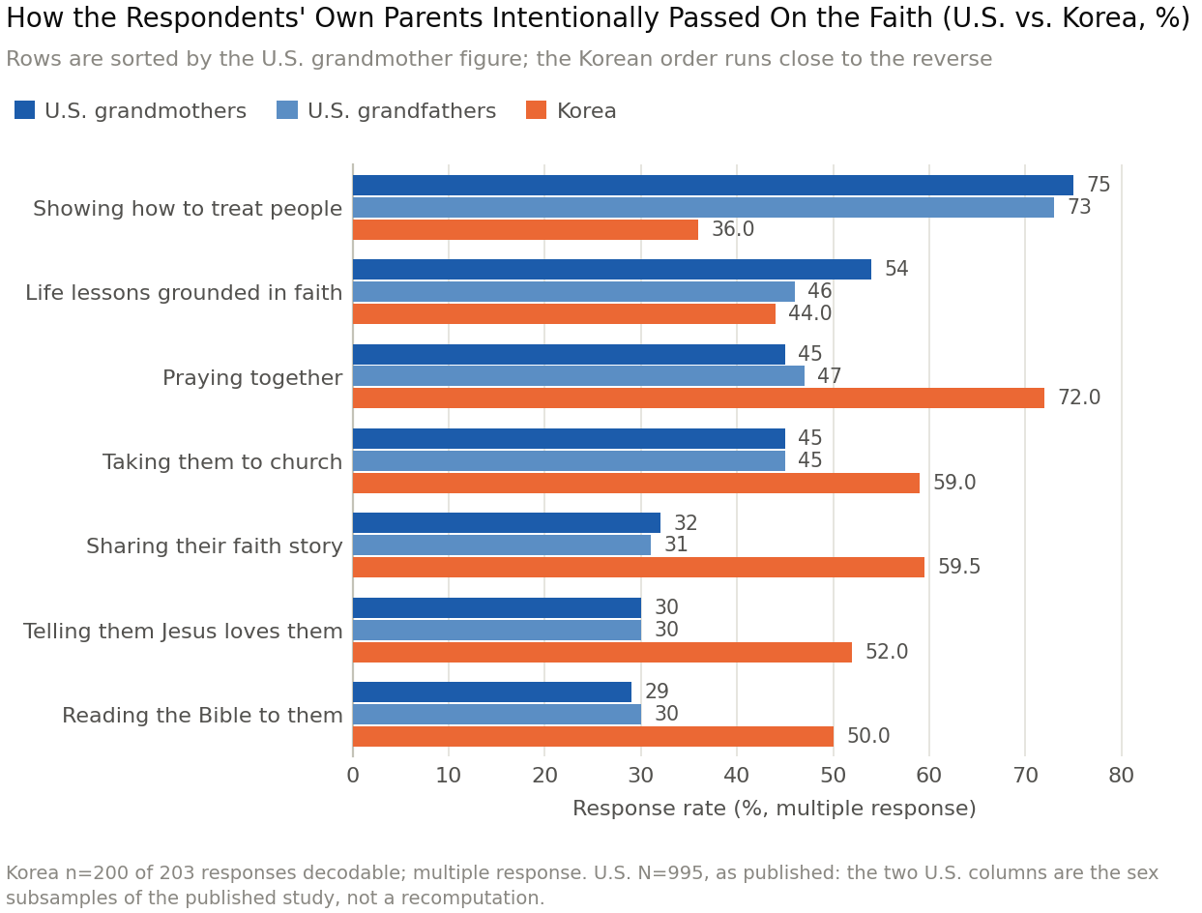
Figure 1. How the Respondents' Own Parents Intentionally Passed On the Faith (U.S. vs. Korea, %)
The item ranked first in the United States ranks last in Korea. That single sentence is the finding, and the table supports it in two separable ways.
The first is the direction of every religious item. Korea is higher on all five explicitly religious acts — praying together, sharing a faith story, taking a child to church, telling a child that Jesus loves him, reading the Bible aloud — than both U.S. columns, the smallest of the ten gaps being 14.0 points and the largest 28.5. A sample simply more willing to check boxes would be higher on all seven options, not on five and lower on the sixth by 37 to 39 points.
The second is the item that does the dividing. What carries the contrast between the two registers is a single option: modelled conduct toward other people. It ranks first for U.S. grandmothers (75) and first for U.S. grandfathers (73), both more than double Korea's 36.0, where it ranks last of seven. It is the one option on the list with no religious vocabulary in it at all — no prayer, no Bible, no church, no name of Jesus — and the one on which the two American subsamples agree almost exactly with each other and disagree almost maximally with Korea: sex explains two points of it, nation thirty-seven. The list's other non-religious option, life lessons grounded in faith, does not behave the same way — Korea's 44.0 is 10.0 points below the grandmother column but only 2.0 below the grandfather column — so what separates the two samples is not religious language against everything else, but conduct toward other persons offered as the thing a child was meant to learn.
Table 2 reproduces both halves of that pattern from a different format, a smaller and different respondent set, a different target generation, and a coding of ours rather than a choice of theirs.
We name this a difference of register. In the U.S. sample faith is handed on predominantly in a moral-relational register, and the item that carries it is how you treat people; in the Korean sample it is handed on predominantly in a devotional register — prayer, Scripture, church, the naming of Jesus. Both are transmission; neither is its absence, and the paper takes no position on which is better. What the difference establishes is that the deficit each church would have to correct is not the same deficit. A curriculum written to correct an American shortage of explicit religious speech was written for a population that ranks such speech last, and will be delivered to one that ranks it first, while the item Korean respondents put last is the one that curriculum has least need to teach.

4.2 Authority endorsed, support flat
The second finding concerns a belief that holds as a norm and fails as a description. The premise of grandparent ministry explicitly rejects the claim that a grandparent's authority precedes the parents'; Korean respondents endorse it nearly unanimously while reporting that they give less to their adult children than American respondents do. Because respondents can be linked item to item, the relation between the two can be examined within persons.
Table 4. Grandparental authority, support to adult children, and the relation between them
Panel A. "Grandparents have the authority over the parents to guide their grandchildren on their perspectives of right and wrong," within sex
Group | n | Strongly agree | Agree | Neither | Disagree | Strongly disagree | Agree total
U.S. women | — | 3 | 4 | 27 | 50 | 17 | 7
Korea women | 140 | 23.6 | 55.0 | 19.3 | 2.1 | 0.0 | 78.6
U.S. men | — | 3 | 8 | 24 | 48 | 18 | 11
Korea men | 68 | 32.4 | 52.9 | 11.8 | 2.9 | 0.0 | 85.3
Korea, all who answered | 209 | 26.3 | 54.5 | 16.7 | 2.4 | 0.0 | 80.9

Panel B. Korean agreement by birth cohort (n=197 with both birth year and an authority response)
Born | n | Agree total | Neither
Through 1944 | 17 | 64.7 | 29.4
1945–1949 | 21 | 95.2 | 4.8
1950–1954 | 52 | 96.2 | 3.8
1955–1959 | 55 | 72.7 | 21.8
1960 and later | 52 | 71.2 | 26.9

Panel C. Support provided to adult children, valid-response basis
Support | U.S. % | Korea %
Advice and ideas — "a lot" | 34.6 | 16.6
Advice and ideas — "some" | 56.7 | 64.1
Material help — "a lot" | 36.4 | 10.7
Material help — "some" | 43.8 | 61.0

Panel D. Authority position × support given "a lot" or "too much" (Korea)
Authority position | n | Advice: a lot or more | Material: a lot or more
Strongly agree | 44 / 47 | 22.7 | 14.9
Agree | 96 / 98 | 21.9 | 15.3
Neither | 32 / 33 | 9.4 | 12.1
Disagree | 4 / 4 | 25.0 | 25.0

Note. Korean bases: advice item 181 valid, material item 187 valid; U.S. bases 903 and 906. Panel D n values are for the advice and material items respectively; the "disagree" row rests on four respondents and supports no conclusion. Pearson r between the authority item and the two support items is −0.094 (n=176) and −0.063 (n=182). In Panel A the Korean rows for women and men are percentages within sex, and the pooled row is printed beneath them under its own base of 209, so that the two are never read for one another.
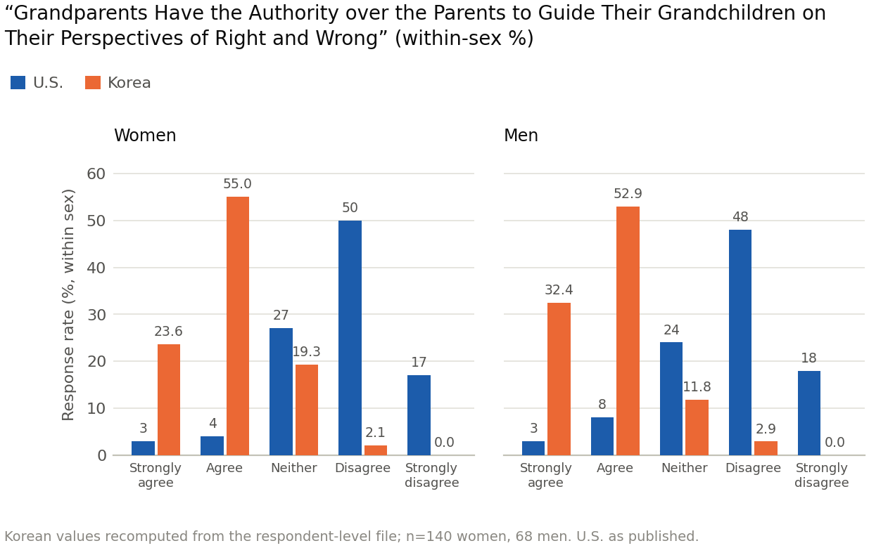
Figure 2. Grandparental Authority over the Parents, Within Sex (U.S. vs. Korea, %)
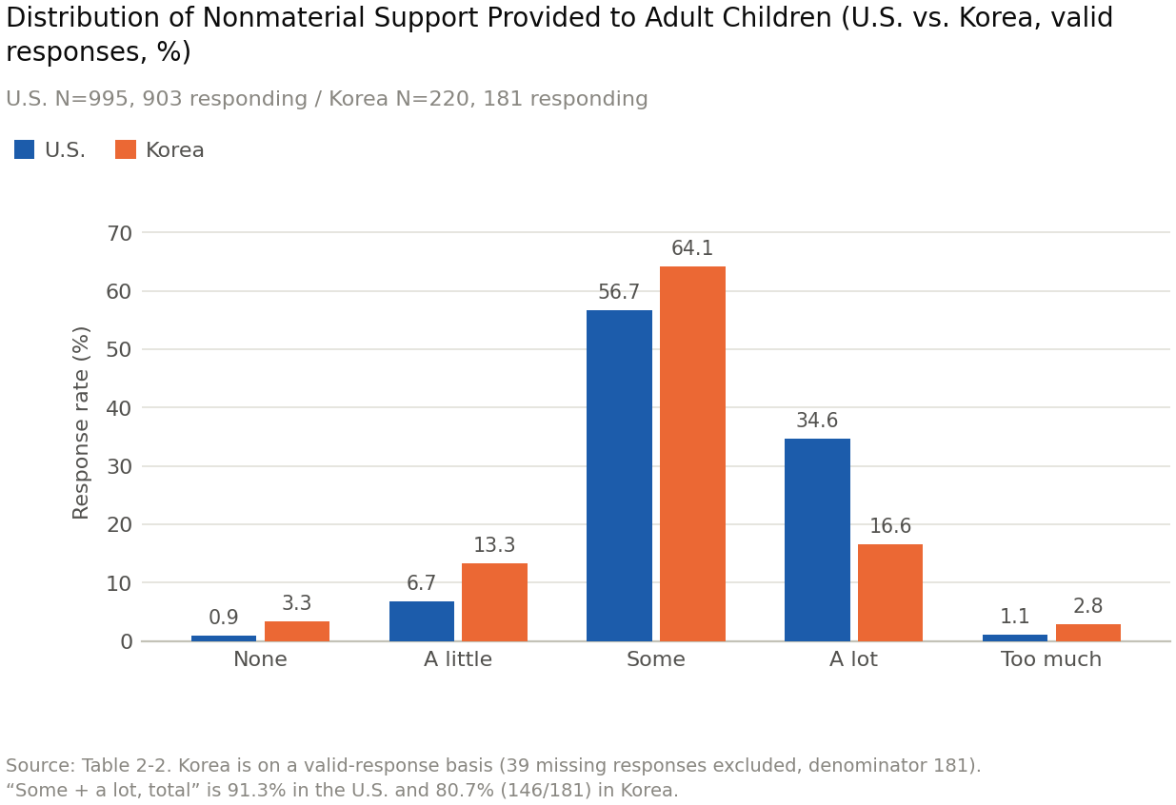
Figure 3. Distribution of Nonmaterial Support Provided to Adult Children (U.S. vs. Korea, valid responses)
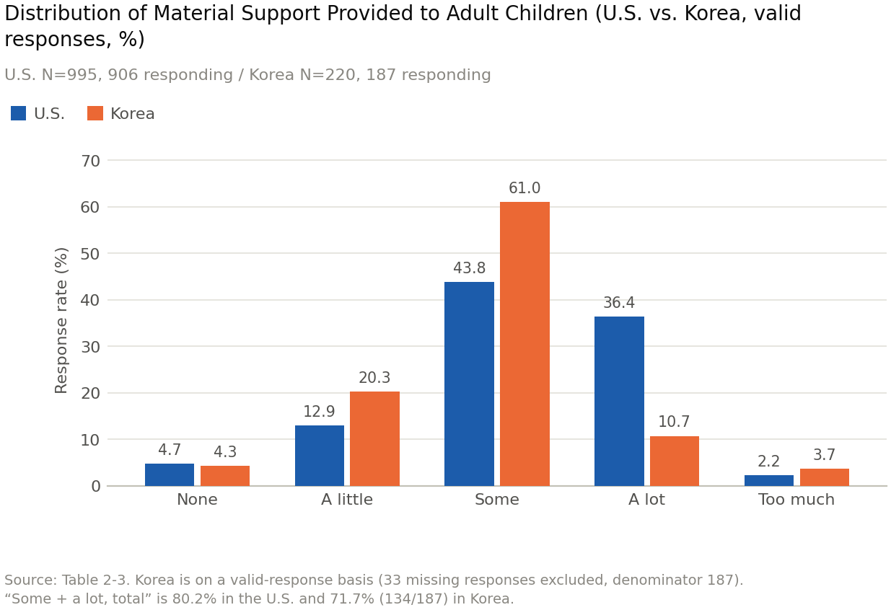
Figure 4. Distribution of Material Support Provided to Adult Children (U.S. vs. Korea, valid responses)
Four things follow, and one thing a reader would reasonably expect does not.
First, the aggregate contrast is very large. Korean agreement within sex stands at 78.6 percent of women and 85.3 percent of men against 7 and 11 percent in the United States, and disagreement at 2.1 and 2.9 percent against 67 and 66. Not one of the 220 respondents chose "strongly disagree." That emptiness is the count of an option that was offered: the Korean form prints all five categories, with no "don't know" and no "not applicable" beside them to absorb a refusal, so a respondent who wished to reject the statement outright had a box to tick and nobody ticked it. This is not a case of two samples leaning different ways on a scale. The two distributions barely overlap.
Second, support runs the other way. "A lot" is 16.6 percent for advice against the American 34.6, and 10.7 percent for material help against 36.4, roughly a third of the American rate, while both Korean distributions pile up on "some," at 64.1 and 61.0. The norm is asserted at the top of the scale and the practice reported at the middle of it.
Third, the sex difference runs in the same direction as the American one, men agreeing more than women in both samples, so any account that treats Korean grandfathers as distinctively authoritarian must explain the American grandfathers too. What differs between the countries is the level, not the gradient.
Fourth, the age pattern is not monotonic. The strongest claim of authority comes not from the oldest grandparents but from the 1945–1954 cohort, at 95.2 and 96.2 percent, on a table whose oldest band holds only 17 people; agreement then falls to 72.7 and 71.2 percent among those born from 1955 onward. Were the endorsement simply the residue of an older Confucian household order it should be highest in the oldest band and decline from there. Instead it peaks in the cohort that came of age with the postwar growth of the Korean church.
What does not follow is the inference the two aggregate facts invite: that if the same people both claim authority and report giving little, then the authority believed in and the authority exercised must be at odds within the person. That claim can be tested at the level of the individual respondent, and it is not supported. The correlations are essentially zero, r = −0.094 and −0.063, and the sign runs the other way — respondents who claim authority more strongly give very slightly more support, not less. Support is flat across authority positions, with 58 to 75 percent of every group answering "some." Being stuck at "some" is a property of the sample, not of the authoritarian; both aggregate statements are true of the sample rather than of any person in it.
Panel D does show one line of division, and it is not the expected one. The group reporting the least support is the group neutral on authority, at 9.4 percent giving advice "a lot" against 22.7 percent among those who strongly agree and 21.9 among those who agree — less than half the rate of either committed group. The cohort table echoes it: "neither" is chosen by 29.4 percent of the oldest band and 26.9 percent of the youngest but by under 5 percent of the two cohorts in between. The line that divides this sample runs not between those who claim authority and those who do not, since those two groups behave alike, but between those who take a position and those who suspend judgment — and it is suspension, not assertion, that travels with the lowest reported involvement.

4.3 The narrowing vocabulary of legacy
The third finding compares two free-text items that ask the same respondent about the two ends of the same inheritance: what he received from his grandparents, and what he intends to leave his grandchildren. Because both come from the same respondents, they can be read against each other person by person as well as in aggregate.
Table 5. The legacy received and the legacy to be left (Korea, free text, coded)
Panel A. Who answered
Item | n | Women | Men | Blank | % of 220
Legacy received from grandparents | 112 | 77 | 35 | 0 | 50.9
Legacy to leave to grandchildren | 162 | 107 | 54 | 1 | 73.6

Panel B. Categories
Category | Legacy received (n=112) | Legacy to leave (n=162)
Faith or belief itself | 63.4 | 86.4
Nothing | 13.4 | 1.2
Prayer | 7.1 | 4.3
Church and worship | 6.2 | 2.5
Example, character, service | 1.8 | 3.7

Panel C. Legacy received × legacy to leave (denominator: all 220)
 | Named a legacy to leave | Did not | Total
Wrote something for legacy received | 96.4 (108) | 3.6 (4) | 112
Left legacy received blank | 50.0 (54) | 50.0 (54) | 108

Note. All counts and percentages are computed from Sheet 2, all 220 respondents, women and men together; Panel B percentages are of those who answered the item, 112 and 162, and Panel C percentages are row percentages on the full sample of 220.
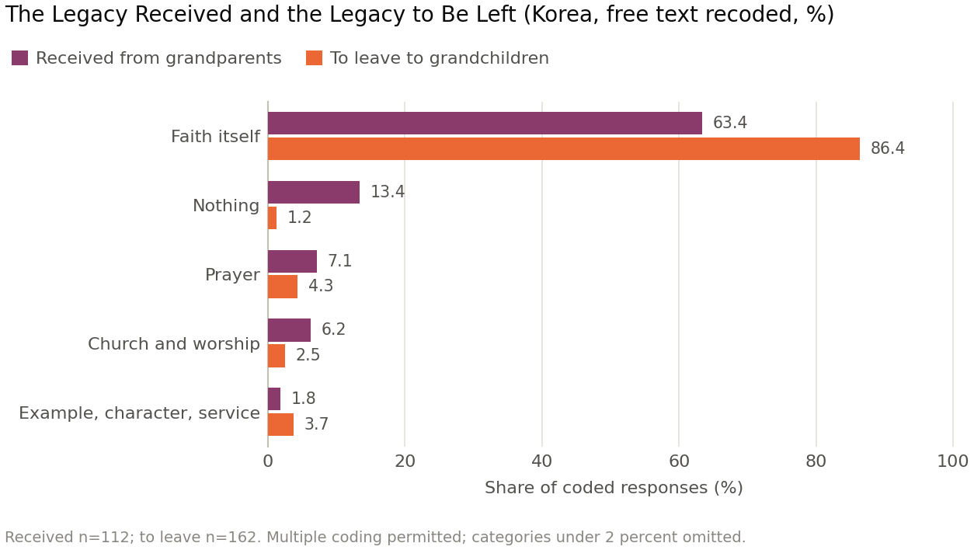
Figure 5. The Legacy Received and the Legacy to Be Left (Korea, free text recoded, %)
Of those who named a legacy they intend to leave, 86.4 percent gave faith itself, usually as the single undifferentiated word 믿음 — faith, or belief. For the legacy received the same category takes 63.4 percent. Every other category is under 5 percent in both columns; "nothing" is 13.4 percent of what was received and 1.2 percent of what will be left. The vocabulary therefore narrows as it crosses the generation: whatever else these respondents inherited, less of it is named on the way out than was named on the way in.
The narrowing is not one movement but two that run together: the concentration into the central category, from 63.4 percent to 86.4, and the disappearance of everything on either side of it — prayer from 7.1 to 4.3, church and worship from 6.2 to 2.5, and "nothing" from 13.4 to 1.2. Only example, character, and service move upward, from 1.8 to 3.7, both figures so small that the category is nearly absent at either end. The received column still holds a range of things a life might have contained, including the honest report that it contained nothing. The bequeathed column has one word in it.
This is not a grandmother phenomenon. Women and men give faith itself at 87.9 and 83.3 percent, a gap of 4.6 points against the 23.0-point gap between the two columns, and response rates are near-identical: 73.8 percent of women and 73.0 percent of men answered the legacy-to-leave item, 53.1 and 47.3 percent the legacy-received item. Grandfathers do not fall silent on legacy questions in these data. The Korean form carries no filter by sex at any point.
Panel C adds the individual-level result, and it cuts against the reading the aggregate figures invite. Answering about the past strongly predicts answering about the future: 96.4 percent of those who wrote anything about the legacy received also named one to leave, against 50.0 percent of those who left the past item blank. The obvious explanation is inheritance — that those given nothing have nothing to pass on — and the file rejects it. Fifteen respondents wrote, in so many words, that they had received nothing. Fourteen of them (93.3 percent) answered the legacy-to-leave item anyway, and twelve of the fifteen — 80.0 percent — wrote something substantive there, the remaining two repeating that there was nothing. Their response rate to the future item is thus higher than the sample's own 73.6 percent, not lower.
Writing "nothing" and writing nothing are therefore opposite acts, though a summary table records them alike. What predicts silence about the future is not an empty inheritance but silence about the past — the failure to bring the question into words at all. This is a result about expression rather than possession, which is the suspicion the next paragraph states.
The interpretive limit remains the sharpest in the paper. This does not imply that Korean grandparents did not live the lives the missing categories describe. Not having lived something and not being able to name it as one's own legacy are different matters. When responses crowd into one word to this degree, the variable to suspect first is breadth of expression rather than intensity of conviction; whether the convergence is purity of faith or uniformity of response language, these data cannot say.

5. Discussion

5.1 What happens to the premise
The premise survives normatively and fails descriptively in Korea, and both halves matter. It survives normatively because nothing in the Korean data disturbs the case for it: parents remain the strongest influence, and the reinforcing mode is still the mode transmission requires.
It fails descriptively in two ways. The first is the register. The American diagnosis is that grandparents showed but did not tell, and the prescription is that they should speak. In Korea the telling is done: praying together, sharing a faith story, taking a child to church, reading the Bible aloud, and naming Jesus' love all run 14 to 28.5 percentage points above the American rates, while what runs 37 to 39 points below is showing how to treat people. A faithful translation of the American curriculum would prescribe to Korean grandparents the thing they already do most, and would be silent about the thing they do least. Each church's prescription is written against its own deficit. Every sentence of that curriculum may be true; a curriculum is not only a set of claims but a distribution of emphasis, and translation preserves emphasis perfectly. What crosses a border safely is a claim. What does not is a proportion.
The second is the authority item. On a claim the premise explicitly rejects — that grandparents' authority precedes the parents' — 80.9 percent of Korean respondents agree and 2.4 percent disagree, against roughly two-thirds American disagreement, and the strongest refusal is chosen by nobody in a sample of 220. At the same time, reported support to adult children is markedly lower than the American figures. Both statements are about the sample as a whole, and the bridge a reader wants to build between them — that the people who claim the authority are the people who withhold the support — is not in the data: the correlations are −0.09 and −0.06, and support is flat across every authority position. What the file describes is a norm held almost universally and unattached to any measured behavior, which is what a belief looks like when it has become a way of speaking about the family rather than of acting in it. Applied to practice this reverses the target: the group giving least is not the 80.9 percent who assert authority but the 16.7 percent who answered "neither."

5.2 The question the data cannot settle
The convergence of Korean legacy responses on a single word admits of two readings, and this paper cannot choose between them. On the first it is a convergence of conviction: Korean Protestantism is young, and a generation for whom faith was personal news rather than family habit may have arrived at one central confession and may mean it. On the second it is a loss of language, since what narrows is the class of answers describing an individual life, and it narrows further on the way out than on the way in.
Descriptive and correlational statistics cannot adjudicate between conviction and vocabulary, and no further tabulation will. What the manuscript offers instead is a criterion a leader can apply in a room: maturity becomes concrete; impoverishment becomes summary. A person who can attach one scene from his own life to the confession is on the side of maturity, and the workshop's free-text item makes that observable rather than assumed.

5.3 The strongest warrant, and the honest counterweight
The strongest warrant for the central claim is the item behind it: a closed check-all item with printed options, answered by 203 of 220 respondents, stable in rank order across two denominators and both sexes, and corroborated by a free-text item of a different format, a different coder, and a different target generation.
The honest counterweight has two parts. The first is that our own coding is a coding, made by analysts who knew what finding was at stake; we cannot remove that risk, only make the work inspectable, which is why the rules and the response-by-response coding are printed in full. The central claim is deliberately anchored in the closed item, which no coding of ours can move.
The second is the documentation asymmetry set out in Section 7: every Korean cell carries its denominator by name and by count, while every American cell can be reported only as its source reports it. That bounds the size of claim this comparison can carry. The register difference rests on gaps of 20 to 40 points, which no plausible difference in reporting convention would erase; nothing here rests on two or three.

6. Implications for Practice
The practical claim is narrow: a faithful translation of an American curriculum delivers the wrong prescription in Korea, because it is written against an American deficit. The workshop below is built from the verified findings only, one table per week.

6.1 The weekly arc
1. What Did I Inherit? — the legacy received, "nothing" printed as an option.
2. Two Registers — the check-all item read aloud.
3. Grandparents Who Uphold Parents — the authority item, and support's flatness.
4. Showing How to Treat People — one concrete act a grandchild can see.
5. From One Word to One Scene — a scene from the participant's life, attached.
6. What Was Received, What Will Be Left — the legacy cross-tabulation.
7. Making One Sentence — a three-minute script told to a real person.
8. Standing as a Partner to the Church — a three-generation service plan.
Three design rules govern the sequence. The workshop does not ask for more religious vocabulary, since the Korean sample already leads the American on every explicitly religious act and adding volume to the dominant register is the one intervention the data rule out. It uses one table per week, none repeated, as a mirror rather than as lecture material. And it inverts the order: week 1 is diagnosis, presentation only in week 7. Eight weeks also allows two non-overlapping four-week windows for the behavioral items.

6.2 Two manuals
Participant and leader materials are separate volumes. The leader's guide carries what the participant workbook cannot: notes specifying how far each figure may be stated and where the statement must stop, principles of group composition, and guidance on sensitive subjects. For every table used in the room it names the denominator, the sex basis, and the cells too small to carry an inference.

6.3 The design feature that matters academically
The pre- and post-session instrument is a sixteen-item abridgement of the original questionnaire, administered in week 1 and week 8 with wording and response categories carried over, so that a response collected in one congregation is measured with the same ruler as the 995 and the 220. It prefers items that already carry a value in both countries, behavioral items capable of changing within eight weeks, and items designed to resolve what the present comparison could not settle.
Two design decisions follow from the analytic policy in Section 3.3. The authority item records sex compulsorily, so that within-sex and whole-sample percentages are both produced and neither can be mistaken for the other; and it prints a separate "no answer" box beside the five categories, so that a zero for strong disagreement can be distinguished from a missing response — a distinction the original questionnaire cannot support. The short form also carries the item asking whether a grandparent believes he is important to his grandchild, which stands in the Korean file with 189 responses and can be set beside the American 77 percent.

6.4 Ethics, and the limit on these data
Consent is read aloud and signed before week 1 and participation is unaffected by refusal; responses carry only a participant code whose key stays with the church; free-text mentions of places and people are redacted at entry; congregations with fewer than ten respondents are never reported alone; withdrawal with full deletion is available at any time; and ethics review is completed on the Korean side before the pilot, with parallel review at any participating U.S. institution.
One limit must be stated as plainly as the design. Workshop participants are a self-selected sample, far from the randomness of either original survey. These data do not substitute for the representativeness of the originals and serve three purposes only: verifying the distribution of the short-form items, measuring change across an intervention, and re-measuring what the originals could not settle.

7. Limitations and Directions for Further Research
Five limitations bound what is written above, and the first two could change it.
The free-text coding is ours. Two of the analyses above — the open item in Section 4.1 and the legacy analysis in Section 4.3 — rest on categorizations the present authors performed, of 89, 112, and 162 free-text responses respectively. No coding sheet accompanied the file, several responses carry personal abbreviations, and multiple coding was permitted where a response named two things. The rules, the category definitions, and the coding of every response are published in the supplementary material precisely so that another analyst can apply different rules and report a different number. A reader who disagrees with our boundary between "showing by one's life" and the devotional categories should recode and say so.
The U.S. side is not computable by us. Every U.S. figure here is a figure printed in the published study. We hold the Korean respondent-level file and not the American one, so the documentation is asymmetric: we can state the denominator of every Korean cell by name and by count, while for the American cells we can state only what the source states. The item-by-item computation we performed on Korea should be performed on the United States by someone who holds that file, and until it is, the comparison rests on one file and one set of tables rather than on two files.
The U.S. sample is one tradition. Of the 995 respondents, 95 percent were white, 74 percent identified with the Republican Party, and more than 800 belonged to the Churches of Christ. Every comparison here should be read as two churches, not two nations, and the register difference in Section 4.1 in particular may be a property of the American fellowship sampled rather than of American Christianity.
The two studies used different methods. The U.S. study combined an online survey with focus groups and interviews; the Korean study is survey-only. Several of the American study's most important claims therefore have no Korean counterpart — most notably that among the adult grandchildren interviewed, not one case could be found in which a grandparent had deliberately told a faith story. That finding shapes the American diagnosis, and its absence in Korea is structural rather than incidental. We propose a Korean interview phase matching the U.S. design, asking where Korean respondents place the line between modelled conduct and explicit religious speech — the boundary on which Section 4.1 turns.
Small cells and unresolved items. Four cross-tabulated groups are too small to carry conclusions and are reported only for completeness: the four respondents who disagree with the authority item, the seventeen born through 1944, the twenty-four who live with a child or grandchild, and the fourteen who report a grandchild living with them. Three questions remain open in the file and are not used above: the factor allocation of the sixteen-item attitude scale is recorded nowhere; two of its items carry the same statement; and one region item contains codes outside the printed options.

8. Conclusion
We began by distinguishing a compass from a map. The premise of grandparent ministry is a good compass: grandparents who reinforce parents rather than replace them, who protect the relationships around the child, and who speak of what God has done in their own lives are pointed in the right direction in Seoul exactly as in Oklahoma, and nothing in 220 Korean responses argues otherwise.
But the curriculum built on that compass is also a map, and the terrain it charts is the terrain of one church. In that terrain the deficit is explicit religious speech, so the prescription is: speak. In Korean terrain the speaking is done — praying together, telling the faith story, naming Jesus, reading Scripture aloud, all above the American rates — and what falls to last place is the item the American church puts first: showing, in how one treats a person, what the faith is for. The instrument travelled; the terrain did not. Handed the American map, a Korean minister sets out to build a bridge over a river that is not there, and walks past the one that is.
Two further results attach to that one. Korean respondents endorse a claim the premise rejects almost without dissent, and the endorsement is unattached to anything they report doing; the group that gives least is not the group that claims most but the group that claims nothing. And when these grandparents are asked to name what they will hand on, five out of six write one word. They are not silent — at 73.6 percent that item is the best-answered of the free-text items, and those who say they inherited nothing answer it at a higher rate still. What is thin is not the conviction but the account of it.
The manuscript's scriptural frame is exact about that difference. Psalm 78 commands that what has been heard not be hidden; Deuteronomy 6 supplies the form the telling takes, since the answer to a child's question begins with a particular — "We were slaves of Pharaoh in Egypt" — and Psalm 78:8 gives the purpose, that the next generation not repeat what the last one was. What is commanded to be handed on is a narrated life, including the parts of it that failed, and not a summary of the right conclusion. One word is a right conclusion. It is not yet a record. The task these data set for grandparent ministry in Korea is therefore not to add conviction, and not to add religious speech, of which there is already more here than in the church that wrote the curriculum. It is to attach to the one word the one scene that earns it — a person treated a particular way, where a grandchild could see it. That is the item the American church puts first and this sample puts last.

References
Bengtson, V. L., Putney, N. M., & Harris, S. (2013). Families and faith: How religion is passed down across generations. Oxford University Press.
Bengtson, V. L., & Roberts, R. E. L. (1991). Intergenerational solidarity in aging families: An example of formal theory construction. Journal of Marriage and the Family, 53(4), 856–870.
Chancey, D. (2025a). Keep faith alive: Grandparents and a godly legacy. ACU Press/Leafwood Publishers.
Chancey, D. (2025b). The Grandparent Project: U.S. grandparent survey conducted for Keep Faith Alive [Unpublished survey dataset and tables, N=995].
Chapman, G., & Campbell, R. (2016). The 5 love languages of children: The secret to loving children effectively. Northfield Publishing.
Kehrwald, L., Roberto, J., Roehlkepartain, G., & Roehlkepartain, J. (2016). Families at the center of faith formation. Lifelong Faith Publications.
Lee, Y. W. (2026). Korean grandparent faith transmission survey [Unpublished respondent-level dataset, N=220].
Pew Research Center. (2023, January 24). Parenting in America today. https://www.pewresearch.org/social-trends/2023/01/24/parenting-in-america-today/
Smith, C., & Denton, M. L. (2005). Soul searching: The religious and spiritual lives of American teenagers. Oxford University Press.
Strom, R. D., & Strom, S. K. (1991). Becoming a better grandparent: Viewpoints on strengthening the family. Sage Publications.
Wuthnow, R. (1999). Growing up religious: Christians and Jews and their journeys of faith. Beacon Press.

Note on citation practice. Jim Burns, named in the Korean edition's preface as the author of a commending foreword to the U.S. volume, is mentioned in text only and given no reference entry, because we were unable to verify the foreword bibliographically. Several studies of grandparenting typology from 1964, 1977, 1986, 2002, and 2012, and the four spiritual roles attributed to Tim Kimmel, are discussed in the U.S. volume and are cited here at second hand through Chancey (2025a) rather than given reference entries we could not verify.

