**PRELIMINARY REPORT**

**MYVALUES: GLOBAL YOUTH VALUES SURVEY**

**A RESEARCH PROJECT BY**

**KAREN E. JONES, PH.D., HUNTINGTON UNIVERSITY, HUNTINGTON, IN**

**PAUL G. KELLY, PH.D., GATEWAY SEMINARY, ONTARIO, CA**

**September 1, 2023**

**INTRODUCTION: WHY YOUTH VALUES?**

To introduce a study of the values of youth from East Africa, the authors made an astounding claim. According to Awiti and Orwa, “Fundamentally, youth attitudes, values and norms will determine the character of East Africa now and its place in the global community of nations.”[1] They suggest that the future of East African countries and their participation in a global society would not primarily be the function of their leadership, of technological and social advances, and not the specific work of education. Instead the values held by the young people of their region would be formative in their future. Given the explosion of the global youth population, the attitudes, preferences, and convictions of adolescents and emerging adults may indeed be one of the driving forces in the world for the next generation.

Cnaan defines *values* as “judgements about what is important in life.”[2] Similarly, Lan and Xiaofeng define them this way: “Values are abstract life goals, reflecting what is most important in people’s lives. Values can guide behaviours, and form a decisive evaluation of people, events, and the Self.”[3] Values may not be at once visible in the life of a young person, but they become obvious when they engage in discussions related to personal understanding of what is moral or correct in human society. Cnaan claims, “Values generally remain static over an individual’s lifetime.”[4] (Cnaan, 3), meaning that what a young person holds as of primary importance in society will likely shape the importance they place on the world as they mature. When values do change, Cnaan contends that they do so gradually.[5]

The values of youth, then, are likely to have a strong correlation to their practices of faith, an influence that is likely to be enduring. Of course, the faith of young people tends to shape the values of teenagers as well, as is demonstrated below. Faith and values function in a circular manner with spiritual belief and practice strongly influencing the values youth hold, and closely held values determining the strength of spiritual convictions and the expressions of faith youth choose. Clearly, faith and values are closely related.

Unfortunately, much of the disciple-making practice in evangelical churches ignores the values of adolescents. As Greenway, et al., have observed, “. . . congregations have overemphasized the importance of upper-level beliefs (e.g., worldviews, reflective thought, reasoning) . . . to a neglect of habits and practices that shape lower-level, intuitive thought.”[6] Churches tend to focus on the things that youth can comprehend but ignore the things they love. Greenway rightly believes that “shaping the heart”[7] is essential to the task of growing disciples of Christ. He states, “As the writers of the Gospels and Epistles describe a disciple of Christ, they often focus on virtues (e.g., what it means to love, the fruit of the spirit) and not solely on proper belief. Hence, shifting to a ‘heart’ focus can help congregations fulfill their call to become disciples of Christ.”[8]

The population of adolescents around the world is surging. Christianity is also growing rapidly around the world, particularly in the global South. Global connections of adolescents with each other creates both opportunity and concern, with young people interacting with peers on the opposite side of the planet through social media platforms, video content sharing, and Internet-based video games. The need for carefully developed discipleship strategies and ministry toward youth has never been more critical and has become an increasingly significant focus of agencies like the International Mission Board of the Southern Baptist Convention. However, this work will require a better understanding of the values and faith practices of youth from a global perspective. This study will target that understanding. The study will address the questions: What values do Christian youth in various regions of the world hold? And, How do the values of global Christian youth correlate with their faith practices?

**REVIEW OF LITERATURE**

Considerable research related to adolescent values has been reported. Researchers have studied the correlation between values and academic success,[9] family structure,[10] pro-social behavior,[11] among other concerns. Some studies examine the connections between religious views and values.[12] Studies have been conducted in a variety of global settings. Research has also examined the spiritual lives of students in a variety of settings.

**Values of Youth Globally**

The world in which adolescents live has changed remarkably in recent decades. Cultural issues that affect the lives of adolescents include the rise of the smartphone, [footnote Twenge], the global market, economic shifts, and the recent Covid-19 pandemic along with the lock-downs attempted to contain the spread of the disease. The resulting impact on adolescents varies from global region to region, but adolescents in many places around the world have been affected. The shifts in culture seem to be leading young people to adjust their values. Researcher Gayle Kimball suggests that these young people will transform the future of human civilization. She asserts the future will be “more egalitarian and compassionate, but more unrest.”[13]

Lan and Xiaofeng, for example, study the changes in values in China. They claim, “Over the past 40 years, during China’s reform and expansion, the values of adolescents have changed significantly. In addition to the traditional values of, for example, family affection, adolescents also relate to modern values, such as fame and fashion values.”[14] While Chinese adolescents do not seem to be rejecting the traditional values of their parents and their culture, they are seeking to add new values to the mix. The new values add complexity to how they determine what is most important in life and create tension between their behavior and attitudes and that of their parents. Lan and Xiaofeng report, “Chinese adolescents believed that acquiring and owning the most popular clothing and electronics is essential, and that satisfaction and happiness in life derive from these items and from their attention to fashion trends.”[15] Certainly, the conflict in values related to money and goods raise conflict, but perhaps the more troubling aspect for Christian leaders will be that Chinese adolescents seem to find ultimate meaning in material goods like clothing and electronics.

Padilla studied levels of conflict in Mexican American homes, especially between adolescents and their parents and the movement of adolescents into adulthood.[16] The values of adolescent children of immigrant families shift toward the values of the host culture, creating conflicts in values between immigrant parents and their children. Padilla asserts that values she calls “*familism* values,” those placing “a strong emphasis on family support, solidarity, and loyalty,”[17] are important values in Mexican American culture and are often held as vital by Mexican American Families. Her study indicates that families who report that *familism* values are held by both parents and youth were associated with “more positive family relationship dynamics.”[18] She posits that these values lead to better life transitions for Mexican American youth.

Engelberg studied young adults in strongly religious Jewish families. Cultural shifts have led many of them to delay marriage until a much older age than is normally accepted by the religious zionist culture. Engelberg explains, “RZ [Religious Zionist] authorities, for their part, insist upon the importance of marriage and delegitimize the experience-seeking of young adulthood. The Tamudic passage stating that ‘any man who has no wife lives without job, without blessing, and without goodness’ is a popular quote in their sermons and writings.”[19] Despite the pressures from the values of their faith community, Jewish young adults are affected by two powerful issues: “the attraction of Western youth culture,” and “feelings of loneliness.”[20] The data Engelberg collected leads him to conclude that Jewish young adults use a strategy of setting apart their single adult lives. “Singlehood is bracketed off from the rest of the lifecycle and viewed as a moratorium during which certain religious indiscretions are viewed as excusable.”[21] Young people Engelberg studied did not reject the values of their families and faith community entirely, but they did lean into the values of their surrounding youth culture to inform their choices related to marriage and sexual expression. The values of the broader youth culture, at least for a season of life, seemed to inform what they deemed as most important in a greater way than their religious values did.

The kind of behavioral shifts in young people related to competing values is likely to occur in adolescents related to other issues. For example, Lan and Xiaofeng found that “values are important factors that influence adolescent learning ability” in Chinese youth.[22] Values such as universalism and benevolence tended to lead to stronger learning motivation, while values such as materialism seemed to lead to poorer academic success.[23]

Cnaan suggests that the interaction of values and the behaviors they tend to lead to may not be so simple. His study on the interaction of values and pro-social behavior suggests that, “in the modern world, materialistic, religious and altruistic values can combine in complex ways to determine pro-social behaviour and that this combination varies across countries and cultures.”[24] In fact, Cnaan found that often materialistic values can correlate strongly with student involvement in certain types of volunteer work. He speculates that students are often more altruistic if being so supports their value of self-attainment.[25]

**Spiritual Life of Global Youth**

Religion and religious practice has a profound effect on the values of young people. The values young people often receive from participation in religious services and in ministries of service seem to be particularly formative for young people. Cnaan suggests that “religion and altruism also seem to support each other, or at least to exist hand-in-hand.”[26] Faith practice is formative for many youth in developing a life of compassion and care for others. Beyond that, the investment of young people in service seems to strengthen their commitment to their faith.

While religion tends to have a significant impact on the values of young people, the manner in which religion and values are developed is affected by the cultural soup in which a young person lives. Cnaan said it this way:

The role of religion may be very different in different countries and it is constantly changing. For example, Japan and Korea are countries where Confucian philosophy and Buddhism are very influential, and they stress familial piety rather than civic engagement. China, a country also influenced by Confucian philosophy, is currently reacting to fifty years of totalitarian Communism. Western Europe is observing a decline in religiosity, while the United States is experiencing a strong upsurge in religious practices that are challenging the secularisation theory.”[27]

While cultural influences on faith practices and the correlation to values is important to note, this study is focused specifically on the connection of values and Christian faith in the lives of adolescents globally.

A recent study by the Barna Research Group called “The Open Generation” involved interviews of nearly 25,000 youth in 26 countries related to their perceptions of Jesus, the Bible, and the impact of the Christian faith.[28] Of their global sample, 52% claim to be Christians. This includes about 30% that Barna calls “nominal Christians.” These young people say they are Christians but have not made any specific commitment to Christ. Their interviews suggest that 22% of the youth in their sample are committed Christians that claim a personal relationship with Christ.

When examining the responses of all participants in the study (those who claim to be Christian, those who are committed Christians, and those who are not Christian), 46% believe Jesus offers hope to people, 43% believe he cares for people, and 38% believe he is trustworthy. Only 23% claim that they can have a personal relationship with him; this number closely corresponds with the number of committed Christians in the study. Apparently, those who claim to be Christians have a positive view of Jesus, and that is to be expected. However, only 7% believe Jesus is judgmental; 6% believe he is irrelevant; and 4% believe he is hypocritical. It seems that only a small portion of youth, Christian or non-Christian, hold a negative view of Jesus.[29]

Despite the generally positive view that “The Open Generation” sample holds of Christ, the study indicates that they only have a partial view of the gospel of Christ. The following indicate the number of Christian teens who agreed with these statements about Jesus:

* He was God in human form (48%).
* He was a prophet of God (22%).
* He was a good teacher but not God or a prophet (9%),
* He was only a normal human being (6%),
* He is a mythical or fictional character (4%),

The number of all youth agreeing with these statements was different, but, surprisingly, not as different as one might expect.

Barna Researcher David Kinnaman described this generation of young people as “The Open Generation,” explaining: “This generation is open to so many things. They are open to their friends. They are open to the world. They are open to Jesus. They are open to spirituality. Now, they are open to anything and everything, but they want to see truth, authenticity, and change in the world.”[30] The opportunity to engage this generation of youth with the message of Christ is significant, but their openness to anything calls youth leaders to winsome and clear teaching about the Christian faith and Christian spirituality.

**THE CURRENT STUDY**

The current study was designed to explore the values of youth (12 to 19 years of age) across countries in five regions of the world: North and Central America, South America, Africa, Europe, and Asia. While this paper is a preliminary report discussing the early findings, the researchers are continuing to work with ministry and research partners in each of these five regions to collect data from teenage participants.

The purpose of the study is four-fold. The researchers intend to develop . . .

* A deeper understanding of the values of Christian teenagers from various global contexts,
* Greater clarity in the differences and similarities in values of teenagers from various cultural contexts,
* Greater clarity in the differences and similarities in faith practices and beliefs of teenagers from various global contexts, and
* An identification of the relationships between teenage values and their faith practices and beliefs.

This paper will describe the state of research at the time of writing. Primarily, the data used will address the first purpose of the study: to gain a deeper understanding of youth values from a variety of global contexts.

The development of the survey began with an examination of research tools commonly used for the research of human values. Several tools were helpful in the development of an appropriate survey to accomplish the purposes of this study. For example, “The Portrait Values Questionnaire” (PVQ) based on Schwartz’s theory of values, identifies ten individual values that tend to influence human actions (Chowdhury, 2019). The values are grouped into four domains: self-directional, universal or transcendent, traditional, and power. The Rokeach Value Survey distinguishes between terminal values–those that “refer to desirable end states of existence,” and instrumental values–those that “refer to preferable modes of behavior” (Rokeach). The MyValues Survey includes values statements that many young people adopt through the influence of family, culture, and faith. Statements related to faith practice were added to the MyValues Survey taken from the Student Assessment of Enduring Faith Factors (Jones, Kelly, Odom, Ross, and Baskin) in order to compare youth values with youth faith practices. Youth indicate their agreement with each statement using a four-point likert scale (strongly agree, agree, disagree, and strongly disagree). Once developed, the MyValues Survey was reviewed by ministry and research partners from four countries to determine how well the items communicate across cultures.The final survey includes 140 items (including demographic questions) and was estimated to take youth about 20 minutes to complete. (See appendix 1.)

In order to facilitate access for students from different language groups, the survey was translated from English into Spanish and Brazilian Portuguese. Translations are currently in progress into Mandarin, Korean, and Swedish. Each translation is reviewed by research partners in the region in which the survey is used to ensure a close similarity of understanding between cultures.

The survey was developed for online delivery through Huntington University and the domain [www.MyValues.LIFE](http://www.myvalues.life) was acquired as the portal for youth to access the survey. Research partners were recruited to invite participation by youth leaders in a variety of countries including: Brazil, Cuba, Ethiopia, Ghana, Mexico, Philippines, Sweden, and the United States. Researchers and research partners met with groups of youth leaders to guide them in the implementation of the survey, to motivate them to motivate youth to participate in the study, and to answer questions about how the data will be used.

Researchers communicated qualifications for participants to research partners and youth leaders. First, participants should be between the ages of 12 and 19 years of age. While the ages of “youth” vary greatly from culture to culture and this age grading more closely matches American youth ministry than that of most other countries, the ages were choses because of the wealth of developmental changes involved in the years around puberty.

Second, youth should be part of a local church ministry. Youth in church ministry may vary greatly from highly committed youth with deeply held faith to youth who are ambivalent about faith and attend for other reasons (e.g., family requirements, friendship, fun events). Youth leaders were told that, for the sake of comparison, the only requirement for involvement in ministry would be that the youth attend some church or youth ministry event at least once each month on average.

Third, youth would need to have access to the Internet. The study does not collect information from the computer, so the same Internet connection could be used for many youth to complete the study. The study can be completed on a smartphone; most youth leaders indicated that would be the way most of their youth would complete it.

Data collection began in September 2022 among youth in Ghana. Collection will continue until at least January 2024. When data collection is complete, the researchers will begin statistical analysis to determine what valid similarities and differences between sample groups as well as correlation between values and faith practices.

**PRELIMINARY FINDINGS**

As of the time of writing, the Global Youth Values survey has been completed by 347 individuals in English, Spanish, and Portuguese. However, almost 20% of those responding are outside the established range of 12 to 19 years of age. The current data include responses from only 285 youth of appropriate age. The youth who have completed the survey are from ten different countries: Argentina, Australia, Brazil, Ghana, Hong Kong, Liberia, Nigeria, the Philippines, the United Kingdom, and the United States. Some of the responses do not indicate the country of the participant.

Since the number of participants is insufficient to find significance in comparisons between groups, these preliminary findings focus on the responses of this cohort of international youth. As more data is collected from each region of the world, greater findings, including a better understanding of how values differ from region to region should be possible. Also, greater participation will also allow for analysis of correlations between issues of faith practice and reported values.

The data included here focus on responses that are likely to be of interest to youth leaders, parents, and pastors as well as cross-cultural ministers. Most of the data included focuses on the description youth offered of their faith. However, we have highlighted some data related to their value claims.

**Values Statements**

The youth participants in this study are participants of evangelical Christian churches. The denominational background, size, and culture of the churches to which the young people attend vary greatly. Some students are highly committed youth. However, youth leaders have been instructed to include youth in the study that attend at least one activity in the church each month on average. So, the values of the youth should not be seen as indicating the theological teachings of the church. Nevertheless, we can learn a lot about teenagers around the world by considering the values that they indicate are important to them.

Success Is Job and Money

What indicates success for a young person reveals something important about their values. Success in Christianity may be counter-cultural. While human society often honors those who attain positions of power or financial affluence as pictures of success, the Bible suggests that success is found in more eternal ventures. Jesus taught, “Do not lay up for yourselves treasures on earth, where moth and rust destroy and where thieves break in and steal, but lay up for yourselves treasures in heaven, where neither moth nor rust destroys and where thieves do not break in and steal. For where your treasure is, there your heart will be also” (Matthew 6:19-21, ESV).

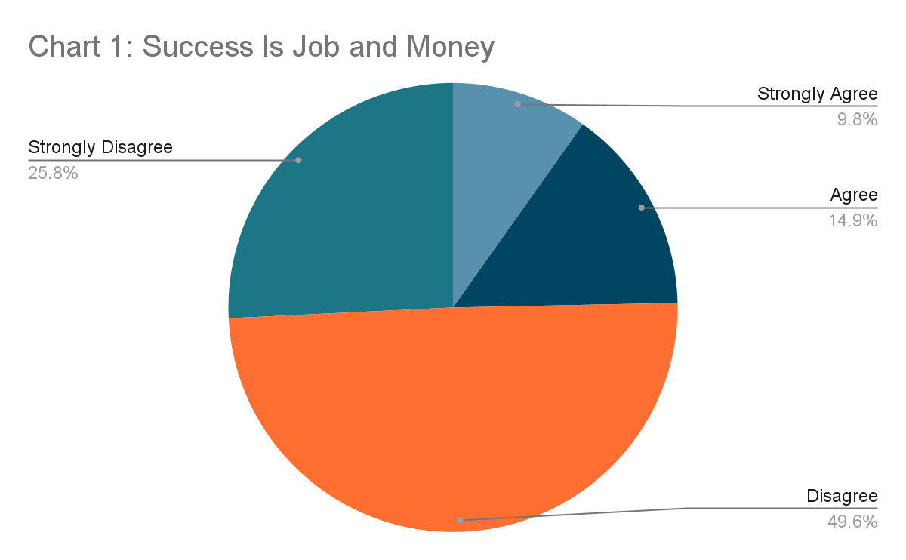Participants rated their response to the value statement, “The best measure of success is the job a person holds and how much money they make.” Their responses are in Chart 1 below.

As might be expected, the majority of youth indicated that they disagree, with a quarter of them strongly disagreeing. However, a quarter of the youth agreed with the statement, and 10% of this group of Christian youth strongly agreed with the statement. If values statements are judgments about what is important in life, then a large percentage of this sample believe that what is ultimately important are temporal successes of wealth and position. Given the strong biblical teaching on finding our greatest success in eternal pursuits, one might posit that a large percentage of the sample would strongly disagree with the statement. Only one quarter of participants reacted that strongly against the statement.

Participants that agree with the statement could be in cultures or churches that highly value the power of God to provide for their temporal needs. If the churches of these young people raise affluent people or people of great influence in society as examples of success, the young people may grow to believe that they only experience the favor of God when they experience worldly success. Upon gathering more data, exploring this questions with respect to denominational and cultural background of participants might provide greater insight into which youth are responding positively to this value statement.

Acceptance of Others

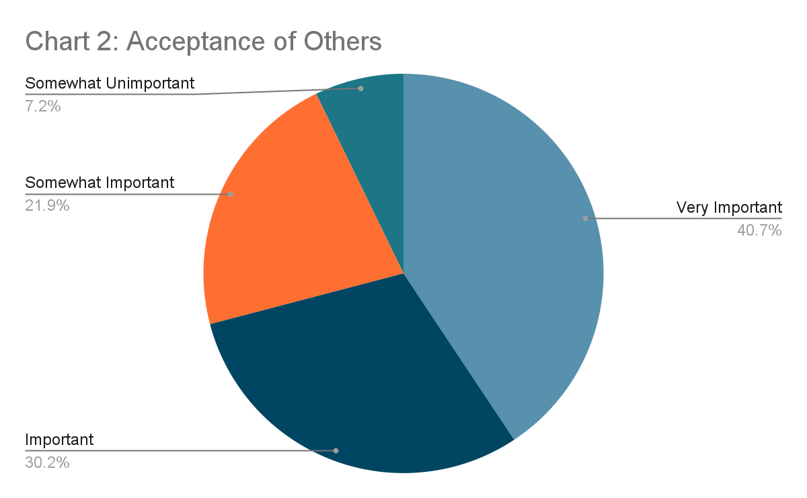One section of the MyValues.Life survey engaged youth in responding to the importance they believe each of a series of values holds. One of those items produced an interesting response. Chart 2 provides the responses participants gave to the item, “Acceptance by Others.”

Adolescence is a time of life in which people crave acceptance, especially by peers. Fuller Youth Institute has posited that one of the three developmental questions adolescents need to answer is, “Where do I fit?”[31] Given the importance of acceptance by most young people, the responses to this question may be understandable.

Jesus warned his disciples, “If the world hates you, know that it has hated me before it hated you. If you were of the world, the world would love you as its own; but because you are not of the world, but I chose you out of the world, therefore the world hates you. Remember the word that I said to you: ‘A servant is not greater than his master.’ If they persecuted me, they will also persecute you” (John 15:18-20, ESV). While acceptance by other people may feel important for young people, the Bible calls followers of Christ to focus on acceptance by God rather than by other people.

It is astounding that 40% of the participants place acceptance at the highest level of importance.[32] Perhaps this is related to the openness described by the Barna Group, mentioned earlier. Kinnaman indicated that youth today are open to everything. Perhaps youth around the world rank this value so high because they believe that everyone should be accepted, regardless of background, life experience, or behavior.

A few participants indicated that acceptance by other people is of no importance at all. Determining why they find this value without merit would provide insight. Are they youth who are committed to seeking acceptance from no one but Jesus? Are they disengaged from other people and disinterested in their opinions? Or are they reacting to painful experiences in their relationships by others? Further research could prove helpful.

**Personal Faith**

Some of the items on the MyValues.Life survey addressed the personal faith of youth. What convictions seem most important to young people and how do they seek to live their faith in Christ?

Confident I Will Go to Heaven

For example, we asked them to indicate their agreement with the statement, “I am confident I will go to heaven when I die.” An astounding 95% indicated that they agree with two-thirds of the participants indicating that they strongly agree. (See Chart 3 below.)

This may indicate a confidence that the grace of God, and not personal merits, provides the promise of heaven. John writes, “And this is the testimony, that God gave us eternal life, and this life is in his Son. Whoever has the Son has life; whoever does not have the Son of God does not have life” (1 John 5:11-12, ESV). This is not clear, as we will see later in this discussion. Regardless, these youth do seem to have an abiding and powerful hope that they will experience God’s favor in the afterlife.

Fearful about My Future

However, another item related to their personal faith seemed to be at juxtaposition. We asked youth to rate their agreement with the statement, “I am fearful about my future.” Despite the confidence in God the vast majority claimed related to God’s provision for life in heaven, almost half indicated fear for their future. (See Chart 4 below.) This seems to suggest that Christian youth feel they can trust God for eternity but not for the challenges of this life.

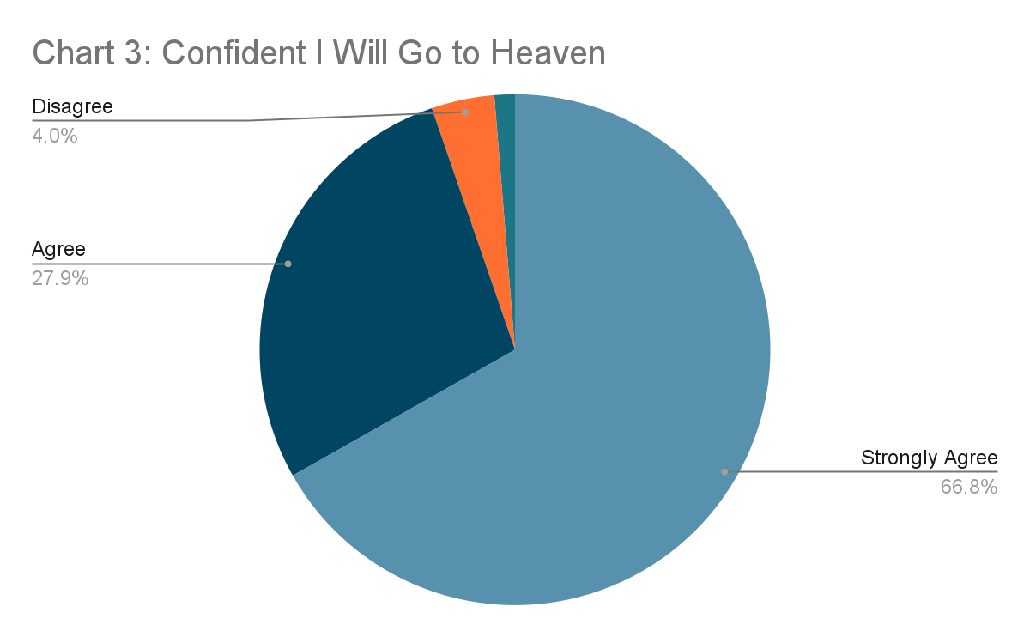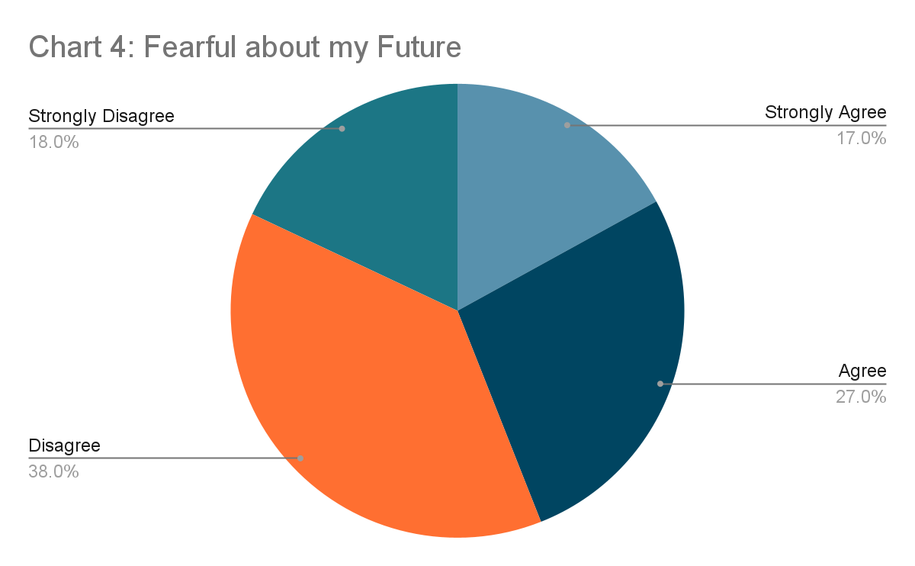

I Know God Is Real

A final issue related to the personal faith of these adolescents relates to their confidence in the existence of God. In rating their level of agreement with the statement, “I know that God is real,” an astounding 99% indicated agreement. Perhaps even more surprising, 90% indicated strong agreement. Less than one percent indicated doubt about the existence of God. No one indicated that they strongly disagree with the statement.

While these adolescents may not be clear on theological and ethical issues in life, they are confident there is someone beyond humanity. The author of Hebrews testifies, “And without faith it is impossible to please him, for whoever would draw near to God must believe that he exists and that he rewards those who seek him” (Hebrews 11:6, ESV). This generation does seem to have an openness concerning God. Perhaps this can lead to a desire to know and follow him. 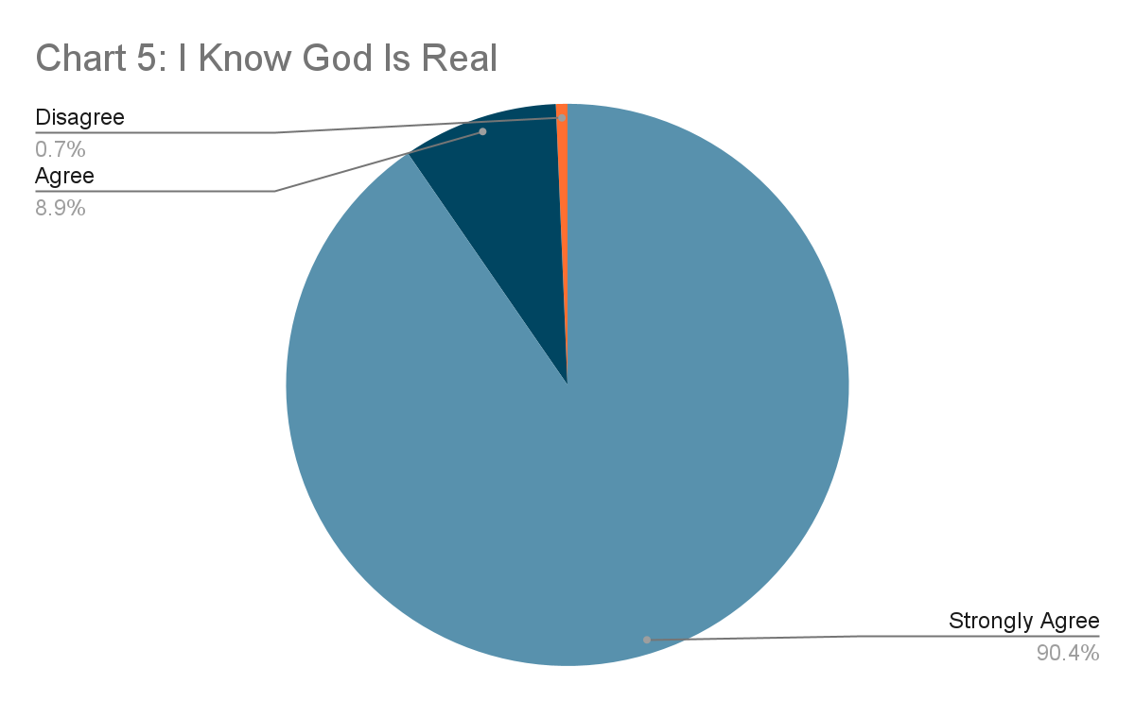

**Family and Faith**

Nearly 20 years ago, Researcher Christian Smith made the claim, “The single most important social influence on the religious and spiritual lives of adolescents is their parents.”[33] The claim is generally accepted as valid by scholars and researchers. Because of this, the MyValues.Life survey includes several items related to the influence of family and parents on the faith practices of adolescents.

My Parents Encourage Christian Growth

For example, we asked students to rate their agreement with the statement, “My parents encourage me to grow as a Christian.” Well over 90% of the participants indicated agreement and one-third indicated that they strongly agree. (See Chart 6.) It would seem that the Christian faith of students is largely a shared faith with their parents.

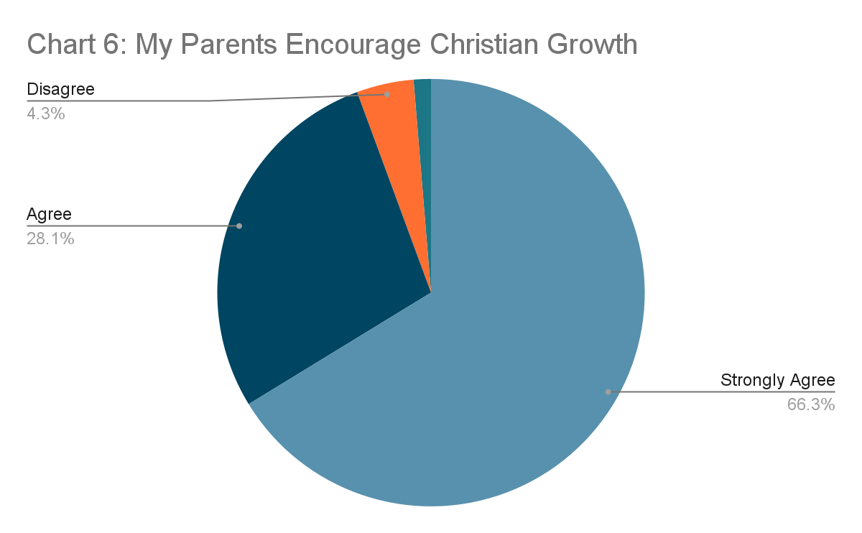

**Understanding of Christianity**

Finally, the survey explored the understanding of adolescents of the teachings of the Christian faith. Many of the responses indicate troubling misconceptions of the teachings of Scripture.

Everyone Goes to Heaven

For example, students rated their agreement to the statement, “Everyone who lives a good and moral life will go to heaven when they die.” The statement indicates a concept of salvation by works: those who are good go to heaven. The Apostle Paul indicated that salvation (suggesting also the hope of heaven) is a matter of God’s grace and not personal merit: “By grace you have been saved through faith. And this is not your own doing; it is the gift of God, not a result of works, so that no one may boast” (Ephesians 2:8-9, ESV).

Almost half of students indicated agreement with the statement, suggesting they consider salvation to be a matter of personal merit. (See Chart 7 below.) This is curious given their apparent confidence that they will go to heaven. Perhaps they are confident in their own ability to live a good and moral life.

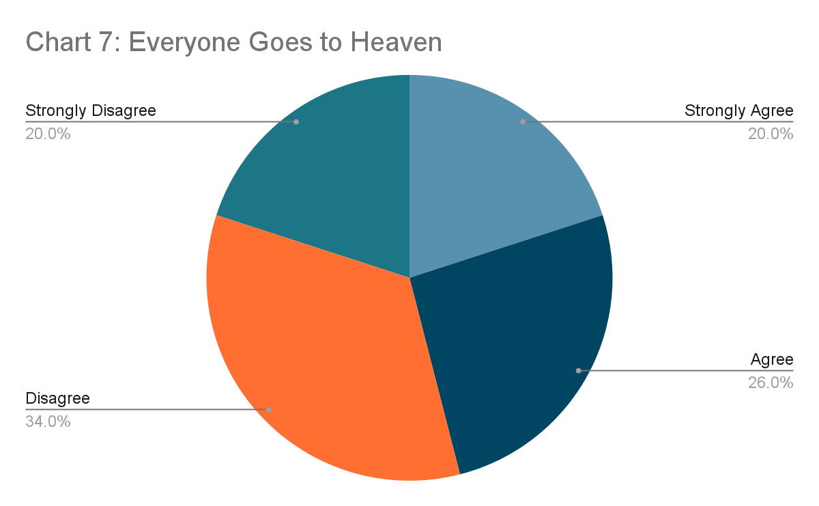

God Wants Everyone Happy

Another item examining how adolescents understand the Christian asked students to rate their agreement with the statement, “God wants all people to be happy.” The Prophet Micah explained, “He has told you, O man, what is good; and what does the Lord require of you but to do justice, and to love kindness, and to walk humbly with your God?” (Micah 6:8, ESV). In Matthew 5, Jesus describes a blessed (or happy) person:

Blessed are the poor in spirit, for theirs is the kingdom of heaven.   
Blessed are those who mourn, for they shall be comforted.  
Blessed are the meek, for they shall inherit the earth.  
Blessed are those who hunger and thirst for righteousness, for they shall be satisfied.  
Blessed are the merciful, for they shall receive mercy.  
Blessed are the pure in heart, for they shall see God.  
Blessed are the peacemakers, for they shall be called sons of God.   
(Matthew 5:3-9, ESV)

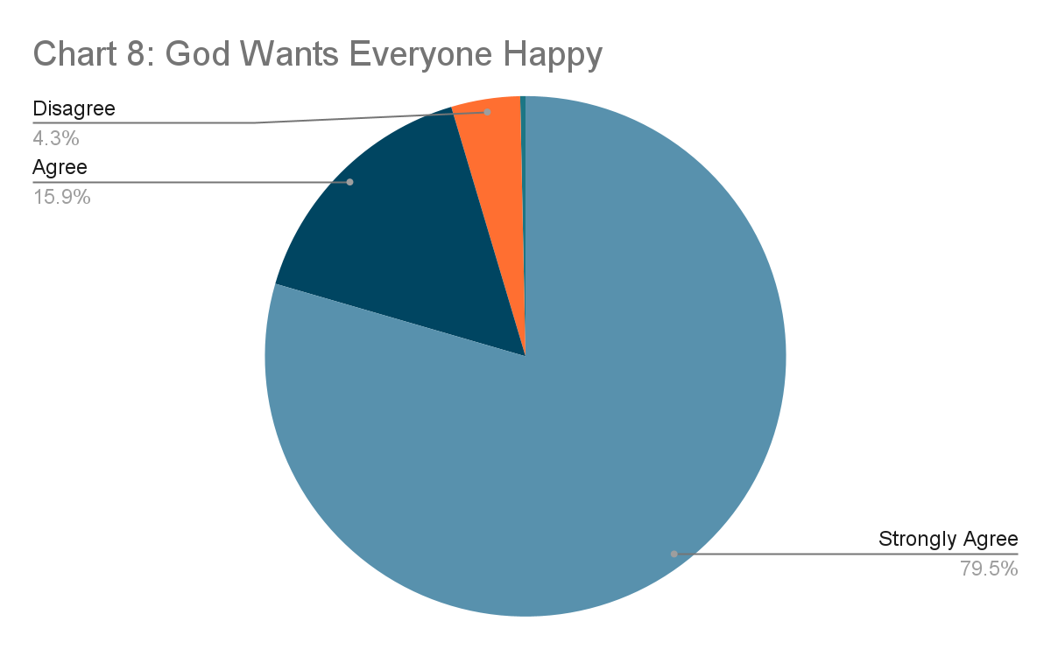The Bible indicates that the desire of God for our lives is to live in step with him: doing justice, being meek, having a pure heart, and so forth. While such a life will lead to happiness, contentment, and joy, the desire of God for us is to be holy.

The participants in this study overwhelmingly agreed with the statement that God desires people to be happy. (See Chart 8 below.) Perhaps many participants reason that, since God wants us to be holy, and that being holy would ultimately make a person happy, that God wants people to be both holy and happy. However, it seems more likely that something like the faith perspective that Smith called Moralistic Therapeutic Deism[34] is operating globally among adolescents. Creasy Dean described this faith perspective as “an agreeable porridge about the importance of being nice, feeling good about yourself, and saving God for emergencies.”[35] Or, more to the point, youth with this tepid faith believe in part, “The central goal of life is to be happy and to feel good about oneself.”[36]

The extent to which youth are espousing a feel good faith is not clear. While this is a concerning finding, further research will be needed to determine what prompts youth to be committed to the idea that God wants everyone to be happy.

All Religions Worship the Same God

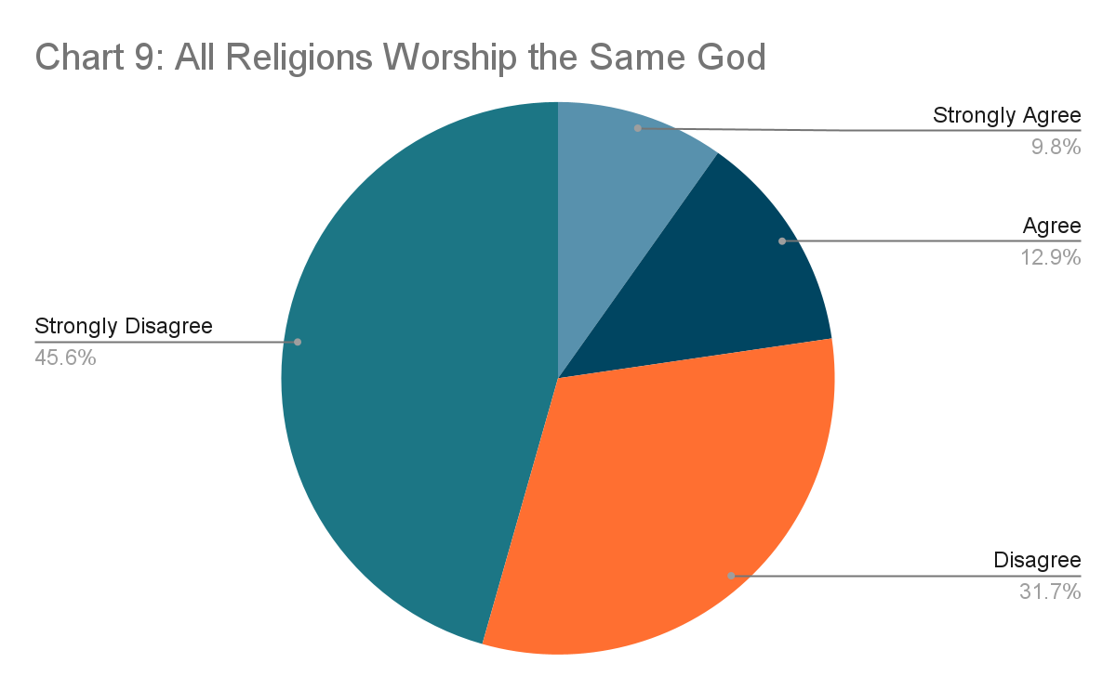Finally, youth indicated their agreement to the statement, “All religions worship the same God.” The statement is intended to assess confidence in the uniqueness of the Christian faith. Jesus claimed, “I am the way, and the truth, and the life. No one comes to the Father except through me” (John 14:6, ESV). The Old Testament called God’s people to worship him as their one and only God. (See Exodus 20:2-3.) The Prophets called the people of God to abandon the idols of other nations. Baal worship was not another path to God. (See Jeremiah 2:4-9.) Likewise, the New Testament decries the false teachers who do not point to the one true God. (1 Timothy 6:3-6)

The majority of the participants disagreed with the statement, almost 50% strongly disagreeing. (See Chart 9.) While this is encouraging, almost a quarter of the youth agreed that all religions worship the same God, with 10% strongly agreeing. It is unclear with the present data whether this is generally true in the world, or if this universalistic tendency represents the global youth culture.

While the current data is not sufficiently robust to determine if a statically reliable difference exists, it is interesting to note that those who responded to the survey in Spanish seemed much less likely to agree with the statement, “All religions worship the same God.” Nearly two-thirds of Spanish-speakers strongly disagreed with the statement, compared to less than half of the total group. Less than 10% of the Spanish-speakers agreed, compared to over 20% of the total group either agreeing or strongly agreeing.

.

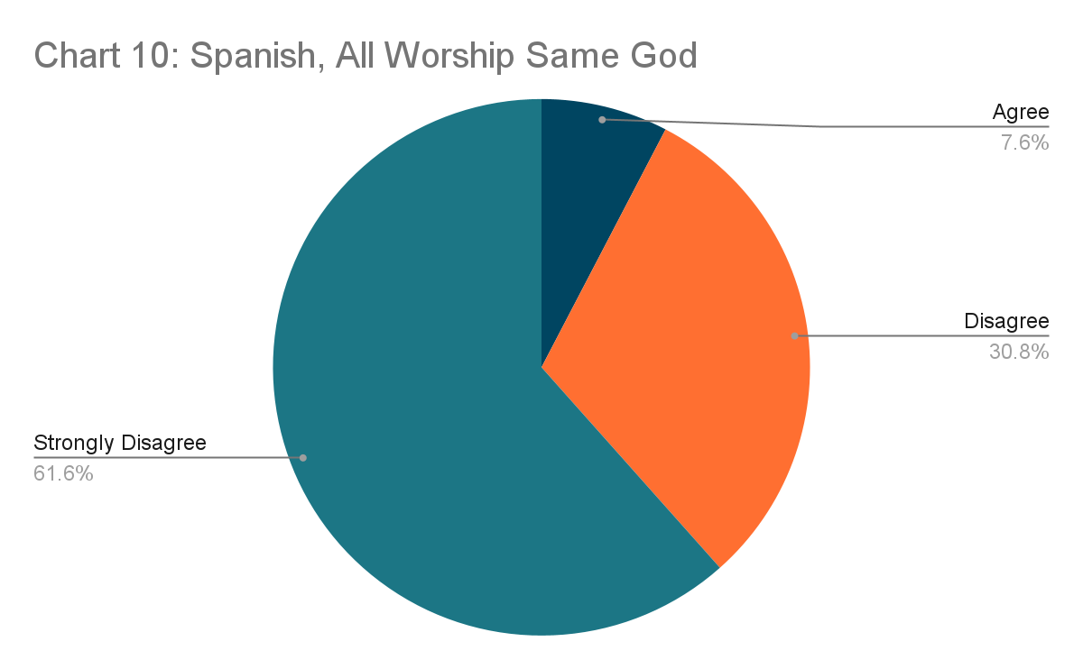

**CONCLUSION**

All of the findings in this paper are preliminary. Additional participants will provide more reliable data. The data collected to date indicates a mixed bag concerning the values and spiritual lives of church adolescents around the globe. They express a deep confidence in the existence of God and in the promise of heaven. They also seem to see God as desiring for people to be happy. They indicate a fear for the future in spite of their hope of God’s eternal care. They indicate support in their faith from their parents. Half of them believe success is defined by a good career and a strong bank account.

Of course, the data described in this paper reflects only a small percentage of the data that has been gathered. These items have been selected as interesting findings that will begin to tell the story about the faith and values of adolescents in the five regions around the world. The greatest need to gain a clearer picture of the values of youth around the world is to engage more Christian teenagers in completing the MyValues.Life survey. To that end, the researchers are engaging ministry partners in a variety of global contexts in motivating Christian teenagers to take the survey. Work is currently underway to add translations of the study into Mandarin, Korean, and Swedish. Once these translations are built, ministry partners in Northern Europe and East Asia will begin meeting with youth leaders in evangelical churches to encourage greater participation.

Multiplying data, dispersed through the five regions of the world, provide opportunities for greater understanding of the values of teenagers globally. Statistical analysis will lead to an identification of differences in values and Christian practice among adolescents between the countries from which youth are participating. We can learn more about what passions stimulate the young people of a region of the world, and how that differs from other regions. Given such data, ministry leaders can begin to reshape ministry resources and activities with the heart of the teenagers in their area in mind.

In addition, a greater pool of data will allow statistical analysis of possible correlation between values and faith beliefs and practices. A greater understanding of the interplay between faith and values may prove invaluable for ministry leaders.

As has been indicated, student responses to survey items can lack deep understanding. Once the quantitative data allows for better analysis of value statements and faith practices, developing deeper understanding of what youth are thinking and feeling may be warranted. Qualitative interviews may help the researchers to develop a deeper understanding of the values and beliefs of youth involved in the study.

The global population of teenagers is booming. The need for better understanding of them will help us to find better ways to partner with them to engage their generation with the Gospel of Christ. If the Barna Group is right, and this is the “Open Generation,” they may sit at the beginning point of a new movement of God in the world. Their values may provide a beginning point for new wineskins for the Gospel of Christ to flourish in places from Austin to Bangkok, Caracas to Dublin.

**BIBLIOGRAPHY**

# Awiti, Alex O. and Caleb Orwa. “Identity, values and norms of East Africa’s youth,” [*International Journal of Adolescence and Youth*](https://www.tandfonline.com/journals/rady20)*.* Vol 24, (2019).

# Barna Research Group, “How Teens Around the World Relate to Jesus,” Part 1 of a series of video interviews concerning the global research on what they call “The Open Generation of Teenagers.” Online at <https://www.barna.com/the-open-generation/open-generation-webinar-replays/>

# Chowdhury, Madhuleena Roy. “The 3 Best Questionnaires for Measuring Values,” *Positive Psychology.Com*. 12 Aug 2019. Online at <https://positivepsychology.com/values-questionnaire/>.

# Cheung, Chris Hin Wah, et. al. “Religious Engagement and Attitudes to the Role of Religion in Society: Their Effect on Civic and Social Values in an Asian Context,” *British Journal of Religious Education*. Vol. 40:2 (2018), 158-168.

# Cnaan, Ram A., et. al. “Student Values, Religiosity, and Pro-Social Behavior: A Cross-National Perspective,” *Diaconia*, vol. 3, 3-25 (2012).

Creasy Dean, Kenda. *Almost Christian: What the Faith of our Teenagers Is Telling the American Church*. New York: Oxford University Press, 2010.

Engelberg, Ari. “Religious Zionist Singles: Caught Between ‘Family Values’ and ‘Young Adulthood,’” *Journal for the Scientific Study of Religion* vol. 55:2 (2016), 349-64.

Epstein, Irving, gen ed. *The Greenwood Encyclopedia of Children’s Issues Worldwide: Sub-Saharan Africa*. Westport, CT: Greenwood Press, 2008.

Eremina, M. A. “Thematic Scientific Bibliography as a Discourse: Modern Youth Values,” *Directory of Open Access Journals* (11:1), 28–43.

Greenway, Tyler S., et. al. “Character-Forming Discipleship: An Analysis of the Discipleship Practices of Ministry Leaders Across the United States,”*Journal of Youth Ministry*, (20:2).

Grossoehme, Daniel H. “Self-Reported Value of Spiritual Issues among Adolescent Psychiatric Inpatients,” *The Journal of Pastoral Care, vol. 55:2* (Summer 2001).

Hill, Peter C. and Ralph W. Hood, Jr., eds. *Measures of Religiosity*. Birmingham, AL: Religious Education Press, 1999.

Khammatova, Rina S., et al. “Specific features of value orientations among the student youth in the context of digital transformation of the education system,” *World Journal on Educational Technology: Current Issues.* Volume 13, Issue 2, (2021) 297- 306.

Kimball, Gayle. *How Global Values Will Change Our Future*. Newcastle-Upon-Tyne: Cambridge Scholars Publishing: 2018.

Lan, Lili and Xiaofeng Wang, “Parental Rejection and Adolescents’ Learning Ability: A Multiple Mediating Effects of Values and Self‑Esteem,” *Behavioral Sciences* 2023, 13, 143. Online at https://doi.org/10.3390/bs13020143.

Padilla, Jenny, et. al. “Parent-Youth Differences in Familism Values from Adolescence into Young Adulthood: Developmental Course and Links,” *Journal of Youth and Adolescence* (2016) 45:2417-2430.

Powell, Kara E., Brad M. Griffin, and Tyler S. Greenway, “Identity, Belonging, and Purpose: New Research on Three Big Questions that Change Every Teenager, *Journal of Youth Ministry*, 21:1 (Spring 2023).

“Rokeach Value Survey,” *PsyNSO*. Online at: <https://psynso.com/rokeach-value-survey/>.

Smith, Christian with Melinda Lundquist Denton. *Soul Searching: The Religious and Spiritual Lives of American Teenagers*. New York: Oxford University Press, 2005.

Yenney, Aaron D., Tyler S. Greenway, Brad M. Griffin, and Kara E. Powell. “Character and Virtue Development in Youth Ministry (Part 1): Relevant Traditions and Current Practices,” *Journal of Youth Ministry* 18:2 (Fall 2020).

______. “Character and Virtue Development in Youth Ministry (Part 2): Virtue Interventions and Future Directions,” *Journal of Youth Ministry* 18:2 (Fall 2020).

1. Alex O. Awiti and Caleb Orwa, “Identity, values and norms of East Africa’s youth,” [*International Journal of Adolescence and Youth*](https://www.tandfonline.com/journals/rady20), vol. 24 (2019).
2. Ram A. Cnaan, et. al., “Student Values, Religiosity, and Pro-Social Behavior: A Cross-National Perspective,” *Diaconia*, vol. 3 (2012), 3.
3. Lan, Lili and Xiaofeng Wang, “Parental Rejection and Adolescents’ Learning Ability: A Multiple Mediating Effects of Values and Self‑Esteem,” *Behavioral Sciences,* vol. 13(2023), 16. Online at https://doi.org/10.3390/bs13020143.
4. Cnaan, 3.
5. Cnaan, 3.
6. Tyler S. Greenway, et. al., “Character-Forming Discipleship: An Analysis of the Discipleship Practices of Ministry Leaders Across the United States,”*Journal of Youth Ministry*, (20:2), 47.
7. Greenway, et. al., 47.
8. Greenway, et. al., 48.
9. See, Lan and Xiaofeng, 19.
10. See, Jenny Padilla, et. al., “Parent-Youth Differences in Familism Values from Adolescence into Young Adulthood: Developmental Course and Links,” *Journal of Youth and Adolescence,* vol. 45 (2016), 2418.
11. See, Cnaan, 4.
12. See, Cnaan, 21; and Ari Engelberg, “Religious Zionist Singles: Caught Between ‘Family Values’ and ‘Young Adulthood,’” *Journal for the Scientific Study of Religion* vol. 55:2 (2016).
13. Gayle Kimball, *How Global Youth Values Will Change Our Future* (Newcastle-Upon-Tyne: Cambridge Scholars Publishing, 2018), xi.
14. Lan and Xiaofeng, 11.
15. Lan and Xiaofeng, 21.
16. Padilla, 2418.
17. Padilla, 2418.
18. Padilla, 2418.
19. Ari Engelberg, “Religious Zionist Singles: Caught Between ‘Family Values’ and ‘Young Adulthood,’” *Journal for the Scientific Study of Religion* vol. 55:2 (2016), 351.
20. Engelberg, 350.
21. Engelberg, 350.
22. Lan and Xiaofeng, 1.
23. Lan and Xiaofeng, 19.
24. Cnaan, 2.
25. Cnaan, 4-5.
26. Cnaan, 21.
27. Cnaan, 7.
28. Barna Research Group, “How Teens Around the World Relate to Jesus,” Part 1 of a series of video interviews concerning the global research “The Open Generation of Teenagers.” Online at <https://www.barna.com/the-open-generation/open-generation-webinar-replays/>
29. Barna Research Group.
30. Barna Research Group.
31. Kara E. Powell, Brad M. Griffin, and Tyler S. Greenway, “Identity, Belonging, and Purpose: New Research on Three Big Questions that Change Every Teenager, *Journal of Youth Ministry*, 21:1 (Spring 2023), 7.
32. Barna Research Group.
33. Christian Smith with Melinda Lundquist Denton, *Soul Searching: The Religious and Spiritual Lives of American Teenagers* (New York: Oxford University Press, 2005), 261.
34. Smith, 262.
35. Kenda Creasy Dean, *Almost Christian: What the Faith of our Teenagers Is Telling the American Church* (New York: Oxford University Press, 2010), 10.
36. Creasy Dean, 14.