Harrison Assessment: Possible Key to Longevity in Ministry?

Dudley Chancey, Stephen Burgess and Michelle Burgess

Abstract: Longevity and burnout are two topics that continue to inundate the literature affecting companies, educational workplaces, government, and churches. These entities struggle with hiring and retaining employees. A recent Gallup Poll reported that many employees are drifting away from their jobs, while of those staying around, only 1 in 4 employees felt connected to their work. The purpose of this study was to create a profile of longevity based on data collected from youth ministers that have worked at the same church for 15+ years. Using the Harrison Assessment, researchers set out to develop a profile that church leadership and youth ministers can use to develop/hone good skills that will empower them to thrive in their churches for years. Initial findings report that leadership appears to be the number one reason for staying and/or leaving in youth ministry jobs. The Harrison Assessment sheds light on other areas that are important for longevity.

Introduction
Church attendance has been in decline in the United States for some time. Recently in a Gallup survey, it was reported that attendance is down four more points since before the Covid pandemic. This decline has caused great concern in religious organizations (church and parachurch). With a decline in church attendance, it seems there would be a necessity to eliminate ministerial jobs. This is not proving to be true. In fact, there is a shortage of ministers in several fellowships around the country. In 2022, the Wall Street Journal reported on the shortage of clergy. To coincide with the shortage, Rabey points out that the numbers of students desiring to study ministry is in decline.
To exacerbate the shortage further, many clergy are choosing to leave the ministry for several reasons. Dance attempts to show that a reported number of 1700 pastors leaving ministry each month is a myth. His research reports only 250 leave per month (3000 annually). Of those leaving, 24 percent have faced forced termination. Besides termination, clergy list burnout, mental health issues, physical healt), toxic leadership, poor compensation (Joynt, 2013), calling (Joynt, 2017), role expectations and, lack of support from leadership.
This project began with an emphasis on longevity in ministry. The researchers began running into several of the reasons listed above as to why there was not much longevity connected to doing pastoral ministry. Joseph Fichter, published a paper in Sociological Analysis titled “The Myth of Clergy Burnout.” He attempts to make the case that “professional burnout” doesn’t really exist as it had been currently reported in research. Over half of his citations for the paper are referred journal articles about burnout. “Burnout” as a concept seems to have emerged or became popular in the early 70s. It simply meant “to fail, to wear out, or become exhausted by making excessive demands on energy, strength, or resources.”
The researchers on this project believe that burnout is a real threat to longevity in ministry. Googling “burnout” returns 310,000,000 hits. It is real. While there are other reasons (listed above) that pastors/ministers give for leaving ministry, it would be a mistake not to mention burnout along with the other reasons as longevity is explored. Let it suffice to mention the above reasons briefly here as they are not the focus of the paper.
Longevity
The concept of “longevity” has been defined as “the ability to last a long time; living for a long time; remaining popular or useful for a long time.” It is becoming a rare concept connected to ministry. The researchers sought out qualities of longevity, examples of longevity, and resources for longevity in the literature review for this paper.
Lewis and Harrison list four qualities of longevity using the TEAM acronym—Trust, Endeavor, Aim, and Motivate. The authors go deeper with each quality:
“Trust takes time, which is why leadership longevity is crucial” p. 21
“Endeavor might be thought of as going the second mile—going all out” p. 22
“Aim is keeping the main thing the main thing, developing people and support” p. 23
“Motivate includes developing others by good communication and listening” p. 24

Bledsoe and Setterlund conducted qualitative interviews with 16 ministers that averaged over 28 years in ministry. For longevity in ministry, the two most prominent themes that emerged from the interviews were support systems and self-care practices. Bloom reports that pastor-ministry alignment is crucial in ministry longevity “a good fit or alignment between people and their work environment is necessary for them to perform well and to be satisfied in their work” (p. 8). The author mentions competencies-duties alignment, needs-supplies alignment, and values alignment as the three kinds of alignment pastors need. He concludes with three essentials for sustaining well-being and longevity in ministry: Small steps, step back, and step together (see chapter nine for more practical suggestions).
Support/supportive relationships lower a pastor’s burnout levels and increases longevity in ministry. Scazzero shows that more vacation time, Sabbath-keeping and, a rhythm of stopping with daily praying promote longevity in ministry. In another qualitative study with long-term pastors (minimum of 10 years in ministry) Simpson found four key areas the pastors had in common that point toward longevity in ministry. The areas were: The minister’s sense of divine calling, his self-care practices, his social supportive networks, and several environmental factors that influence a minister’s health, well-being, and the propensity to stay in ministry.
Many highly relational ministers are not very good at organization. Ministers get fired for not being organized. To help organizationally challenged ministers, Willis created a practical methodology to help establish longevity in ministry. The methodology provides structure and a plan for keeping a minister organized in all areas of life. Longevity was a primary concern of the Pulpit & Pew project sponsored by the Lily Endowment, Inc. They discovered five marks of excellent ministry that all contribute to a minister’s health and longevity (Resiliency and Spiritual Disciplines, Agility and Reflective Leadership, Trust and Personal Authority, Staying Connected, and Self-Directed Career-Long Learning).
In reference to longevity in ministry, several researchers explore self-care as a must for ministers to stay healthy which should enable them to last longer in ministry. For example, Olson, et. al., discovered four basic steps to self-care for ministers in their research. They were Step One—Increase your skills in advocating for a balanced life with needed self-care; Step Two—Become more effective in time management; Step Three—Use self-care creativity in engaging media; and, Step Four—Write and follow a self-care covenant. The Alban Institute was advocating minister self-care in the 1980s and 1990s. Oswald proposes 13 self-care strategies for ministers (Living in tension, The spiritual uplift, Letting go techniques, Time out, Support systems that work, Getting the body moving, Monitoring our intake, The psychotherapy tune-up, Getting control of our time, The value of assertiveness, The power of laughter, Monitoring our ambitions and, Routes to detachment). In discussing the importance of self-care Oswald says:
“With no encouragement or support in self-care, clergy are left to twist in the wind. It is only after they are burned out that some clergy scramble out of the boiling cauldron and find saner professions. Those who remain pastors often plug along in cynical exhaustion.” (Oswald, 1991, p. ix).

Reed calls for self-care to be a priority among ministers to remain in ministry for the long haul. Gill, Packer, and Ballantyne advocate for spiritual retreats as a part of ministerial self-care. Studies with United Methodist clergy highlight the need for self-care differences between male and female clergy. Bond identified four themes having to do with a minister’s longevity and self-care: Utilizing coping strategies during stressful and difficult seasons, Locating personal identity in Christ alone, Having relational support systems, and Maintaining a healthy relationship with spouse. Self-care is a key to longevity in ministry.
The Need
This current project evolved from discussions about the shortage of ministers. Instead of discussing the negative, the researchers began to think about and discuss the positive aspects of ministers that were staying in ministry, and specifically those staying in long-term relationships with one church. What makes them stay in ministry? What makes them stay at the same church for long tenures? Is it the personality of the minister? Is it a phenomenal church? Is it big salaries and benefits?
If longevity is a reality in youth ministry, how might that be explored? Can this be assessed? What tool(s) are available for this type of assessment. These and other questions let to a partnership with colleagues that uses one such assessment tool in their secular business.
The Sample
Due to the nature of this project, the sample in the Youth Ministry Profile project was very purposeful. The researchers specifically wanted a sample from Churches of Christ (both researchers are a part of this fellowship). Churches of Christ are a part of a movement of free churches that constitutes one of the three strands of the Stone-Campbell Restoration Movement (Churches of Christ, Independent Christian Churches, and Disciples of Christ Christian Churches—there are over 58 different fellowships within these three main strands). To do a comparison from other fellowships, the researchers acquired names from several different church backgrounds of ministers serving or having served in the same church for 15+ years. The fact that other religious denominations are different, could hold some clues to longevity. This and other requirements were submitted to the IRB at Oklahoma Christian University, following all guidelines to ensure proper protocols for participants.
The Harrison Assessment
The brief discussion above about burnout and longevity leads into the basis of this research project. Several of the studies referenced in the literature review mention different assessment tools. This research project uses the Harrison Assessment (HA) to study longevity among youth ministers that worked or are still working at a particular church for 15+ years. The HA is rated high in face validity, test-retest reliability, construct validity, and criterion validity. From the website:
HA was founded in 1990 with a single vision and purpose - to help companies optimize their human capital by leveraging their deep understanding of human resources and psychology. The company focuses on providing the most trusted and accurate employee assessment tools in the industry. The tools help managers throughout the entire HR process, helping companies become more productive and efficient, leading to increased profitability. HA rates high in face validity, test-retest reliability, construct validity, and criterion validity. HA uses Harrison Paradox Technology to measure complementary traits, instead of the often used “either-or” scales. This technology allows those hiring to assess if a potential candidate can perform (eligibility) and will that person perform (suitability). By assessing 175 traits, the HA identifies behavioral tendencies and implications that can result in:

- Success on the job
- Quality of relationships with others
- Personal fulfillment
- Limitations or derailers for success
- Difficulties in certain situations

Burgess adds the following:
The result from the HA gives insight into the traits (behavioral preferences) needed for better job performance and satisfaction. The assessment is designed to help with employee recruitment and employee and leadership development. The assessment helps identify a person’s behavioral preferences (traits) and the traits needed for their role. The assessment gives insight to the individual’s interpersonal, achievement, and leadership skills to identify their strengths and areas of imbalance. It identifies the areas where growth is needed and where compensatory behaviors may be better suited. “Until you make the unconscious conscious, it will direct your life, and you will call it fate.” Carl Jung “How can you draw closer to God when you are far from yourself?” Augustine

While the HA was originally developed to use with secular business, in recent years it has added profiles for two types of clergy jobs. The following are the two Job Success Analysis reports used to assess the youth ministers in our Phase 1 project:
Youth Worker -- Extensive previous experience performing similar work is required for this job. This job requires supervising workers, in addition to performing the work as described here: Work with young people to encourage their growth and development. Select appropriate curricula or class structures for educational programs. Implement program plans. Collaborate with various others to develop ways to encourage program participation.
Director of Religious Activities -- Extensive previous experience performing similar work is required for this job. This job requires managing workers who are performing work as follows: Plan, direct, or coordinate programs designed to promote the religious education or activities of a denominational group. Provide counseling and guidance relative to marital, health, financial and religious problems. Identify and recruit potential volunteer workers. Train and supervise religious education instructional staff.

We used both reports initially but determined “Director of Religious Activities” yielded higher suitability results. Regardless of the Job Success Analysis, the assessment coupled with our additional questions, allowed us to find similarities in each person and better understand their success.
Methodology
Due to the nature of this project, the sample as indicated above was purposefully chosen. The researchers sought out individuals that met the criteria for the project (in ministry 15+ years at the same church) and called or emailed each one. IRB protocols were used for the potential participants to opt in or out (all that were asked opted in). After agreeing to participate, the participants were emailed a link to the HA. The average time to complete the assessment was 30 minutes. The results are on a secure password protected server at HA. The researchers of this project have access to the data generated by the assessment. In addition to the HA, the researchers emailed some additional questions to the participants. These questions are listed in the appendices of this paper.
Results
The HA produces 60+ pages of output per participant to show the results of the 175 traits that were examined, as well as the Harrison Paradox Report. There is also a 15-page printout of all participants as a team. The shaded colors on each table below represent essential traits for the position (GREEN) and desirable traits (BLUE) for the position. Suppose a church is interviewing two candidates for a youth ministry position. Which candidate should they hire from our pool of participants? Two (YM1 and YM2) of the 22 participants in phase one were selected to examine their traits for the job of Director of Religious Activities described above. The traits are gathered in the following categories:
1. Life Themes: Highest values and key potential strengths
2. Strengths and Preferred Focus: Potential strength and preferred focus
3. Acceptable Areas: Moderate strengths and preferences
4. Willing To Do: Willing to do if not time consuming
5. Prefer Not to Do It: Prefer to be doing other things than these
6. Strongly Prefer No to Do It: Strongly prefer to be doing other things than these
Figures for each of these areas are presented below comparing YM1 and YM2. Both youth ministers are excellent in their jobs. They are well respected in their youth ministry circles. The figures will show how different these two youth ministers are in doing the same type of job in two different churches. How should a church go about choosing one over the other?
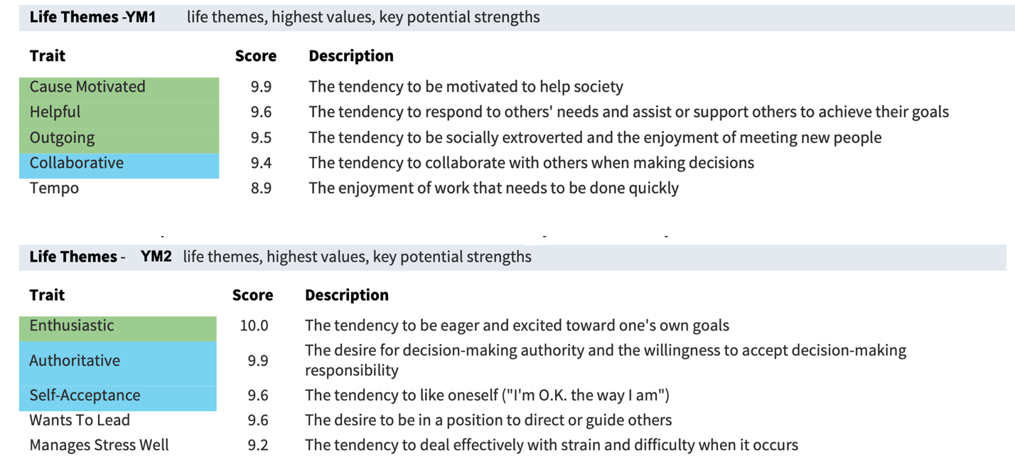
Figure 1 Life Themes

Figure 1 shows the top five values and preferences in the lives of YM1 and YM2. Notice they are totally different. Context, experiences, and culture can influence people’s values. One person’s values are not necessarily valuable to another. The context of religion is associated with more concern for the welfare of others and maintaining the status quo, whereas more individually oriented occupational factors like higher income and self-employment are linked to achievement and change-related values.
While no two candidates for a job are alike, there is evidence that no two churches are alike. Churches have different personality types, that is most likely shaped by the members, the leadership, and the theological emphases. A potential candidate for a ministry job should be able to match his/her values and strengths to a church’s values and character. Candidates should be interviewing the church as the church is interviewing him/her. Needing a job may not be a good enough reason to accept a position at a church that doesn’t line up with a candidate’s life themes. The HA Life Themes when utilized in a person’s job, increases satisfaction and longevity. It has been shown that people that are engaged and enjoying their work have higher wellbeing, better retention, lower absenteeism and higher productivity. Based off Figure 1, would a church hire YM1 or YM2 to lead its young people?
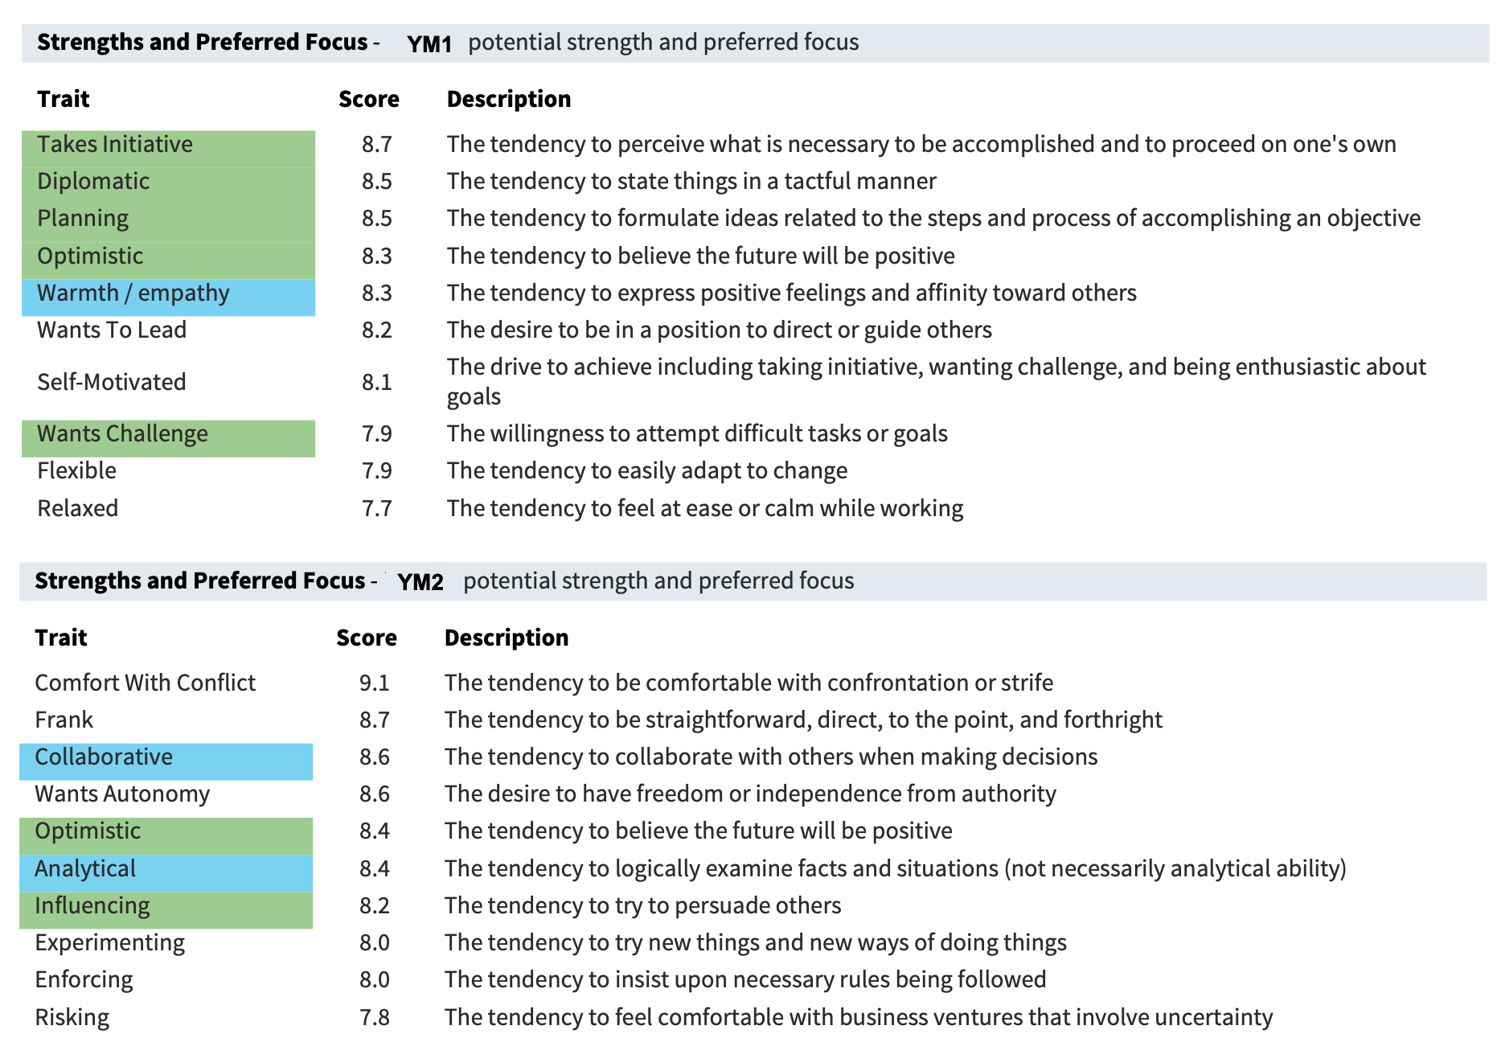
Figure 2 Strengths and Preferred Focus

Recall that both participants are very successful in their youth ministry jobs (same church 15+ years). Figure 2 shows once again, two different areas of strengths and preferred focus. YM1 has five of the essential traits (YM2 has two) for the job of Director of Religious Activities. None of the essential traits for the job of Director of Religious Activities are about a college education or certificate. In the secular workforce, there has been a surge in “skills-based hiring.” The Boston Consulting Group reports “death of the degree” based on their current research of hiring practices. The group examined 20 million job postings and surveyed job seekers to find that many wished employers would look at skills and experience instead of degrees and certifications. Typically, churches looking for a youth minister will ask for a person with 3-5 years of experience and some type of Bible/ministry undergrad college degree. Some denominations may require a Master of Divinity or ministry related master’s degree.
Currently as of 2025, candidates for youth ministry positions are not easy to find or move. Many churches that are looking now to hire get desperate and grab the first live person that comes along if they love teenagers. Most job descriptions from churches looking to hire a youth minister are unrealistic. Many churches expect the youth minister to take care of all the duties that the senior minister doesn’t do along with the duties of youth ministry. Old school churches also expect the spouse of the new hire to serve in the youth ministry, a two-for-one deal. Research shows that ministerial spouses feel like a commodity of the church and unprepared for the expectations of the hiring church.
Figure 2 provides insight into why churches might look at skill sets and traits of individuals along with degrees and certifications. YM1 and YM2 are optimistic. This is the only essential trait they have in common. If a church needed a take-charge kind of person on their staff, they might choose YM1 over YM2. However, if they needed someone to come on board to pull the staff together and work as a team, they might hire YM2 over YM1. Mixing a desired trait (collaborative) with an essential trait (influencing) could prove helpful in bringing cohesion among a church staff.
Figure 3 Acceptable Areas
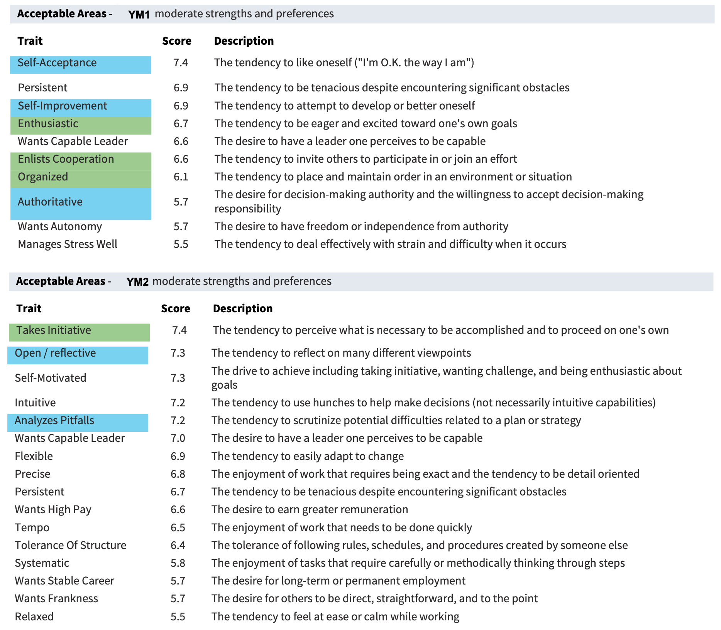
Figure 3 reveals that YM1 has three essential traits, and three desirable traits compared to YM2’s one essential trait and two desirable traits. Acceptable areas are areas that participants show moderate strengths and preferences. The more essential traits and desirable traits in areas 1-3 are critical to a person’s assessment. If youth ministers get opportunities to utilize these traits in these three areas while doing ministry, their job satisfaction and longevity at their church should increase. Once again, looking at the acceptable areas in Figure 3, which candidate would a church hire?
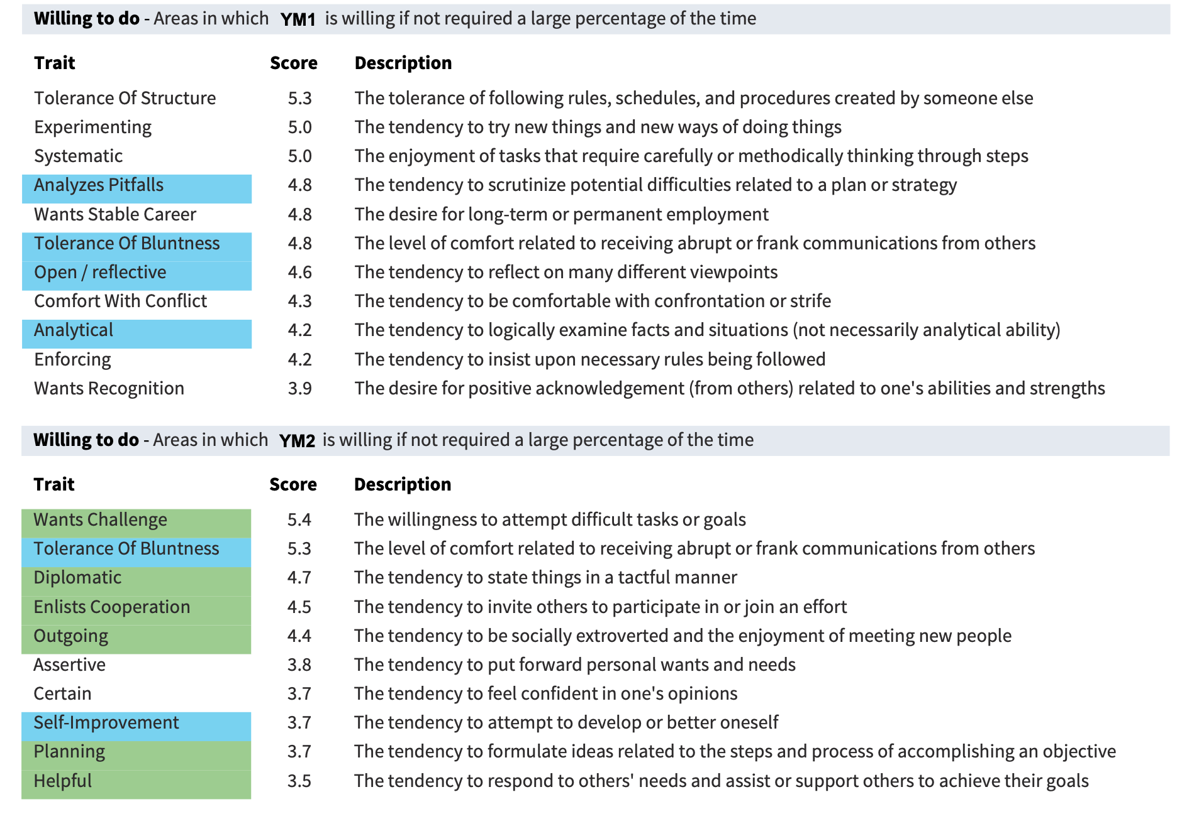
Figure 4 Willing To Do

Figure 4 area describes traits that our candidates are willing to do if they don’t take up much of their time. Recall the purpose of this research project was two-fold, to assess the HA as a tool to help churches and candidates make better decisions about youth ministry positions and to discover possible links to longevity in ministry. Churches would probably choose YM1 over YM2 based on Figure 4. Recall that essential traits are shaded in green and the desirable traits in blue. The HA scores for YM2 place half of the essential traits necessary for the job of Director of Religious Activities in the “willing to do” category. A church interview committee might read this as “I will do these if I have some extra time.” What has kept YM2 at the same church for 15+ years only focusing on half of the essential traits needed for the job? We asked the analysts at HA how someone can be a top performer on the job and yet score low on the essentials. An analyst replied:
As for the low suitability and good performance, a couple of insights.
First, I always say that performance and preference need to be teased apart, I ALWAYS say that, because SMART PEOPLE CAN do anything! What I look for when there’s that gap is the impact on enthusiasm, on optimism, on wanting a challenge because something is eroding while people work against their nature. That’s one thing.
Secondly, if I have that situation I ask about their practices - think military, musicians, athletes - who learn to override their nature and just do it. These people may suffer in those 3 environmentally sensitive areas mentioned above - enthusiasm for their own goals, optimism, and/or wanting a challenge - or not. Sometimes the discipline is so deeply engrained they just do it.

Enthusiasm and optimistic scored high for YM2, while wanting a challenge scored low and is in the Figure 4 category of things to do if they don’t take much of my time. It appears from the data that YM2 may fall into the second insight above. YM2 knows the job, knows the church, and just does it!
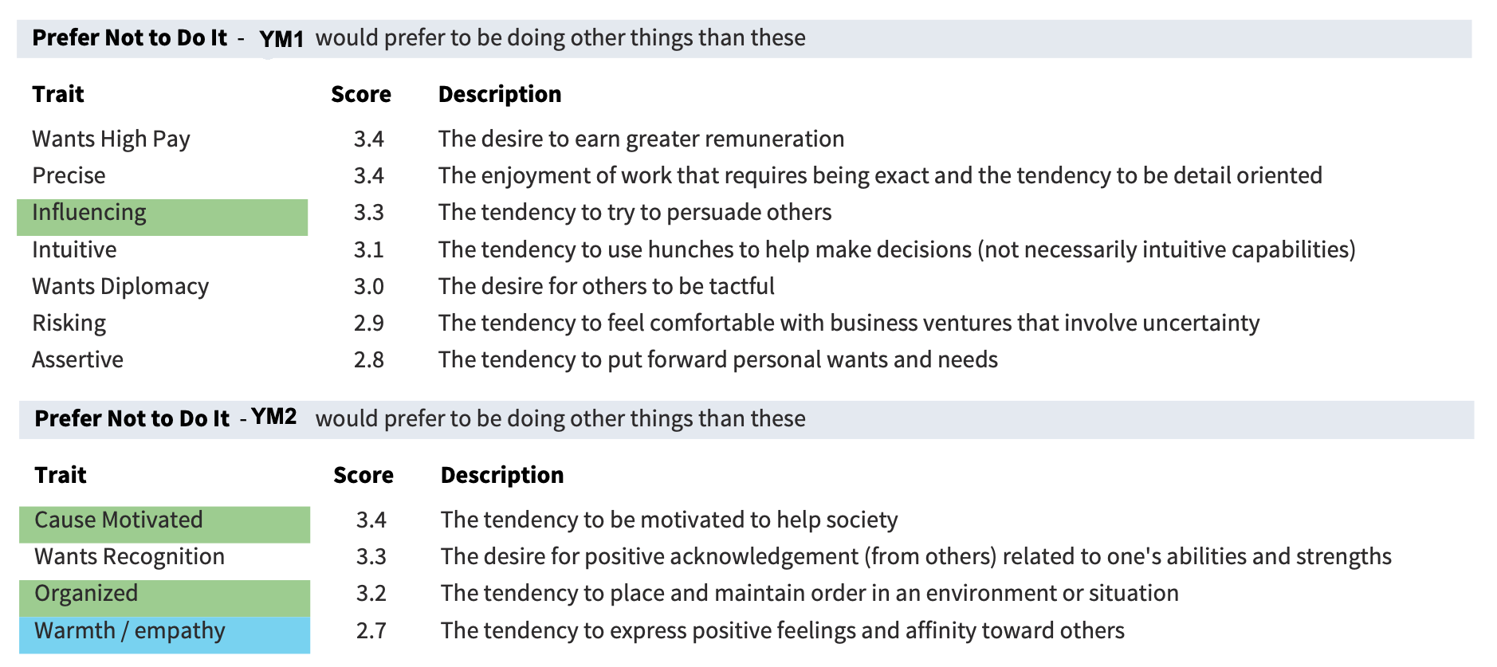
Figure 5 Prefer Not To Do It

Figure 5 provides scores for traits participants would rather not do. YM1 has one essential trait in this category. YM2 has two essential traits and one desirable trait in this category. Conservative churches would choose YM1 based on the scores in Figure 5. Most conservative church leaders disklike talking about money (wants high pay) and they do not like change or surprises from uncertainty (risk taking). Many church leaders are not concerned with their staff’s personal needs and wants (assertive). In the extra questions we were allowed to add to the HA, we did find that these 15+ years participants felt well taken care of overall by their church and leadership. It could be that if a church is taking care of its staff, some of the essential and desirable traits become less important. It does appear looking at our 22 participants that YM2 and the church where YM2 serves, are anomalies (outliers) compared to the rest of the group.
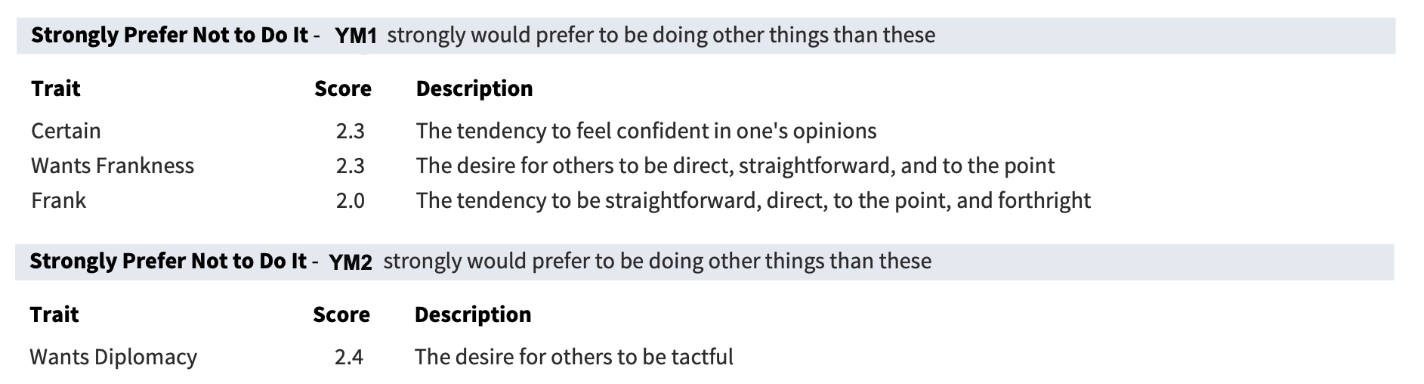
Figure 6 Strongly Prefer Not To Do It

Figure 6 contains the lowest scores of YM1 and YM2. These traits are not in the essential or desirable categories. These traits compared to all others give YM1 and YM2 the least amount of satisfaction.
Expectations About The Ministry Position
The HA provides a list of expectations that the survey participants bring to the table. Church leaders can use this list to compare with the expectations they have in the job description for a youth minister at their church. This comparison should give both parties affirmation (or concern) that there is compatibility and a possible agreement to pursue interviewing. The expectations of YM1 and YM2 are listed below in Figure 7. The expectations are for the job of Director of Religious Activities.
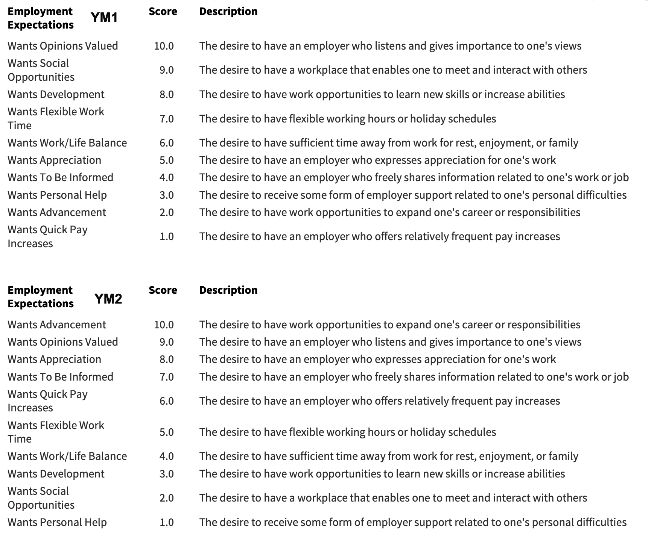
Figure 7 Employment Expectations

Notice that the expectations for YM1 and YM2 are the same but in a different order. The top five in this list are very important to have discussions about according to HA. “Wants opinions valued” is the top choice for YM1 and second choice for YM2. Feeling heard and having one’s opinions valued are cornerstones of close relationships and crucial to healthy self-development. This would be a good question for candidates to ask in an interview. It would also be good to ask the former youth minister if he/she had a voice at the table.
Each of the expectations in Figure 7 should be addressed by the hiring committee/leadership. What does “wants advancement” as an expectation look like in that hiring process. Many youth ministers that “advance” in church settings go on to preach, do counseling, or become family ministers. The youth ministry profession has attempted to steer people away from the notion that youth ministry is a steppingstone to being a real minister. “Advancement” for longevity in youth ministry may mean allowing the youth minister to use his/her other gifts to bless the church.
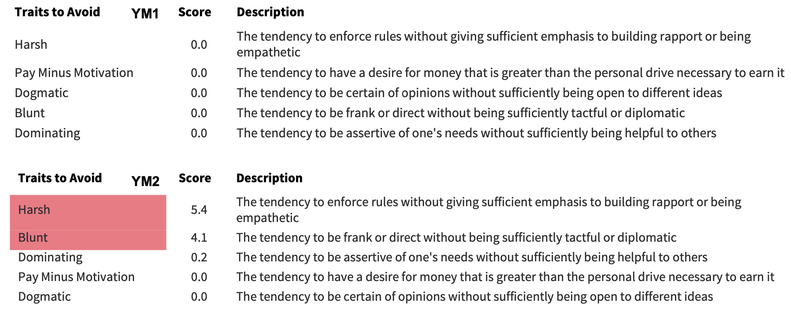
Figure 8 Traits To Avoid

HA describes scores in Figure 8 as being best if they equal zero. This indicates that the participant does not have these traits. Traits with red highlights indicate that these scores could hinder a participant’s job satisfaction and success. These areas need to be addressed. Would a church choose YM1 or YM2 based on this table?
Recall the HA assesses 175 traits of a participant. The traits above in Figures 1-8 are a sample of results provided by the HA. Figure 9 below gives the overall results of YM1 and YM2 related to Job Success Analysis. We continue to explore how two very successful youth ministers can have two very different outcomes. Perhaps it is as the HA analyst reported above, “smart people can do anything, and/or some people just do it.” Based off Figure 9 only, would a church choose YM1 or YM2?
Figure 9 Job Success Analysis
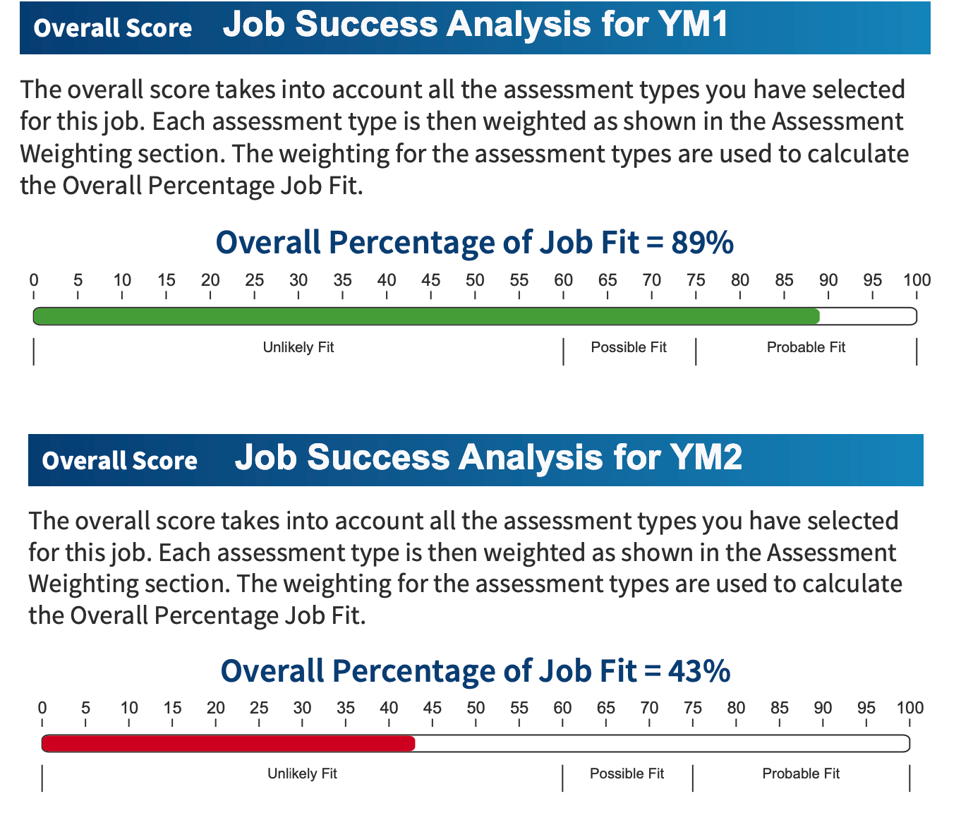

Figure 10 below gives church leaders and the candidate a report on the strengths followed by a summary of the assessment. This report and summary should be used by the church leaders to further evaluate the candidate. The candidate can use this report to be more aware of his/her behavior. Knowing how to maintain strengths and work on areas of weakness should be very valuable for future development.
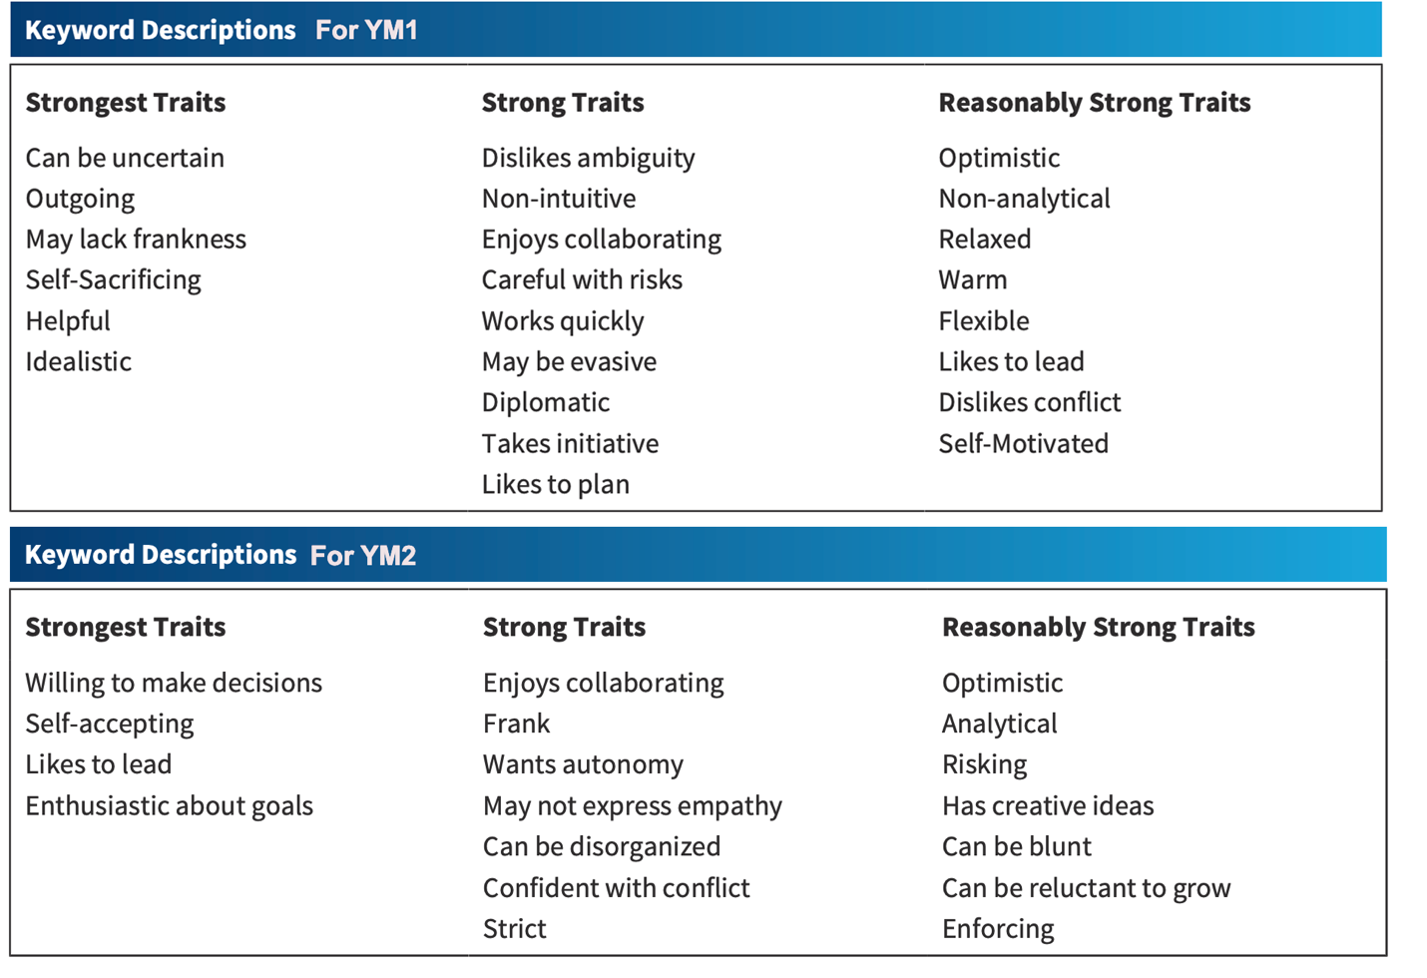
Figure 10 Summary and Keywords

Discussion
A quick search on the Internet for employee assessment tools produces many choices. When the search is narrowed to include clergy only, several are available. One of the purposes of the Youth Ministry Profile study was to assess the HA’s utility to help churches and ministers in making the best choice possible when looking to hire or be hired as a youth minister for the long haul. The nine figures above are a small sample of the data that is produced by the HA. Other areas below are presented in detail in the HA analysis:
  - How to attract this candidate
  - Detailed engagement and employment expectations
  - How to manage, develop, and retain the candidate
  - The Paradox Report
  - Development for the position
  - Your greatest strengths
The data from YM1 and YM2 shows that the HA provides good information on a candidate’s strengths and weaknesses and how those may be addressed by the candidate and the hiring committee. Further research with this assessment tool (using for ministry) is needed to understand the assessment results compared to the actual life and job performance of an individual. Other assessment tools for clergy are well documented.
Caution is advised when using assessment tools. Assessment tools can be a starting point to an eventual face-to-face interview when hiring. An assessment tool can help eliminate subjective bias (especially first impressions), reduce costs, and facilitate faster decision-making. On the negative side, assessment tools can be limited in scope, and they can be manipulated by good test takers. In the secular human resource world, there is a science to assessing and hiring employees. Churches should be just as diligent in hiring the best fit for their congregation. Churches should have a system set up for the hiring process that can be followed diligently with no steps skipped. Following are some take aways from out first-time use of the Harrison Assessment with our 22 youth ministry participants:
- The HA can be used as an assessment tool to screen and interview potential candidates for youth ministry.
- The HA could and should be used as an informative tool for maintaining a current youth minister’s well-being.
- The data output from the HA is well worth the cost.
- The HA can use compared and used with other assessments.
- Overall, the HA can improve a church’s hiring process, reduce the time to hire, ensure a better minister fit, and increase the longevity of the hire.

Future Research
With the shortage of good preaching ministers (pastors), it would be fruitful to work with HA to develop a Job Success Analysis for preaching ministers. The Youth Ministry Profile additional questions provided evidence that church leadership is key for a minister’s longevity. There is evidence forthcoming (Youth Ministry Profile 2) that church leadership can also be a detriment to a youth minister’s tenure at a church. Work with HA to develop a Job Success Analysis for elders/church boards would be beneficial. Most churches use First Timothy 3:1-7 and Titus 1:5-9 as criterion to select leadership. Anecdotally, it is ironic, that many church leaders end up being men of power and or money in the community. The HA would provide a deeper look into the characters of these men.

Appendix A Additional Questions for HA Participants
How long have you been in Youth Ministry?
How many churches have you served as a Youth Minister?
How long have you been serving as the Youth Minister at your current church?
If you have taken the Enneagram, what is your number?
How satisfied are you in your role(s) at this church. Would you say you are at more, less,
or the same satisfaction level now as when you first began working for this church years ago?
What makes it more, less or the same?
Do you have a group of people that you are accountable to (Like an NCYM covenant
group, or something similar), or maybe a mentor that you meet with? Be specific on this if you
can. you don’t have to mention names.
If “Yes” how often do you meet? Does this support help you with personal, family, or work situations?
Do you practice any spiritual disciplines on a regular basis?
If “Yes” which ones and how often.
Have you had a sabbatical from your church?
If “Yes” how many and how long were they?
Did you have any tasks to complete on the sabbatical?
Was this encouraged or did you request?
Do you participate in the regularly scheduled elder’s meetings?
Would you say you serve “with” or “for” the elders at the church you work?
How would you rank your relationship with the elders at your church?
Do your elders pursue a relationship with you?
Do you pursue a relationship with your elders?
Do you have a dominating Elder?
If “yes” can you give a couple examples of how you perceive this elder to be dominating.
Do you have a champion Elder that has your back?
If “yes” can you give a couple examples of how this elder has been in your corner.
Do you have conflict with your elders?
If yes, what is the frequency of conflict?
If yes, how has conflict been handled through the years that you have been at this church?
How is it resolved?
Knowing your leadership, would you say at your church they are in alignment with (more
tuned into): the people, or money stuff, or goals of the church.
If you could offer one piece of advice to leaders in other churches to help them with
keeping their staff healthy, what would that be?
If you could offer one piece of advice to a new youth minister to help them in their
relationship with elders, what would that be?
How satisfied are you in your role(s) at this church.
(very dissatisfied, moderately dissatisfied, slightly dissatisfied, neutral, slightly satisfied,
moderately satisfied, very satisfied)
Would you say you are at more, less, or the same satisfaction level now as when you
first began working for this church years ago? What makes it more, less or the same?

Gallup, “Unleashing the human element at work: Transforming workplaces through recognition” (2002). https://www.workhuman.com/resources/reports-guides/unleashing-the-human-element-at-work-transforming-workplaces-through-recognition?utm_source=google&utm_medium=cpc&utm_campaign=2023_wh_sem_nb_awareness_blog_post_na_phr_pros&utm_content=employee_retention
Jeffrey M. Jones, “U.S. Church Attendance Still Lower Than Pre-Pandemic” (Gallup, 2023) https://news.gallup.com/poll/507692/church-attendance-lower-pre-pandemic.aspx
Ian Lovett, “Houses of Worship Face Cergy Shortage as Many Resign During Pandemic” (The Wall Street Journal, 2022). https://www.wsj.com/articles/houses-of-worship-face-clergy-shortage-as-many-resign-during-pandemic-11645452000
Steve Rabey, “Enrollment Declines and Shifts Continue at Evangelical Seminaries” MinistryWatch, 2022). https://ministrywatch.com/enrollment-declines-and-shifts-continue-at-evangelical-seminaries/
Mark Dance, “Pastors are not Quitting in Droves. (Lifeway Research, 2019). https://research.lifeway.com/2019/07/10/pastors-are-not-quitting-in-droves-2/#:~:text=%E2%80%9CToo%20Many%20Pastors%20Are%20Burning,leave%20the%20ministry%20every%20month.
Jerry D. Hall, A Multi-case Study of Cergy Termination. Doctoral dissertation. (Virginia Beach, VA: Regent University, 2004).
S. Joel Palser, The Relationship Between Occupational Burnout and Emotional Intelligence Among Clergy or Professional Ministry Workers. Doctoral dissertation (Virginia Beach, VA: Regent University, 2004); M. H. Miner, M. Dowson, and S. Sterland, “Ministry Orientation and Ministry Outcomes: Evaluation of a New Multidimensional Model of Clergy Burnout and Job Satisfaction,” Journal of Occupational and Organizational Psychology, 83, (2010);167-188. John B. Morse, (2011). Pastoral Self-care: Maintaining a Balance to Serve Others: A Narrative Inquiry into the Experience of Church-based Clergy. Doctoral dissertation (Ft. Collins, CO: Colorado State University, 2011). Laura K. Barnard and John F. Curry, “The Relationship of Clergy Burnout to Self-compassion and Other Personality Dimensions,” Pastoral Psychology, 61, (2012);149-163. Jody Becker, The Ecological Gift of Spiritual Formation: A Renewal for Healthy Clergy. Doctoral dissertation (Newberg, OR: George Fox University, 2017).
Kelvin J. Randall, (2013). “Clergy Burnout: Two Different Measures,” Pastoral Psychology, 62, (2013); 333-341. S. Muse, M. Love, and K. Christensen, “Intensive Outpatient Therapy for Clergy Burnout: How Much Difference Can a Week Make?,” Journal of Religion and Health, 55, (2016);147-158. Kristen Sager, An Examination of the Roles of Distress, Self-stigma, Caregiver Role Identity, and Self-compassion in Clergy Help-seeking Attitudes. Doctoral dissertation, (Lawrence, KS: University of Kansas, 2019). Andrea M. Sielaff, Kate Rae Davis, and J. Derek McNeil, “Literature Review of Clergy Resilience and recommendations for future research,” Journal of Psychology and Theology, 49, 4 (2020).
Haitung King and John C. Bailar, III., “The Health of the Clergy: A Review of Demographic Literature. Demography, 6, (1969);37-43. Teresa F. Cutts, Gary R. Gunderson, Rae Jean Proeschold-Bell and Robin Swift., “The Life of Leaders: An Intensive Health Program for Clergy,” Journal of Religion and Health, 51 (2012);1317-1324.
Leslie Bumgardner, “Adventist Women Clergy: Their Call and Experience,” Journal of Applied Christian Leadership, 9, 2 (2015); 40-53. Shaun Joynt, “Exodus of Clergy: The Role of Leadership in Responding to the Call. HTS Teologiese Studies/Theological Studies, 73 4 (2017). https://doi.org/10.4102/hts.v73i4.4625
Shaun Joynt, “Exodus of Clergy: A Practical Theological Grounded Theory Exploration of Hatfield Training Centre Trained Pastors,” HTS Teologiese Studies/Theological Studies, 69, (2013). https://hdl.handle.net/10520/EJC140221
Joynt, S. (2017). Exodus of clergy: The role of leadership in responding to the call. HTS Teologiese Studies/Theological Studies, 73 (4), a4625. https://doi.org/10.4102/hts.v73i4.4625
Douglas W. Turton and Leslie J. Francis, “The Relationship Between Attitude Toward Prayer and Professional Burnout Among Anglican Parochial Clergy in England: Are Praying Clergy Healthier Clergy?, “Mental Health, Religion & Culture, 10 1, (2007); 61-74. DOI: 10.1080/13674670601012246. Alexis D. Abernethy, Gillian D. Grannum, Carolyn L. Gordon, Rick Williamson and Joseph M. Currier, “The Pastors Empowerment Program: A Resilience Education Intervention to Prevent Clergy Burnout,” Spirituality in Clinical Practice, 3, 3 (2016); 175-186. Joseph D. Visker, Taylor Rider and Anastasia Humphers-Ginther, “Ministry-related Burnout and Stress Coping Mechanisms Among Assemblies of God-Ordained Clergy in Minnesota,” Journal of Religion and Health, 56, (2017); 951-961. Wesley D. Cohoon and Jessica Smartt Gullion, “Maybe I’m Just too Damaged”: Revisiting Clergy Reasons for Leaving the Profession,” Discernment: Theology and the Practice of Ministry, 9, 1 (2023). https://digitalcommons.acu.edu/discernment/vol9/iss1/3;
Jeren L. Rowell, “Clergy Retention in the Church of the Nazarene, the Role of the District Superintendent in Clergy Decision-making Regarding Persistence in Active Vocational Ministry. Doctoral dissertation (Bourbonnais, IL: Olivet Nazarene University, 2010).
Joseph H. Fichter, “The Myth of Clergy Burnout,” Pastoral Psychology, 62, (1984); 333-341.
Herbert J. Freudenberger, “Staff Burnout,” Journal of Social Issues, 30 1 (1974); 159-165.
Philip Lewis and John Harrison, Longevity in Leadership (Abilene, TX: Abilene Christian University Press, 2016).
Scott Bledsoe and Kimberly Setterlund, “Thriving in Ministry: Exploring the Support Systems and Self-care Practices of Experienced Pastors. The Journal of Family and Community Ministries, 28, (2015); 48-66.
Matt Bloom, Flourishing in ministry (New York, NY: Rowman & Littlefield, 2019).
Cameron Lee and Judith Iverso-Gilbert, “Demand, Support, and Perception in Family-related Stress Among Protestant Clergy. Family Relations: An Interdisciplinary Journal of Applied Family Studies, 52 3 (2004); 249–257. https://doi.org/10.1111/j.1741-3729.2003.00249.x
Peter Scazzero and Warren Bird, The Emotionally Healthy Church: A Strategy for Discipleship That Actually Changes Lives (Grand Rapids, MI: Zondervan, 2003). See also, Peter Scazzero, Emotionally Healthy Spirituality: It’s Impossible to be Spiritually Mature, While Remaining Emotionally Immature (Grand Rapids, MI: Zondervan, 2017).
Gary William Simpson, “Burn On, Don’t Burn Out: Factors That Promote Longevity in Ministry,” (Abilene, TX: Digital Commons @ ACU, Electronic Theses and Dissertation, 2022).
Ryan Latham and Paul Turner, Prepared for Impact: Twelve Keys to Unlock You and Your Youth Ministry (Redbank, NJ: Newman Springs Publishing, 2017).
David A. Willis, D. A., God’s Call and a Practical Methodology for Establishing Longevity in Ministry. Doctoral dissertation. (Pasadena, CA: Fuller Theological Seminary, 2003).
Https://www.pulpitandpew.duke.edu
Jackson W. Carroll, God’s Potters: Pastoral Leadership and the Shaping of Congregations (Grand Rapids: Eerdmans Publishing Co., 2006).
Richard P. Olson, Ruth Lofgren Rosell, Nathan S. Marsh and Angela Barker Jackson, A Guide to Ministry Self-care: Negotiating Today’s Challenges with Resilience and Grace. (New York, NY: Rowman & Littlefield, 2018).
Roy M. Oswald, Clergy Self-care: Finding a Balance for Effective Ministry. (Herndon, VA: The Alban Institute, 1991).
Angela Reed, “Rooted in Relationship: Longevity in Congregational Ministry. Review & Expositor, 113 3 (2016). https://doi.org/10.1177/0034637316659304
Chelsea Gill, Jan Packer and Roy Ballantyne, “Exploring the Restorative Benefits of Spiritual Retreats: The Case of Clergy Retreats in Australia,” Tourism Recreation Research, 43 2 (2018).
Sara LeGrand, Rae Jean Proeschold-Bell, John James and Amanda Wallace, “Healthy Leaders: Multilevel Health Promotion Considerations for Diverse United Methodist Church Pastors. Journal of Community Psychology, 41 (2013); 303-321.
Dwayne Ramon Bond, Idealism & Reality: A Phenomenological Exploration of Pastoral Expectations & Ministry Realities Experienced by Protestant Church Planting Pastors. Doctoral dissertation (Lynchburg, VA: Liberty University, 2014).
Michael W. Casey, and Douglas A. Foster, The Stone-Campbell Movement: An International Religious Tradition (Knoxville, TN: University of Tennessee Press, 2002).
Https://www.harrisonassessments.com
Michelle Burgess, personal email communication, December 21, 2024.
Kyle C. Longest, Steven Hitlin and Stephen Valsey, “Position and Disposition: The Contextual Development of Human Values. Social Forces, 91 4 (2013); 1499-1528.
Michael Adam Beck, The Five Congregational Personality Types: An Ancient Pathway for Congregational Renewal in the 21st Century (Plano, TX: Invite Press, 2023).
Ginny Olson, Diane Elliot and Mike Work, Youth Ministry Management Tools. Grand Rapids, MI: Zondervan, 2001). See also, Tim Schmoyer, “Questions I Ask When Interviewing for a Youth Ministry Position” (2011). http://www.studentministry.org/questions-ask-interviewing-youth-ministry-job/
Gallup, “Employee Engagement,” (2024). https://www.gallup.com/394373/indicator-employee-engagement.aspx
Sagar Goel, Orsolya Kovacs-Ondrejkovic, Rucha Vankudre, Scott Bingham, and Julia Nitschke, “Competence Over Credentials: The Rise of Skills-based Hiring,” (2023). https://www.bcg.com/publications/2023/rise-of-skills-based-hiring
Tammy Dunahoo and Jaime Handley, “How to Become a Pastor. (2025). https://www.georgefox.edu/seminary/articles/become-a-pastor.html#:~:text=Some%20denominations%20require%20a%20master,but%20have%20internal%20training%20programs.
Dan Istvanik, “More Reasons for the Youth Pastor Shortage,” (2024). https://youthminhub.com/2024/10/10/more-reasons-for-the-youth-pastor-shortage/
Brian Foreman, “Why Church Expectations for a Youth Minister May be Uunrealistic and How to Change Them,” (2022). https://baptistnews.com/article/why-church-expectations-for-a-youth-minister-may-be-unrealistic-and-how-to-change-them/#:~:text=Krista%20Hughes%2C%20director%20of%20a,why%2C%20but%20also%20the%20how.
Tara Baker Dew, Survive or Thrive? An Exploration of the Preparedness of Southern Baptist Pastors Wives for Ministry.” [Doctorate of Education, Southeastern Baptist Theological Seminary]. ProQuest Dissertations & Theses Global database, (2018).
Paul Turner, “12 More Critical Youth Ministry Job Interview Questions You Should Ask, (2018). https://thediscipleproject.net/13-more-critical-youth-ministry-job-interview-questions-you-should-ask/
Carla Anne Roos, Tom Postmes and Namkje Koudengurg, “Feeling Heard: Operationalizing a Key Concept for Social Relations,” National Library of Medicine 18 11 (2023). doi: 10.1371/journal.pone.0292865. PMID: 38032901; PMCID: PMC10688667.
Daniel K. Campbell-Meiklejohn, Dominik R. Bach, Andreas Roepstorff, Raymond J. Dolan and Chris D. Frith, “How the Opinion of Others Affects Our Valuation of Objects, National Library of Medicine 20 13, (2010);1165-70. doi: 10.1016/j.cub.2010.04.055. Epub 2010 Jun 17. PMID: 20619815; PMCID: PMC2908235.
Jon Coombs, “Youth Ministry is not Just a Steppingstone,” (2019). https://www.thegospelcoalition.org/article/youth-ministry-not-just-stepping-stone/
Syler Thomas, “What makes youth pastors stay?” (2019). https://outreachmagazine.com/features/leadership/46387-what-makes-youth-pastors-stay.html; See also, Dave Chiswell, “A Plea for More Unicorns in Youth Ministry, (2023). https://au.thegospelcoalition.org/article/a-plea-for-more-unicorns-in-youth-ministry/
Roy M. Oswald, and Otto Kroeger, Personality Type and Religious Leadership (Herndon, VA: The Alban Institute, 1988).
Lin Grensing-Pophal, “Pros and Cons of Tests and Take-home Assignments in Recruiting,” (2020). https://www.shrm.org/topics-tools/news/talent-acquisition/pros-cons-tests-take-home-assignments-recruiting
Elaine D. Pulakos, Selection Assessment Methods: A Guide to Implementing Formal Assessments to Build a High-quality Workforce (Alexandria, VA: SHRM Foundation, 2005).
Jim Baker, “Ten Steps You Must Follow in Hiring Church Staff, (2016). https://sacredstructures.org/manpower/tn-step-you-must-follow-in-hiring-church-staff/#:~:text=Look%20closely%20at%20both%20how,results%20for%20the%20ideal%20candidate.&text=Once%20you%20have%20narrowed%20the,Relocation%20discussion

